DELHI PUBLIC SCHOOL – BPKIHS, DHARAN
DASHAIN HOLIDAY HOMEWORK – 2023

CLASS – XII COMMERCE
Serial no. | Subject | Page no.
1. | English | 1 – 7
2. | B. St | 8 – 21
3. | Economics  - Indian Economics  - Macro Economics | 22 – 33  34 – 53
4. | Accountancy | 54 – 65
5. | Mathematics | 66 – 82
6. | CS | 83 – 102
7. | IP | 103 – 125

ENGLISH

GENERAL INSTRUCTION
Attempt question based on specific instructions for each part. Write the correct question number in your answer sheet to indicate the option/s being attempted.
- Answer all the Questions ( 4 Marks)
Read the given extracts to attempt the questions with reference to context:
(1) but after airport’s
security check, standing a few yards
away, I looked again at her, Wan,
pale
as a late winter’s moon and felt that
old
familiar ache, my childhood’s fear
but all I said was, see you soon,
Amma,
All I did was smile and smile and
smile ------
Choose the correct option :
(i) In the above extract the narrator feels
(a) satisfied
(b) fearful
(c) nostalgic
(d) regretful
(ii) Identify the word in the extract that means ‘colourless’.
(iii) Complete the following analogy correctly :
She sang like a bird : Simile
All I did was smile and smile and smile : ______
(iv) Read the following statement and choose the correct option :
(1) The poet had gone through the security check.
(2) She did not want to look at her mother.
(a) (1) is true, but (2) is false.
(b) (1) is false, but (2) is true.
(c) Both (1) and (2) are true.
(d) Both (1) and (2) are false.
(v) What childhood fear is the poet referring to ?
(vi) Fill the blank with appropriate words with reference to the extract:
Pale as a winter’s moon suggests _______.
(2) Sometimes I feel myself I can hardly bear
The thought of so much childish longing in vain,
The sadness that lurks near the open window there,
That waits all day in almost open prayer.
For the squeal of brakes, the sound of a stopping car,
Of all the thousand selfish cars that pass,
Just one to inquire what a farmer’s prices are,

(i) What is the sentiment expressed in the above extract ?
(i) remorse (ii) regret (iii) empathy
(iv) disappointment (v) guilt
Choose the correct appropriate option.
(a) (iii) and (iv)
(b) (ii) and (iii)
(c) (iv) and (v)
(d) (i) and (v)
(ii) Identify the phrase in the extract that suggests ‘innocent desires’.

(iii) The roadside stand owners pray for ______.
(a) a relief from the heat (b) free housing
(c) cars stopping (d) benefits from pollution

(iv) Complete the following analogy correctly :
He fought like a lion : Simile :: selfish cars : _____

(v) On the basis of the extract, choose the correct option with
reference to (1) and (2) given below :
(1) The people who have put up the roadside stand keep
waiting for customers.
(2) They become sad when someone turns up.
(a) (1) is true, but (2) is false.
(b) (1) is false, but (2) is true.
(c) Both (1) and (2) are true.
(d) Both (1) and (2) are false.

(vi) Fill the blank appropriately with reference to the extract. ‘Squeal of brakes’ implies ________

3)The clerk figured the fare – he glanced at my fancy hat band, but he
figured the fare – and I had enough for two coach tickets, one way.
But when I counted out the money and looked up, the clerk was
staring at me. He nodded at the bills. “That ain’t money, mister,” he
said, “and if you’re trying to skin me, you won’t get very far,” and he
glanced at the cash drawer, beside him. Of course the money was
old-style bills half again as big as the money we use nowadays and
different looking.
(i) Why did Charley ask for two tickets ?
(ii) Complete the sentence by choosing the correct option :
When Charley offered money to the booking clerk, the latter stared at Charley because the booking clerk
(a) thought it wasn’t money .
(b) did not trust Charley.
(c) thought Charley was trying to tease him.
(d) thought that Charley had given him less money.
(iii) Select the option that best describes Charley in this extract. He is
(a) a cheat
(b) gullible
(c) an opportunist
(d) an escapist
(iv) ‘If you’re trying to skin me’ suggests ________.

(4) What prevented the Shokalskiy from going further ? What did the captain instruct the passenger to do ? (Journey to the End of The Earth)
(5) What did the Maharaja and dewan do to avoid the danger of losing the throne?
(6) What did Judewin tell the narrator? What was the effect?
7)Why did Gandhi agree to a settlement of twenty-five percent refund
to the peasants ? (Indigo)
8)What made the ironmaster invite the peddler to his house ?
9)What was the expectation of the people who had set up the roadside
stand ?
10)Why did Aunt Jennifer create tigers so different from her own
character ?
11)Why can the bangle-makers not organise themselves into a
cooperative ? (Lost Spring)
12)Why did Douglas decide to go to the YMCA pool to learn swimming ?
(Deep Water)
- What were the authors’s initial emotions on setting foot in Antartica? (journey to the end of the earth)
- What impression do you form of Dr. Sadao’s father from the story “The Enemy”?
- What does Zitkala-sa mean by “ Eating Formula”?
16)The description of Seemapuri creates a very dismal picture. Explain.
(The Lost Spring)
17)Why was the peddler hesitant to accompany the ironmaster to the
manor house ? (The Rattrap)
18)Why was M. Hamel dressed in formal clothes in school ?
(The Last Lesson)
- In the poem of ‘The thing of Beauty,how is grandeur connected with the mighty dead?
- Why did Sophie long for her brother’s affection?
- Why did the booking clerk refuse to accept the money offered by
Charley ? (The Third Level)
22)Why does Derry not like being with people ?
23)What message does the story The Tiger King give to the readers ?
24) What does Gandhi refer to as ‘conflict of duties’ ?
(25) What does the expression ‘polished traffic’ refer to ? What does it
reveal about city people ?
(26) Why did the iron master compare Edla to a parson ?
(27) What is the significance of the word ‘but’ in ‘but all I said was see
you soon, Amma ? (My Mother at Sixty-Six)
(28) What handicap did Douglas suffer from ? How did he overcome that ?
(29) What according to Pablo Neruda in the poem ‘Keeping Quiet’ is the
lesson that we should learn from mother earth ?
(30)Why was Dr. Sadao not sent abroad with the troops ?
31) What was the hidden agenda behind the Tiger King’s marriage with
the princess in the neighbouring state ?
32)What are the significant features of ‘Students on Ice Programme’ ?
33)What gave Derry the courage to go back to Mr. Lamb’s house despite
his mother’s refusal ?
34)What did the astrologers depict about the child when he was born ?
The Tiger King)
35)Why did Geoff Green include young students in his programme ?
36)What role does Sam’s letter play in the story ?
37) How did the ‘duraisani’ behave on receiving the gifts ?
38How does Mr. Lamb try and convince Derry that there is no essential
difference between them ?
39)What did Charley find in his collection of first day covers ?
40)Who was Edla Williamson ? Why did she visit the forge at
night ?
II Answer all the Questions (5 MARKS)

1)After seeing off the enemy soldier, Dr. Sadao must have felt relieved.
He was able to uphold the oath that he had taken as a doctor. Dr.
Sadao made an entry into his daily diary explaining the dilemma
faced by him and how he resolved it.
Imagine yourself to be Dr. Sadao and express his thoughts.
(You may begin like this : I was able to uphold the oath that I had taken as a doctor….)

2) Both Bama and Zitkala-Sa were from marginalized communities. They challenged the system to bring dignity into their lives. Justify.

3) ‘Last Spring’ and ‘Indigo’ bring out how the common man is a victim of exploitation. Explain.
(4) ‘Aunt Jennifer’s Tigers’ and ‘A Thing of Beauty’, can be read together
to show the permanence and everlasting impact of art and of things
of beauty. Comment.
- Fantasizing and unrealistic dreams sometimes lead to disappointment and disillusionment. Discuss this with reference to the story Going Places

6)Firozabad presents a strange paradox the beauty of the glass
bangles and the misery of the people who make bangles. Discuss.
7)Describe briefly the Third Level. How did it differ from the Second
Level ?
8)What was the Maharaja’s mission? How did he resolve to overcome
the obstacles in the fulfilment of his mission ? (The Tiger King)
9)Why is the Champaran episode considered as the beginning of the
Indian struggle for independence ? (Indigo)
- Edla is a contrast to her father, the ironmaster. Explain. (The Rattrap)
11)How can a visit to Antarctica be an enlightening experience ?
Elaborate. (Journey to the end of the Earth)
12)Bama and Zitkala-Sa, though victims of a system that crushes their
aspirations, are determined to break out. Comment.
13)The last lesson reflects the flaws in human character that led to the sad plight of people in Alsace. Substantiate your answer with evidences from the text.
14) A Roadside Stand is a social satire depicting the two contrasting
worlds existing in society. Justify this statement with reference to
the poem.
15)Mr. Lamb stands as a symbol of optimism and hope. Support your
answer with examples from the text.
16) Dr. Sadao emerges as a saviour of humanity. Substantiate your
answer with evidence from the text.
17)No other forms of art in India has influenced the society like films. Do you agree? Comment on it with the help of Poet and pancakes.
18)Explain different celebrities’ views on the process of interview?
19)Day dreaming is quite common in teenagers. Are there any benefits of day dreaming? What may be the demerits of day dreaming?

20)Should a teenager fix his/ her aim in life as per their parents’ socio-economic background? If not, then give reasons why one should dream high?
21) “I will not submit! I will struggle first!” says Zitkala-Sa. What was she going to resist and why? What efforts did she make and what was the outcome?
22)How did Bama react to the threshing proceedings in a corner of their street and the spectacle of a big man carrying a packet by its string ?
23)The fog in the story, ‘The Enemy’ is symbolic. Elucidate.
24)A positive attitude helps to tackle all difficulties in life. Elaborate with reference to Lamb.
25) Various factors can lead to psychological changes in one’s personality. Discuss with reference to Derry’s experience.
26) What will counting upto twelve and keeping quiet help us to achieve?Do you think the poet advocates total inactivity and death?
27) ”All lovely tales that we have heard or read;An endless fountain of immortal drink”Correlate to your childhood sessions of listening to stories from Grandmother with the above lines ?
- Gandhi’s focus was more on making the peasant free from fear. How is fear a deterrent for the people to realize their true potential? Illustarte your asnwer with respect to the peasants and William Douglas in the lesson ‘ Deep Water.

- Imagine that the bully who threw Douglas into the pool, reads this chapter and realizes his mistake. As the bully, write a dairy entry penning down your response to Douglas’ perseverance and your own feelings of guilt and regret.

- How would you evaluate Mukund Padmanabhan as an interviewer? Mention at least two qualities he displays in his interview, supported by textual evidence.

31)Imagine that you are Christopher Sylvester. You have been invited to a seminar series titled – ‘Ethics and Techniques of Interviewing’. The organisers would like you to speak about the challenges of conducting interviews, and skills interviewers must have in order to conduct good and ethical interviews. Based on your reading of The Interview, Part I and II, draft your speech. Include relevant details from the text in support of your answer.

32)Imagine Sophie meets Danny Casey after several years. Write a dialogue exchange between them where Sophie explains what that meeting means to her.

33)You are a blogger who loves to record travel stories. You recently visited a picturesque location and you were enamoured by its beauty. Pen down the post for your blog giving vivid descriptions of the natural beauty of this place. Supplement your writing with Keats’ ideas about beauty.

34)The tigers represent Aunt Jennifer’s spirit and her hands represent her reality.’ How?

- The poem ‘Aunt Jennifer’s Tigers’ is about the power of art. Justify it.

******************************************************************

BUSINESS STUDIES

i. Section A – MCQs of 1 mark each.
ii. Section B – carry 3 marks each. Answer to each question may be from50 to 75 words.
iii. Section C- carry 4 marks each. Answers to the questions may be about150 words.
iv. Section D – carry 6 marks each. Answers to the questions
Section A
1. DK Choudahry who was unwell, called his son Ramesh and gave him a gift packet. Ramesh
opened the packet and saw many crumpled share certificates inside. His grandfather told him
that they had been left behind by his late father. As no trading is now done in physical form,
Ramesh wants to know the process by adopting which he is in a position to deal with these
certificates.
Identify the process.
(a) Dematerialisation
(b) Demutualisation
(c) Neither (a) nor (b)
(d) Both (a) and (b)

2. Manahis Sharma works readymade garments factory. in an production manager. He was shifted
sales department without any substantial change in the responsibility and status.
Which type of recruitment is done in this case?
(a) Horizontal recruitment
(b) External recruitment
(c) Internal recruitment
(d) None of these

3. Identify the right of consumers being promoted in the given picture.

(a) Right to be heard
(b) Right to seek redressal
(c) Right to be informed
(d) Right to consumer education
4. A new packaging machine is to be installed in a fast food factory. Which type of decision is
taken while deciding about its installation?
(a) Working capital decision (b) Capital budgeting decision
(c) Financing decision (d) All of these
5. SolarTop Power Private Limited set up a factory for manufacturing solar lanterns in a remote
village as there was no reliable supply of electricity in rural areas. The revenue earned by the
company was sufficient to cover the costs and the risks. The demand of lanterns was increasing
day-by-day, so the company decided to increase production to generate higher sales. For this,
they decided to employ people from the nearby villages as very few job opportunities were
available in that area. The company also decided to open schools and crèches for the children
of its employees.
Identify the objectives of management discussed above.
(a) Social objective (b) Organisational objective
(c) Neither (a) nor (b) (d) Both (a) and (b)

6. Match the work performed by specialist foremen under functional foremanship in Column I
with job assigned to them in Column II.
Column I Column II
A. Ensures discipline (i) Inspector
B. Check quality of work (ii) Instruction card clerk
C. Draft instructions to workers (iii) Disciplinary
(a) (iii), (ii), (i) (b) (i), (iii), (ii)
(c) (iii), (i), (ii) (d) (ii), (iii), (i)
7. PS Fabric Company is planning to measure potential of each employee for learning new skills
to know their capacity to develop.
Which type of test will cater company’s aim?
(a) Aptitude test (b) Intelligence test
(c) Trade test (d) Interest test
8. Which of the following is the first and largest depository presently operational in India.
(a) Central Depository Services Limited (CDSL)
(b) National Securities Depository Limited (NSDL)
(c) Neither (a) nor (b)
(d) Both (a) and (b)

9. Identify the element of directing that aims to influence the behaviour of people to strive them
willingly for the achievement of group goals.
(a) Motivation (b) Supervision
(c) Leadership (d) None of these

10. For the following two statements choose the correct option:
Statement I: Working capital requirements of a company is affected by inflation.
Statement II: ‘Choice of technique’ affects the requirement of fixed capital of a company.
Choose the correct option from the options given below:
(a) Statement II is true and I is false
(b) Statement I is true and II is false
(c) Both the statements are false
(d) Both the statements are true

11. Familiarising the selected employees with the rules and policies of the organisation and
introducing the selected employees to other employees is the process of:
(a) Induction training (b) Performance appraisal
(c) Employment interview (d) None of these

12. ‘The human resource manager assessed the number and type of human resources necessary for
the performance of various jobs under an electronic division, and found it to be understaffed.’
Which type of analysis has been done by human resource manager?
(a) Workload analysis (b) Workforce analysis
(c) Human resource analysis (d) None of these

13. A company earned a profit @12% last year. Debts are available in the market @15%. If the
company issue debt for its financial needs, it will be______.
(a) Unlevered (b) Unfavourable levered
(c) Favourable levered (d) Cannot decide

14. Which of the following is not a characteristic of a good brand name?
(a) Short and simple (b) In local language
(c) Sufficiently versatile (d) Distinctive

15. A manager should replace ‘I’ with ‘We’ in all his conversations with workers to foster team
spirit. Which principle of management is being highlighted here?
(a) Order (b) Equity
(c) Discipline (d) Espirit de Corps

16. Arrange the following steps involved in the staffing process in correct sequence:
(i) Estimating the Manpower Requirements
(ii) Selection
(iii) Recruitment
(iv) Performance Appraisal
(v) Training and Development
(vi) Placement and Orientation
(vii) Compensation
(viii) Promotion and career planning
(a) (i), (iii), (ii), (iv), (vi), (v), (vii), (viii)
(b) (i), (ii), (iii), (v), (vi), (vii), (viii), (iv)
(c) (i), (ii), (iii), (vii), (v), (viii), (iv), (vi)
(d) (i), (iii), (ii), (vi), (v), (iv), (viii), (vii)

17. A element/dimension of business environment involves improvements and innovations which
provide new ways of producing goods and services and new methods and techniques of operating
a business?
Select the above element :
(a) Technological (b) Political
(c) Economic (d) Social
18. Which of the following principle of equity does not imply ?
(a) Equal pay to everyone
(b) Fair treatment to all employees
(c) Stern action against the lazy personnel
(d) No discrimination against anyone on the basis of gender, religion, language, caste, belief,
etc.

19. GSV Steel Ltd. is a steel manufacturing company located in India. It is enjoying buoyant
demand for its products as economic growth is about 9 to 10 percent and demand for steel is
growing. The company has decided to set up a new plant to cash on the increase demand. It is
estimated that it will require about ` 5,000 crores to set up and about ` 1,000 crores of working
capital to start the new plant.
Identify the decision taken by the financial manager in the above case?
(a) Financial decision (b) Investment decision
(c) Dividend decision (d) Capital structure decision

20. Which of the following is not an advantage of functional structure?
(a) Minimum duplication of work
(b) Coordination across departments
(c) Ease in training of employees
(d) Control and coordination within departments
21. Newtech company has shifted workforce from surplus departments to those where there is
shortage instead of laying them off. Which stage of staffing reveal the surplus/shortage of
workforce?
(a) Training and development
(b) Recruitment
(c) Performance appraisal
(d) Estimating manpower requirement

22. The principles of management are flexible. Select appropriate reason :
(a) they are dependent upon the prevailing situation.
(b) they aim at influencing the behaviour of human beings.
(c) they apply to all types of organisations.
(d) they can be modified by a manager as per the situation.

23. The financial incentive offered over and above the wage/salary to an employee is________.
(a) Bonus
(b) Productivity-linked wage incentive
(c) Profit sharing
(d) Perquisites

24. Match the type of tests in Column I with their meanings in Column II.

Column I Column II
A. Intelligence Test (i) Measures an individual’s potential for learning new skills
B. Aptitude Test (ii) Measures the existing skills of an individual
C. Trade Test (iii) Measures the level of intelligence of an individual
(a) (iii), (i), (ii) (b) (i), (ii), (iii)
(c) (ii), (i), (iii) (d) (ii), (iii), (i)

25. Which of the following is not a function of stock exchange?
(a) Safety of transaction
(b) Pricing of securities
(c) Providing liquidity and marketability to existing securities
(d) Holding securities in electronic form

26. Safex BioScience Private Limited, a pharmaceuticals company, has introduced mosquito
repellent bands under the brand name ‘Jaddu’ in the wake of outbreak of dengue in various
parts of the country. The product attracted many people from all age groups, especially kids.
However, the company failed to provide adequate guidance for the users on the label of the
product in terms of time period of the effectiveness of the repellent band once its seal is opened.
Because of this ambiguity, many buyers faced problems.
Identify the consumer right which has been overlooked by the company.
(a) Right to be informed (b) Right to safety
(c) Right to be heard (d) Right to be assured

27. For the following two statements choose the correct option:
Statement I: Management is called an inexact science.
Statement II: Management deals with complex human behaviour, which cannot be determined
with accuracy. Choose the correct option from the options given below:
(a) Both the statements are true
(b) Both the statements are false
(c) Statement I is true and II is false
(d) Statement II is true and I is false

28. ‘To get the benefit of the hi-tech consumers who made use of computer more in their lives,
TATA Sons even launched a website for e-greetings.’ Which dimension of business environment
is reflected here?
(a) Social environment (b) Economic environment
(c) Political environment (d) Technological environment

29. Rajeshwari, a home science graduate from a reputed college, has recently done a cookery
course. She wished to start her own venture with a goal to provide ‘health food’ at reasonable
prices. She discussed her idea with her teacher (mentor) who encouraged her. After analysing
various options for starting her business venture, they shortlisted the option to sell readymade
and ‘ready to make’ vegetable shakes and sattu milk shakes. Then, they weighed the pros and
cons of both the shortlisted options.
Name the function of management being discussed above.
(a) Controlling (b) Organising
(c) Planning (d) Directing

30. “Management principles are not as rigid as principles of pure science.” Which of the following
best describes the given statement?
(a) Principles of management are formed after research in work situations, which are technical
in nature.
(b) Principles of management contribute towards the development of management both as a
science and as an art.
(c) Management principles deal with human behaviour and thus, are to be applied creatively
given the demands of the situation.
(d) None of these

31. Centralisation refers to:
(a) creating divisions as profit centers.
(b) dispersal of decision-making authority.
(c) retention of decision-making authority.
(d) opening of a head office/centre of importance.

32. ‘Managers at all the levels need to perform the controlling function to keep a check on the
activities in their respective areas of operation.’ Which feature of controlling is being referred
to?
(a) Controlling is all pervasive
(b) Controlling is looking back
(c) Controlling is forward looking
(d) Controlling is a goal-oriented process

33. Which of the following statements is not correct about recruitment?
(a) External sources of recruitment gives satisfaction to the existing employees.
(b) Internal sources of recruitment motivates the employees to improve their performances.
(c) Process of recruitment proceeds selection.
(d) Recruitment is a positive process.

34. Grouping of activities on the basis of functions form a___
(a) Decentralised structure
(b) Functional structure
(c) Centralised structure
(d) None of these

35. In today’s dynamic business environment, companies are specialising in their core competency
and divesting non-core businesses. In this context, one may cite the decision of Piramal Limited
in divesting non-core businesses of chemicals and seeds. Some companies are outsourcing their
non-core activities like share-transfer management and advertising to outside agencies. So much
so, that even core processes such as R&D, manufacturing and marketing are being outsourced
today. Thus, the significance of ‘Business Process Outsourcing’ (BPO) and ‘Knowledge Process
Outsourcing’ (KPO) has increased. Identify the significance of principles of management
highlighted here.
(a) Meeting changing requirements
(b) Optimum utilisation of resources
(c) Scientific decisions
(d) Providing managers with useful insight into reality

36. Which of the following helped to eliminate the use of share certificate in physical form?
(a) Depository Trust Company
(b) Securities Exchange Commission
(c) Dematerialisation of securities
(d) Fedral Depository Insurance Corporation
37. Arrange the following needs in the correct sequence of Maslow’s Need Hierarchy Theory of
Motivation:
(i) Affiliation/Belongingness Needs
(ii) Basic Physiological Needs
(iii) Safety/Security Needs
(iv) Self-actualisation Needs
(v) Esteem Needs
Choose the correct option:
(a) (ii), (iii), (i), (v), (iv) (b) (v), (iii), (ii), (i), (iv)
(c) (iv), (i), (v), (iii), (ii) (d) (i), (ii), (iv), (iii), (v)

38. Apart from top level managers, placement agencies are suitable for which type of employees?
(a) Unskilled labours
(b) Fresh graduates
(c) Technical and professional personnel
(d) All of these

39. Using external sources for filling vacant positions:
(i) gives a wider choice.
(ii) simplifies the process of selection.
(iii) instils a competitive spirit among the existing employees.
(iv) does not infuse fresh talent in the organisation.

Section : B
40. Differentiate between Functional and Divisional Structure.
41.How does planning lead to economy and efficiency? Explain briefly.
42. Explain the type of training that is suitable to train the employees to handle highly sophisticated
machinery and equipments.
43.Identify and explain the importance of a concept of management which aims at distribution of
decision making responsibility among various hierarchical levels.
44. Stock exchange acts as a regulator of the securities market. It creates a continuous market
where the securities are bought and sold. It gives investors the chance to disinvest and reinvest.
Through this process of disinvestment and reinvestment, savings get channelized into their
most productive investment avenues. To ensure that the investing public gets a safe and fair
deal in the market, the membership of the stock exchange is well regulated and its dealings are
well defined according to the existing legal framework. It also ensures wider share of ownership
by regulating new issues, better trading practices and taking effective steps in educating the
public about investments.
Identify and state any three functions performed by the Stock Exchange discussed in the above
para.
45. A construction company got a contract for constructing a foot-over bridge. It appointed an
engineer to take charge of the same. The engineer was instructed that the work should be
completed within a period of two months with the maximum cost of ` 5,00,000. Any negative
variation in the cost beyond 5% should be brought to the notice of authorities immediately.
He was also asked to keep a special check on the supply of construction material as if it is not
supplied in time then, the entire project would get delayed.
Which concept(s) is/are being referred to in the given case? Discuss.

46. “If we delegate the authority, we multiply it by two; if we decentralise it, we multiply it by
many”. How?
47. Which marketing management philosophy lays more emphasis on the consumer welfare rather
than the consumer satisfaction? How is it different from the Production Concept?
48. Rajesh was working as a First Line Manager. At which level of management was he working?
State any two functions performed at that level.
49. Nowadays the market offers a lot of opportunities to the marketers as the customer income is
rising. People have developed a taste for better quality products even though they may have to
pay more. Their aspiration levels have increased.
(a) Which dimension of business environment is being referred to?
(b) Explain one more dimension of business environment with example.
50. What is meant by ‘Financial Management’? State its objective.
51. It is that component of Financial market, in the absence of which the primary market will
become unattractive as there will be no liquidity. Identify the type of Financial market and list
its two functions.

Section : C
52. Explain the concept of Democratic leadership and state its features.
53.Write a short note on any four types of employment tests.
54. What are the functions of packaging?
55. Describe the concept of Authoritative leadership and state its features.
56. NODIA Solution Private Limited is in the business of software solutions. It has a share capital
of ` 70 lacs at the face value of ` 100 each. Company is considering a major expansion of
its production facilities and wants to raise ` 50 lacs. The chief financial officer (CFO) the
company has recommended that the company can raise funds of the same amount by issuing
7% debentures. Given that earning per share of the company after expansion is ` 35 and tax
rate is 30%, did CFO give a justified recommendation? Show the working.

57. Malini is a well-known businesswoman in the field of publishing. She owes the success of her
business to her own education in business management and her team of certified management
consultants. Therefore, she decides to send both her children Darshit and Pihu abroad to
acquire a degree in business management in their individual area of expertise. She feels that
all over the world there is marked growth in management as a discipline, but still it is not
considered to be a full-fledged profession for certain reasons.
(a) Explain the reasons because of which Malini considers management as a discipline.
(b) Critically examine the various reasons because of which management is not considered to
be a full-fledged profession.

58.Explain the concept of Democratic leadership and state its features.
59. Rajesh bought a car worth ` 17,50,000. After driving it, she found that the AC of the car
stopped functioning. She approached the dealer who refused to look into the matter.
(a) Suggest her suitable authority where she can file a complaint under the Consumer
Protection Act, 2019.
(b) What procedure will be followed by the concerned authority to redress her grievance?
60. In an organisation the morale of the employees is very low in-spite of the different financial
incentives offered to them. The organisation does not provide any developmental opportunities
to them. Neither they are involved in the decision making nor their work appreciated by the
top level management.
(a) Why is the morale of employees low?
(b) State the different incentives that the organisation should offer by giving reference to the
relevant lines.
61. Explain the concept of Democratic style of leadership and state its any two features.
62.‘An ideal controlling technique is the one that checks each and every stage in the process of
production.’ Comment.
63 . Elctroreck limited is in the business of manufacturing and exporting untransformed. It has
a share capital of ` 80 lacs at the face value of ` 100 each. Company is considering a major
expansion of its production facilities and wants to raise ` 60 lacs. The finance manager of the
company Mr. Dinkar has recommended that the company can raise funds of the same amount
by issuing 8 % debentures. Given that earning per share of the company after expansion is `
35 and tax rate is 30%, did Mr. Dinkar give a justified recommendation? Show the working.

64. In an organisation different workers completed the same task by adopting different methods,
involving different movements and took different amount of time. This led to a lot of variation
in the type of work performed and the output produced. To do away with this, Rakesh, the
manager decided to eliminate unnecessary diversity of products and find out the best way of
doing the job. Various studies were undertaken to determine standard way and time of doing
a work.
Explain any two techniques of Taylor used by Rakesh.
65. Harish Sharma set up a small factory manufacturing toys. To begin with he employed 12 people
who had the experience of working in small factories. He was a strict task master. He kept all
the decision making power with himself. The employees were frequently leaving the job as they
were not satisfied about his way of dealing with them and as such Harish faced a lot of problems
tackling the employees. He then appointed a Manager who through his experience, creativity
and personalized way created an atmosphere of complete co-operation and coordination which
led to the achievement of goals.
(a) Which principles of management were ignored by Harish? Identify by quoting the lines.
(b) What does the manager’s way of dealing tell about the nature of management? Discuss.

66. Give your argument in the support that success of a business enterprise is significantly influenced
by its environment?
67. State and explain any four points of importance of planning.

Section : D

68. After laying down the plans, a function is initiated to lay down the organisational structure.
Explain the importance of this function in management.
69.Planning is deciding in advance the future course of action. Explain briefly what all needs to
be done to make effective and efficient plans.
70. A company was marketing ‘water purifiers’ which were very popular due to their quality and
after sales services provided to the customers. The company was a leading company in the
market and earning huge profits. Because of huge profits, the company ignored the after sales
services. As a result, its relations with the customers got spoiled and the image of the company
was damaged in the public. Top management became concerned when the profits for the
current quarter fell steeply. On analysis, it was revealed that ignoring the after sales services
was its reason. Therefore, the company took all possible measures to protect and promote its
favourable image in the eyes of the public. As a result, the goodwill of the company improved
in the society.
(a) Name and state the communication tool used by the marketer in the above case to
improve its image.
(b) Also explain role of the tool as identified in part (a).

71. A company wants to replace its old machinery with new hi tech machines available in the
market. For this, it will have additional funds requirement of at least ` 50 Crores. As a Finance
Manager, help the company in deciding the right source for raising the money by explaining
the different factors that impact such a decision.

72. Market ‘A’ involves the sale of securities by the new companies or further issue of securities by
the existing companies to the investors, whereas Market ‘B’ involves the purchase and sale of
existing securities.
Identify the Market ‘A’ and Market ‘B’ highlighted here and differentiate between the two on
any five basis.

73. Blue Heavens Private Limited purchased a new hi-tech machine from Germany for manufacturing
high quality auto components in a cost effective manner. But during the production process,
the manager observed that the quality of production was not as per standard. On investigation
it was found that there was lack of knowledge amongst the employees of using these hi-tech
machines. So, frequent visit of engineers was required from Germany. This resulted in high
overhead charges.
Suggest what can be done to develop the skills and abilities of employees for producing
high quality products by using these hi-tech machines. Also state how the employees or the
organization will benefit from your suggestion.

********************************************************

ECONOMICS :INDIAN ECONOMICS
1 MARK QUESTIONS
1. When was the Planning Commission set up in India?
a) 1952
b) 1950
c) 1964
d) 1975
2. Which economy produces the goods that can be sold in the domestic or foreign market for profit motive?
a) Capitalist economy
b) Socialist economy
c) Mixed Economy
d) None of the above
3. Who was the Chairperson of the Planning Commission of India ?
a) President of India
b) Finance Minister of India
c) Prime Minister of India
d) Governor of RBI
4. Which one of the following , is not a goal of the Planning Commission ?
a) Economic Growth
b) Equity
c) Resource conservation
d) Self-reliance

5. In the language of economics, which one of the following is a good-indicator of economic growth?
a) GDP
b) NDP
c) GNP
d) NNP
6. What is the term used for the policy ,which promote setting up of an upper limit of the land that could be owned by a landowner ?
a) Land Fragmentation
b) Land Ceiling
c) Land Cultivation
d) Land Tilling

7. Name the two states in which land-reform were successful ?
a) Maharashtra and Tamil Nadu
b) Karnataka and West Bengal
c) Uttar Pradesh and Bihar
d) West Bengal and Kerala

8. For the growth of___________, use of HYV seeds was beneficial.
a) Rice
b) Barley
c) Wheat
d) Pulses
9. What percentage of population was employed in agriculture by late 1990s ?
a) 65
b) 75
c) 60
d) 55
10. Which sector was given the main emphasis in 2nd five-year plans?
a) Agriculture
b) Trade
c) Industry
d) Transport

11. In which year, Industrial Policy Resolution was adopted?
a) 1956
b) 1950
c) 1965
d) 1953
12. Name the committee formed for the Village and Small-Scale Industries in 1955.
a) Narasimhan committee
b) Karve Committee
c) Basel Committee
d) Rangarajan Committee
13. What is the trade-strategy, which India adopted in the first-seven five-year plans?
a) Partially inward-looking trade strategy
b) Partially outward looking trade strategy
c) Inward looking trade strategy
d) Outward looking trade strategy
14. In which year, The New Economic policy was introduced?
a) 1992
b) 1993
c) 1996
d) 1991
15. In 1950-1951,gross area under cultivation was ___crore hectare which now has shot up to __crore hectare.
a) 15,17
b) 13,19
c) 10,20
d) None of the above
16. Consider the following statement with respect to Indian agriculture and mention the correct combination.
I) Green Revolution led to the introduction of new technology
II) Green Revolution started the usage of HYV seeds
III) Green Revolution resulted in the improvement in oilseeds.
a) I and II
b) II and III
c) I only
d) None of the above.
17. Consider the following statement with respect to Indian Industries and mention the correct combination.
I) Industrial Policy resolution was adopted in 1956
II) Karve Committee was set up in favour of small-scale industries
III) In 1991,Industrial Licensing policy was abolished for the improvement of Industries

a) Only I
b) Only II and III
c) None of the above
d) All of the above.
18. The four goals of five-year plans include which of the following : –
a) Growth ;
b) Modernization
c) Self-reliance
d) All of the above
19. The economy which produces only those consumer goods , which are demanded by the buyers and which can be sold in domestic or foreign markets profitably is known as : –
a) Market economy.
b) Capital Economy
c) Both A and B
d) None of the above
20. Land-ceiling is a policy of land-reform, under which the ——– size of the agricultural land that can be hold by a landowner is fixed.
a) Maximum
b) Minimum
c) Average
d) All of the above
21. The use of HYV seeds requires availability of :
a) Regular supply of water ;
b) Use of pesticides and fertilizers in correct proportion
c) Both A and B
d) None of the above
22. The portion of agricultural produce which the farmer actually sells in the market after satisfying his domestic need is called : –
a) Profitable
b) Marketed Surplus
c) Cost surplus
d) None of the above
23. Industries are classified into __________ categories in the Industrial Policy Resolution:
a) Two
b) Three
c) Four
d) Five
24. Small scale industries in 1950 were defined as all those industries in which maximum investment was ________ lakh rupee
a) Five
b) Ten
c) Twenty
d) Once Crore
25. Small scale industries today defined as all those industries in which maximum investment is _________
a) Less than Five Lakh
b) Less than Ten Lakh
c) Twenty Crore
d) Less than ten Crore
26. At the time of independence_______ system of economy appealed to Jawaharlal Nehru the most. ( Fill in the blank with correct option )
a) Capitalist
b) Socialist
c) Mixed economy
d) Open economy
27. ________ refers to an arrangement by which central problem of an economy are solved.( Fill in the blank with correct alternative)
a) Economic growth
b) Social welfare
c) Economic system
d) Socialism
28. ______ spells out how the resources of a nation are put to use ( fill in the blank with correct alternative)
a) Plan
b) Feedback
c) Economic system
d) Policy
29. The planning commission was set with the _________ as its chairman. ( Fill in the blank with correct alternative)
a) Prime minister
b) President
c) Civil servants
d) State ministers
30. _________ is known as the architect of Indian planning. ( Fill in the blank with correct alternative)
a) Jawaharlal Nehru
b) Mahatma Gandhi
c) Mahalanobis
d) M Visvesvaraya
31. The contribution made by each sector of the economy into GDP is called_______.( Fill in the blank with correct option)
a) Real GDP
b) Structural GDP
c) Structural composition
d) Real composition
32. Read the following statement given below and choose the correct alternative
Statement 1- Small scale industries are more capital intensive
Statement 2- Industrial policy resolution formed the basis of second five year plan
a) Both are correct
b) Both are incorrect
c) Statement 1 is correct and statement 2 is incorrect
d) Statement 1 is incorrect and statement 2 is correct
33. Read the following statement given below and choose the correct alternative
Statement 1- Inward looking trade policy is known as import substitution
Statement 2- Tariffs and quotas were the instruments of import substitution policy
a) Both are correct
b) Both are incorrect
c) Statement 1 is correct and statement 2 is incorrect
d) Statement 1 is incorrect and statement 2 is correct
34. Read the following statement given below and choose the correct alternative
Statement 1- In a capitalist economy, goods and services are distributed on the basis of what people actually need
Statement 2- In a socialist economy, goods and services are distributed on the basis of purchasing power
a) Both are correct
b) Both are incorrect
c) Statement 1 is correct and statement 2 is incorrect
d) Statement 1 is incorrect and statement 2 is correct
35. Read the following statement given below and choose the correct alternative
Statement 1- Small scale industries were important for employment generation
Statement 2- Small scale industries contributed in foreign trade
a) Both are correct
b) Both are incorrect
c) Statement 1 is correct and statement 2 is incorrect
d) Statement 1 is incorrect and statement 2 is correct
36. Read the following statement given below and choose the correct alternative
Statement 1- The investment limit of small scale industries is INR 10 crore
Statement 2- There are 68 items which are reserved for small scale industry
a) Both are correct
b) Both are incorrect
c) Statement 1 is correct and statement 2 is incorrect
d) Statement 1 is incorrect and statement 2 is correct
37. Choose the correctly matched pair from the following
Column A Column B
A. Small scale industry 1. Green revolution
B. Introduction of new technology and scientific farm management practices 2. Prone to pest attacks
C. Indian agriculture at the time of independence 3. Dependent on monsoon
D. HYV crops 4. Established in 1955
a) A-1
b) B-2
c) C-3
d) D-4

38. Choose the correctly matched pair from the following
Column A Column B
A. Subsidy 1. Economic benefit granted by government to domestic producers
B. Economic planning 2. Reducing dependence on imports
C. Modernization 3. Optimum utilisation and coordination of limited resources
D. Self reliance 4. Adoption of new technology
a) A-1
b) B-2
c) C-3
d) D-4
39. Read the following statement given below and choose the correct alternative
Assertion(A)- After independence, India adopted inward looking trade strategy which is called import substitution
Reason ( R)- Import substitution was highly regulatory and restrictive in nature
a) Both assertion and reason are true. Reason is the correct explanation of assertion
b) Both assertion and reason are true. Reason is not the correct explanation of assertion
c) Assertion is true but reason is not
d) Reason is true but assertion is not

40. Read the following statement given below and choose the correct alternative
Assertion (A)- After independence, India adopted mixed economy
Reason (R )- After independence, India adopted the objective of economic growth with social justice.
a) Both assertion and reason are true. Reason is the correct explanation of assertion
b) Both assertion and reason are true. Reason is not the correct explanation of assertion
c) Assertion is true but reason is not
d) Reason is true but assertion is not
41. Read the following statement given below and choose the correct alternative
Assertion (A)- In a mixed economy, factors of production are owned by the public sector
Reason (R )- Consumer sovereignty exists in mixed economy
a) Both assertion and reason are true. Reason is the correct explanation of assertion
b) Both assertion and reason are true. Reason is not the correct explanation of assertion
c) Assertion is true but reason is not
d) Reason is true but assertion is not
42. Read the following statement given below and choose the correct alternative
Assertion ( A)- Economic planning means coordination and utilisation of available resources in an economy
Reason ( R)- Economic planning is undertaken by the private sector in an economy
a) Both assertion and reason are true. Reason is the correct explanation of assertion
b) Both assertion and reason are true. Reason is not the correct explanation of assertion
c) Assertion is true but reason is not
d) Reason is true but assertion is not
43. Read the following statement given below and choose the correct alternative
Assertion(A)- Land reforms refers to the change in the ownership of landholdings
Reason (R )- Equity in agricultural sector called for land reforms in 1950
a) Both assertion and reason are true. Reason is the correct explanation of assertion
b) Both assertion and reason are true. Reason is not the correct explanation of assertion
c) Assertion is true but reason is not
d) Reason is true but assertion is not
Read the case study given below and answer the questions that follows
Economic growth suggests a steady expansion in GDP or a predictable expansion in the degree of production or a reliable expansion in the progression of labor and products in the economy throughout an extensive stretch of time.
Modernisation– It is a process of updating or improving something especially in the field of science and technology where we are doing technological advancement and innovation.
Self reliance– It implies staying away from imports of those products which can be produced in India itself. This approach was viewed as a need to lessen our reliance on Foreign nations, particularly for food.
Equity suggests impartial dispersion of pay with the goal that the advantages of development is shared by the general public at large.
44. Which of the following are objectives of planning ( choose the correct alternative)
a) Modernization
b) Equity
c) Self reliance
d) All of the above
45. _______ refers to means avoiding imports of goods which could be produced in India ( Fill in the blank with correct option)
a) Equity
b) Modernization
c) Self reliance
d) Economic growth
46. Economic growth refers to constant increase in _______.( Fill in the blank with correct option)
a) Production
b) GDP
c) Equity
d) None of the above
47. Modernization facilitated ; ( choose the correct alternative)
a) Innovative
b) Invention
c) Adoption of new technology
d) All of the above
48. Equity aims at ;( choose the correct alternative)
a) Equitable distribution
b) Economic growth
c) Modernization
d) All of the above
49. Identify, which of the following indicates the adverse impact of British rule in India.
a) Introduction of communication networks in India
b) Change in composition of India’s foreign trade
c) Introduction of modern administrative system in India
d) Introduction of railways in India
50. _________ and _____ are the reasons for the slowdown of the Pakistan economy since
independence.
I. political instability
II. over-dependence on remittances from abroad
III. stable performance of agriculture sector
IV. growth of service sector
Alternatives:
a) I and II
b) II and III
c) III and IV
d) I and IV

3MARK QUESTIONS
1.What is plan? Why should plans have goals?
2.Define the following:-
Capitalist Society ,Socialist Society, Mixed economies
3.Write a short note on Growth as a goal of planning?
4.What do you mean by modernisation?
5.Avoiding imports of those goods which could be produced in India was one of the important aspects why?
6.Explain the need and type of land reforms implemented in the agriculture sector.
7.What are HYV seeds?
8.Write a short note on Green Revolution?
9.What is market surplus?
10.What is sectorial composition of an economy? Is it necessary that the service sector should contribute maximum to GDP of an economy? Comment.
11.Briefly explain the industrial policy resolution 1956?
12.What do you mean by small scale industries? Why are small scale industries considered as ‘labour intensive’?
13.What was the Effect of Policies on Industrial Development?
14.Define permit license raj?
15.Explain the condition of agriculture at time of independence?
16.What was the two fold motive of the colonial government behind the policy of systematically deindustrializing India?
17.What do you mean by capital goods industry?
18.Explain the following briefly
19.Competition from machine
20.New pattern of Demands
21.Discriminatory Tariff policy
22.Explain the condition of foreign trade at the time of independence?
23.What was the focus of the economic policies persuaded by the colonial government in India? What were the impacts of these policies?
24.Explain the occupational structure of India during colonial period?
25.What objectives did British intend to achieve through their policies of infrastructure development of India?
4 MARKS QUESTIONS
1.What are the main impacts on India’s agriculture and industrial sector during the colonial period?
2.Why and how the private sector regulated under IPR 1956?
3.Why were economic reforms introduced in 1991?
4.Define poverty and explain the different causes of poverty.
5.Define human capital and how it is different from human capital and human development.
6.”Infrastructure contributes to the economic growth of the country”. Do you agree? Explain with reason.
7.Explain the term informalisation and what are the causes behind informalisation in India.
8.Write the difference between the formal sector and the informal sector of employment.
9.What are the steps needed for sustainable development in India?
10.Briefly explain the common strategies India and its neighbours followed for their respective development paths.
11.Explain three-dimensional attacks on poverty adopted by India.
12.What are the major factors responsible for the growth of the service sector in India?
13.What will be the impact of GST and demonetisation in Indian economy?
14.Explain growth and Equity as a planning objective.
15.Suggest some measures to remove poverty in Rural India.
16.How can we increase the effectiveness of health care programme in India?
17.Define Organic farming and its advantages.
18.”Rate of economic growth and consumption of Energy are direct related”. Comment.
19.What was the impact of the Zamindari system on peasant’s welfare?
20.Do you think outsourcing is good for India and why developing countries are opposing it?
21.I ndicate the volume and direction of trade at the time of independence.
22. Were there any positive contributions made by the British in India? Discuss.
23. State whether the following statements are true/false, with valid arguments:
a) Human Capital and Human Development are one and the same thing
b) India has a poor stock of technical manpower.
24. Discuss briefly, how institutional reforms (land reforms) have played a significant role in
transforming Indian agriculture.
- a) Name any one Maharatana company.
b) ‘Land ceiling promotes equity.’ Support the given statement with valid explanation.

******************************************************************************

ECONOMICS :MACRO ECONOMICS

50 QUESTIONS FOR 1 MARK EACH
1.Which of the following is a part of domestic territory of India?
(a) Indian embassy in USA
(b) Russian embassy in Australia
(c) Chinese embassy in India
(d) None of the above
2. Which of the following are not covered under domestic territory of India?
(a) Google office in India
(b) Indian embassy in Australia
(c) State bank of India in USA
(d) Air India on Russia’s Airport
3. Which of them are excluded from domestic territory?
(a) Embassies of foreign country
(b) Military consultants of foreign country
(c) International organizations (UNO, WHO)
(d) All of the above
4. Domestic territory is also called:
(a) Economic territory
(b) Political territory
(c) Foreign territory
(d) None of the above
5. Which of the following is a part of normal resident of India?
(a) Indian official working in Indian embassy in USA
(b) Australian tourist staying for 5 days in India
(c) Indians staying for medical treatment in UK
(d) None of the above
6.Which of the following is not a normal resident of India?
(a) Indians staying in UK for watching cricket match
(b) Japanese staying in USA for visiting relatives
(c) Russian official working in Indian embassy in Russia
(d) All of the above
7.Centre of economic interest includes:
(a) Resident lives or works in domestic territory
(b) Resident operates economic activities at that place
(c) Both (a) and (b)
(d) None of the above
8. A Chinese living in India for more than a year for the purpose of his economic activity is:
(a) Citizen of India
(b) Resident of India
(c) Both (a)) and (b)
(d) None of them
9. Which of the following is a factor income?
(a) Rent paid for land
(b) Wages paid to labor
(c) Interest paid on Capital
(d) All of the above
10. Which of the following is not a factor income?
(a) Rent
(b) Land
(c) Scholarship
(d) Both (b) and (c)
11. Which type of concept is factor income?
(a) Earning concept
(b) Receipt concept
(c) Transfer concept
(d) None of the above
12. Which of the following is included in National income?
(a) Transfer income
(b) Intermediate consumption
(c) Factor incomes
(d) All of the above
13. Which of the following is a transfer income?
(a) Rent
(b) Wages
(c) Land
(d) Scholarships
14. Which of the following is not a transfer income?
(a) Scholarships
(b) Old age pensions
(c) Wages and salaries
(d) Pocket money paid to children
15. Which type of concept is transfer income?
(a) Earning concept
(b) Receipt concept
(c) Payment concept
(d) None of the above
16. Which of the following is not included in National Income?
(a) Transfer income
(b) Factor income
(c) Goods and services produced
(d) None of the above
17. Final goods are neither:
(a) Resold
(b) Used for further production
(c) Inside production boundary
(d) All of the above
18. Finals goods have:
(a) Direct demand
(b) Derived demand
(c) Indirect demand
(d) None of the above
19. Which of the following is not a final good?
(a) Milk purchased by household
(b) Machinery purchased by firms
(c) Milk purchased by sweet shop owner
(d) All of the above
20. Which of the following is a final good?
(a) Chalk purchased by institution
(b) Milk purchased by diary shop owner
(c) Cold drinks purchased by local shop owner for resale
(d) Ice cream purchased by shop owner for self consumption
21. Intermediate goods are:
(a) Resold
(b) Used for further production
(c) Inside production boundary
(d) All of the above
22. Intermediate goods have:
(a) Direct demand
(b) Derived demand
(c) Indirect demand
(d) None of the above
23. Which of the following is an intermediate good?
(a) Milk purchased by sweet shop
(b) Bread purchased by bakery shop
(c) Cold drink purchased by retail shops
(d) All of the above
24. Value of intermediate good is:
(a) Taken as the final value
(b) Included in final good
(c) Not merged with final goods’ value
(d) None of the above
25. Which of the following is not consumption good?
(a) Durable goods
(b) Capital goods
(c) Non durable goods
(d) Services
26. Consumption goods satisfy human wants:
(a) Directly
(b) Indirectly
(c) Partially
(d) None of the above
27. Which of the following are consumption goods?
(a) Pens used by students
(b) Notebooks used by students
(c) Furniture used by household
(d) All the above
28. Consumption goods are always:
(a) Final goods
(b) Intermediate goods
(c) Capital goods
(d) None of the above
29. Capital goods have:
(a) Direct demand
(b) Derived demand
(c) Indirect demand
(d) None of the above
30. Which of the following is a capital good?
(a) Pens used by teachers
(b) Notebooks used by students
(c) Machinery used by firms
(d) All of the above
31. Which of the following is not a feature of capital goods?
(a) Used for production purpose
(b) Inside production boundary
(c) Need repair or replacement
(d) Have derived demand
32. All capital goods are always:
(a) Producer goods
(b) Final goods
(c) Intermediate good
(d) None of the above
33. What is the difference between gross and net called?
(a) Depreciation
(b) Net indirect tax
(c) Factor income from abroad
(d) All of the above
34. Which of the following is correct?
(a) GROSS INVESTMENT= Net Investment- depreciation
(b) GROSS INVESTMENT= Net Investment+ depreciation
(c) NET INVESTMENT= Gross Investment+ depreciation
(d) TOTAL INVESTMENT= Net Investment- Gross Investment
35. Depreciation is also called:
(a) Capital consumption allowance
(b) Cost of fixed capital consumed
(c) Current replacement cost
(d) All of the above
36. Depreciation is caused due to:
(a) Normal wear and tear of asset
(b) Passage of time
(c) Obsolescence
(d) All of the above
37. Net indirect tax is the difference between :
(a) Indirect tax and subsidies
(b) Direct tax and indirect tax
(c) Direct tax and subsidies
(d) Subsidies and indirect tax
38. Subsidies are also called:
(a) Economic assistance
(b) Financial assistance
(c) Both (a) and (b)
(d) None of the above
39. Net indirect tax gives the difference between:
(a) Factor cost and market price
(b) Gross and net
(c) National and domestic
(d) None of the above
40. Which of the following is correct?
(a) Market Price= Factor Cost+ NIT
(b) Market Price= Factor Cost- NIT
(c) Factor Cost= Market Price+ NIT
(d) None of the above
41. NFIA gives the difference between:
(a) National and domestic
(b) Gross and net
(c) Factor cost and market price
(d) None of the above
42. Components of NFIA are:
(a) Net retained earnings
(b) Net income from property
(c) Net compensation of employees
(d) All of the above
43. NFIA can be:
(a) Negative
(b) Positive
(c) Zero
(d) All of the above
44. Which of the following is correct?
(a) National income= Domestic income+ NFIA
(b) Domestic Income= National income+ NFIA
(c) Domestic Income= National income+ Gross investment
(d) None of the above
45. NFIA will always be zero in case of:
(a) Open economy
(b) Closed economy
(c) Government economy
(d) None of the above
46. Indian embassy in Japan is an example of ______.
(a) Economic sector
(b) Domestic territory
(c) International territory
(d) None of the above
47. Domestic territory is also known as ______ .
(a) Economic territory
(b) Foreign territory
(c) International territory
(d) None of the above
48. Normal resident includes _____ and _____ .
(a) Individuals, Institutions
(b) Business firms, Foreign sector
(c) International territory
(d) None of the above
49. Indian working in Russian embassy is an example of _____.
(a) Foreign Resident
(b) Normal Resident
(c) Both a and b
(d) None of the above
50. _____ Incomes are included in National income.
(a) Transfer income
(b) Factor income
(c) Both a and b
(d) None of the above
3MARK QUESTION
Question 1.
What do you mean by direct tax? (All India 2019)
Or
What is a direct tax? (Delhi (C) 2014)
Or
Define a direct tax. (All India 2012)
Answer:
Direct taxes are those taxes for which the incidence and impact of tax falls on the same person, i.e. actual burden of these taxes cannot be shifted, e.g. income tax, corporation tax etc.

Government Budget and the Economy Class 12 Important Questions and Answers Macroeconomics Chapter 5
Question 2.
State any two examples of non-tax revenue receipts of the government. (All India 2019)
Or
Give two examples of non-tax revenue receipts. (All India (C) 2014)
Or
State any two sources of non-tax revenue receipts. (Delhi (C) 2011)
Answer:
Two sources of non-tax revenue receipts are

Fees
Grants/donations
Question 3.
What do you mean by an indirect tax? (All India 2019)
Or
Define an indirect tax. (All India (C) 2014)
Answer:
An indirect tax is one in which the burden of the tax can be shifted to another person.

Question 4.
Define the term ‘tax’. (Delhi 2019)
Or
What is a tax? (All India (C) 2014; Delhi (C) 2012)
Or
Define tax. (Delhi 2012: All India 2010)
Answer:
Tax is a compulsory payment made by an individual, household or a firm to the government without reference to anything in return.

Question 5.
Define government budget. (All India (C) 2017,2014; Delhi 2014)
Or
What is government budget? (Delhi 2014,2013, All India (C) 2012)
Answer:
Government budget is a statement of expected receipts and expenditures of the government over the period of a financial year, i.e. from 1st April to 31st March.
Question 6.
What are revenue receipts in a government budget? (Delhi, All India 2016)
Or
Define revenue receipts in a government budget. (All India 2010)
Answer:
The receipts which neither create any corresponding liability for the government nor create any reduction in assets, are termed as revenue receipts, e.g. tax receipts of government.

Question 7.
What is revenue expenditure? (Delhi 2016)
Or
What is revenue expenditure in government budget? (Delhi (C) 2010)
Answer:
The expenditure of the government which neither cause any increase in the government assets nor cause any reduction in government liabilities, are termed as revenue expenditures, e.g. expenditure on old age pensions, salaries etc.

Question 8.
Give two examples of indirect taxes. (Delhi (C) 2014, 2013)
Answer:
Sales Tax and Value Added Tax

Question 9.
Give two examples of revenue expenditure. (All Indio (C) 2014)
Answer:
Salaries of government employees and administration expenses.

Question 10.
Give two examples of capital receipts in a government budget. (All India 2012)
Answer:
Two examples of capital receipts are

Proceeds from disinvestment of public sector units.
Loan from World Bank.
Question 11.
Give two examples of direct tax.AII India 2010
Answer:
Two examples of direct tax are

Income tax
Corporation tax
Question 12.
Define capital expenditure. (Delhi (C) 2010)
Answer:
The expenditure of the government which leads to an increase in government assets or reduction in government liabilities, is termed as capital expenditure, e.g. expenses on the construction of national highways, dams and re-payment of loans etc.

Government Budget and the Economy Class 12 Important Questions and Answers Macroeconomics Chapter 5

Question 13.
Explain the basis of classifying taxes into direct and indirect tax. Give examples. (Delhi 2017)
Or
Explain the basis of classifying taxes into direct and indirect tax. Give two examples of each. (All India (C) 2016)
Answer:
The basis of classifying taxes into direct and indirect taxes is ‘shifting the impact of tax’. Direct taxes are those taxes for which the incidence and impact of tax falls on the same person, i.e. actual burden of taxes cannot be shifted, e.g. income tax, corporation tax etc. Whereas indirect taxes are those taxes for which the incidence and impact fall on separate persons, i.e. burden of these taxes can be shifted to others, e.g. service tax, entertainment tax etc.

Question 14.
Distinguish between direct taxes and indirect taxes. Give an example of each. (All India 2017)
Or
Distinguish between direct tax and indirect tax. (All India 2011)
Or
Explain the distinction between direct tax and indirect tax. Give one example of each. (Delhi (C) 2012)
Answer:
Differences between direct tax and indirect tax are

Basis Direct Tax Indirect Tax
Meaning A direct tax is one in which the burden of tax cannot be shifted. An indirect tax is one in which the burden of tax can be shifted.
Nature Progressive nature Regressive nature
Example Income tax and corporation tax are examples of direct tax. Value Added Tax and Goods and Service Tax are examples of indirect tax.
Question 15.
Is the following a revenue receipt or a capital receipt in the context of government budget and why?
(i) Tax receipts
(ii) Disinvestment (All India 2014)
Answer:
(i) Tax receipts are revenue receipts for the government because neither they create a liability nor they lead to reduction in any assets.

(ii) Disinvestment refers to the withdrawal of existing investment, e.g. the government of ‘ India is undertaking disinvestment by selling its shares in Maruti Udyog Ltd. It is a capital receipt for the governments as it reduces the assets of the government.

Question 16.
Is the following revenue expenditure or capital expenditure in the context of government budget? Give reason.
(i) Expenditure on collection of taxes.
(ii) Expenditure on purchasing computers. (Delhi 2014)
Answer:
(i) Expenditure on collection of taxes is a revenue expenditure for the government as it neither adds to the assets nor reduces the liabilities.
(ii) Expenditure on purchasing computers is a capital expenditure for the government as it results in increase in assets.

Question 16.
Giving reason, state whether the following is a revenue expenditure or a capital expenditure in a government budget
(i) Expenditure on scholarships
(ii) Expenditure on building a bridge (Foreign 2014)
Answer:
(i) Expenditure on scholarships is a revenue expenditure because neither it leads to decrease in liabilities nor leads to an increase in assets.
(ii) Expenditure on building a bridge is a capital expenditure because it increases the assets of the country.

Question 17.
State three sources each of revenue receipts and capital receipts in government budget. (All India 2013)
Answer:
Sources of revenue receipts are
Income from public enterprises
Tax revenue
Fees and fines
Sources of capital receipts are
Recovery of loans
Borrowings
Disinvestment
Question 18.
Explain any one objective of government budget. (Delhi 2013)
Answer:
One of the objectives of government budget is ‘Generation of Employment’. Government takes steps to promote labour intensive technology, public works programme like construction of roads, dams, canals, bridges etc. to promote employment generation in the economy. Several programmes are initiated through budget to reduce the problem of poverty and unemployment. MNREGA is one such example.

Question 19.
Distinguish between revenue expenditure and capital expenditure in a government budget. Give an example of each. (Delhi 2013; All India 2013)
Or
Distinguish between revenue expenditure and capital expenditure in a budget. Give examples. (Delhi 2012)
Or
Distinguish between revenue expenditure and capital expenditure. (All India 2010)
Or
Distinguish between the following Revenue receipts and capital receipts.
Answer:
Differences between revenue expenditure and capital expenditure are

Basis Revenue Expenditure Capital Expenditure
Meaning Revenue expenditure is the expenditure of government which neither cause increase in government assets nor cause any reduction in government liabilities. Capital expenditure is the expenditure of government which leads to increase in government assets or reduction in government liabilities.
Purpose Revenue expenditure is spent on normal functioning of government departments and for providing various provisions for social welfare. Capital expenditure is spent on acquisition of assets, re-payment of borrowings and granting of loans and advances.
Example Expenditure on old age pensions, expense on administrative services, expense on national security, expense on health and education etc. Expenditure on the construction of national highways, re-payment of government loans, establishment of factories etc.
Question 20.
Distinguish between revenue receipts and capital receipts in a government budget. (All India 2013, Delhi (C) 2010)
Or
Distinguish between revenue receipts and capital receipts in a government budget. Give example in each case. (All India 2012)
Or
How are capital receipts different from revenue receipts? Discuss briefly. (Delhi 2019)
Or
Distinguish between revenue receipts and capital receipts. Give two examples of each. (All India 2011)
Answer:
Differences between revenue receipts and capital receipts are

Basis Revenue Receipts Capital Receipts
Meaning The receipts which neither create any corresponding liability for the government nor do they create any reduction in assets, are termed as revenue receipts.
The receipts which create corresponding liability for the government or which lead to r eduction in assets of the government are termed as capital receipts.
Nature Revenue receipts are recurring in nature.
Capital receipts are non-recurring in nature.
Example Tax receipts and non-tax receipts, i.e. fees, grants, donations etc.
Loans taken by the government and disinvestment of PSUs etc.
Question 21.
Explain the basis of classifying government receipts into revenue receipts and capital receipts. Which type of these receipts are ‘borrowings by government’ and why? (All India 2013)
Answer:
The basis of classifying government receipts into capital and revenue receipts is ‘reduction in assets’ or ‘increase in liabilities’.
The receipts which result in reducing the assets of the government or increasing its liabilities are referred to as capital receipts. The receipts which neither reduce government’s assets or increase it’s liabilities are revenue receipts. Borrowings by government are capital receipts as they increase the liability of the government.

Government Budget and the Economy Class 12 Important Questions and Answers Macroeconomics Chapter 5

Question 22.
State three objectives of a government budget. (Delhi (C) 2011)
Answer:
Objectives of a government budget are as follows

Re-distribution of income and wealth.
Re-allocation of resources.
Economic stability.
Question 23.
On what basis is government expenditure classified into capital expenditure and revenue expenditure? Give an example of each. (Delhi (C) 2011)
Answer:
Government expenditures are aimed at providing benefits to the people and enhancing the development of the country. On the basis of causing a change in the assets and liabilities position of the country, these expenditures can be classified as
(i) Capital expenditure: The expenditure of the government which leads to an increase in government assets or reduction in government liabilities, is termed as capital expenditure, e.g. expenses on the construction of national highways, dams and re-payment of loans etc.

(ii) Revenue expenditure: The expenditure of the government which neither cause any increase in the government assets nor cause any reduction in government liabilities, are termed as revenue expenditures, e.g. expenditure on old age pensions, salaries etc. Payment of salaries to government employees is revenue expenditure as it neither results in increase in assets or reduction in liabilities.

Question 24.
Explain how the government can use the budgetary policy in reducing inequality of income in the economy? (All India 2019)
Answer:
Reducing inequality is a major objective of government’s budget especially in developing country like India, where inequality of income and wealth is very high.
Government uses its financial tools of taxation and subsidies to enhance equal distribution of income and wealth. In order to ensure equity of income, progressive tax structure is followed in India, which imposes higher burden of taxes on higher income group and lesser burden on lower income group. Also, those who earn below a substantial limit are exempted from payment of taxes. The additional income generated from higher income group is re-distributed by the government in the form of subsidies to the poor sections of the society, to ensure the objective of welfare. LPG subsidy is a good example of such re-distribution of income.

Question 25.
Discuss briefly the role of the government budget in influencing “allocation of resources” in the economy. (All India 2019)
Answer:
The government of a country, through its budgetary policy, directs the allocation of resources in a manner such that there is a balance between the goals of profit maximisation and social welfare by ensuring that there should be production of necessity goods as well .as comfort and luxury goods and the goods which cannot be provided through market mechanism e.g. roads, parks, street lights (public goods) etc are provided by the government.

So, the government levies tax on the richer sections of society. The money collected from taxes is spent on providing public goods and giving subsidies on necessary goods to the poorer section of society.

So, the government re-allocates resources by collecting taxes from the rich and giving subsidies to the poor, and tries to achieve equitable distribution of income.

4MARKS QUESTIONS FOR MACRO ECO

Will the following be included in gross domestic product / Domestic Income of India? Give reasons for each answer.
Consultation fee received by a doctor.
Purchase of new shares of a domestic firm.
Profits earned by a foreign bank from its branches in India.
Services charges paid to a dealer (broker) in exchange of second hand goods.
Ans.

Yes, It is a factor income. It is his salary.
No, It is not included in GDP, because it is a merely financial transaction which does not help directly in production.
Yes, It is a factor income in domestic territory.
It is included because it is his factor income (salary).
How will you treat the following while estimating domestic product of India? Give reasons.
Rent received by a resident Indian from his property in Singapore.
Profits earned by a branch of an American Bank in India.
Salaries paid to Koreans working in Indian embassy in Korea.
Ans.
It will not be included in domestic product of India as this income is earned outside the domestic (economic) territory of India.
It will be included in domestic product of India as the branch of American bank is located within the domestic territory of India.
It will be a part of domestic product of India because this income is earned within the domestic territory of India. Indian embassy in Korea is treated as located within the domestic territory of India.
State whether the following is a stock or flow:
(a) Wealth, (b) Cement production, (c) Saving of a household, and (d) Income of household.
Ans. Stock – (a) & (b), since these are variables measurable at a point of time.
Flow – (c) & (d), since these are variables measurable over period of time.
State whether the following is a stock or flow:
(a) National capital, (b) Exports, (c) Capital formation, and (d) Expenditure on food by households.
Ans. Stock – (a), since national capital is a variable measurable at a point of time.
Flow – (b), (c) & (d), since these are variables measurable over period of time.
Are the following included in the estimation of National Income a country? Give reasons.
Bonus received by employees.
Government expenditure on defence.
Money sent by a worker working abroad to his family.
Profit earned by a branch of Indian Bank in London.
Ans.
It should be included in NI because it is a part of the compensation of employees (salary in cash).
It should be included in NI because defence service is considered final service so far as it provides peaceful and secure environment to the citizens.
It is included in NI because it is a part of NFIA.
It is included in NI of India because it is a part of NFIA.
Are the following included in the estimation of National Income a country? Give reasons.
Rent free house to an employee by an employer.
Purchases by foreign tourists.
Purchase of a truck to carry goods by a production unit.
Payment of wealth tax by a household.
Ans.
It should be included in NI because it is a part of the compensation of employees (salary in kind).
It is included in NI because it is a part of the final consumption expenditure on domestic product.
It should be included in NI because it is an addition to the capital stock of the production unit.
It should not be included in NI because it is a compulsory transfer payment and paid from past savings of the tax payers.
Is net export a part of NFIA? Explain.
Ans. No, it is not.Net export, the difference between export and import (X- M), is a part of expenditure on domestic product. While NFIA is the difference between income earned from abroad by the normal residents of a country and income earned by non-residents in the domestic territory of that country. It is not included in the domestic product rather it is a component of NI. Therefore both are different concepts.
Calculate gross value added of factor cost :
(i) Units of output gold (units) 1000
(ii) Price per unit of output (Rs.) 30
(iii) Depreciation (Rs.) 1000
(iv) Intermediate cost (Rs.) 12000
(v) Closing stock (Rs.) 3000
(vi) Opening stock (Rs.) 2000
(vii) Excise (Rs.) 2500
(viii) Sales Tax 3500
Ans. GVAFC = (ixii) + v – vi – iv – vii – viii
= (1000X30) + 3000 – 2000 – 12000 – 2500 – 35000 = Rs. 13000

Calculate Net Value added at factor cost :
(i) Consumption of Fixed capital (Rs.) 600
(ii) Import duty (Rs.) 400
(iii) Output sold (units) 2000
(iv) Price per unit of output (Rs.) 10
(v) Net change in stock (Rs.) (–) 50
(vi) Intermediate cost (Rs.) 10000
(vii) Subsidy (Rs.) 500
Ans. NVAFC = (iii x iv) + v – vi – ii + vii – i
= (2000×10) + (–50) – 10000 – 400 + 500 – 600 = Rs. 9450

Find Net Value added at market price :
(i) Output sold (units) 800
(ii) Price per unit of output (Rs.) 20
(iii) Excise (Rs.) 1600
(iv) Import duty (Rs.) 400
(v) Net change in stock (Rs.) (–) 500
(vi) Depriciation (Rs.) 1000
(vii) Intermediate cost (Rs.) 8000
Ans. NVAmp = (i x ii) + v – vii – vi
= (800×20) + (–500) – 8000 – 1000 = Rs. 6500

Giving reasons classify the following into intermediate products and final products
Furniture purchased by a school.
Chalk, duster, etc, purchased by a school.
Ans.

It is final product because it is purchased for final investment.
These are intermediate products because these are taken to be used up completely during the same year.
Giving reasons, explain the treatment assigned to the following which estimating national income.
Family members working free on the farm owned by the family.
Payment of interest on borrowings by general government.
Ans.
Imputed salaries of these members will be included in national income.
It will not be included in national income because it is non-factor payment as general government borrows only for consumption purpose.
Giving reasons, explain the treatment assigned to the following which estimating national income.
Payment of income tax by a firm
Festival gifts to employees.
Ans.

Not included, as it is transfer payment from firm to government.
Not included, as it is transfer payment.
Explain the basis of classifying goods into intermediate and final goods. Give suitable examples.
Ans. Goods which are purchased by a production unit from other production units and meant for resale or for using up completely during the same year are called intermediate goods for example : raw material. Goods which are purchased for consumption and investment are called final goods for example : Purchase of machinery for installation in factory.
Giving reason classify the following into intermediate and final goods.
Machine purchased by a dealer of machine.
A car purchased by a house hold.
Ans.

It is an intermediate good because it is meant for resale in the market.
It is a final good because it is meant for final consumption.
How will you treat the following in estimating rational income of India? Give reasons for your answer.
Value of bonus shares received by shareholders of a company.
Interest received on loan given to a foreign company in India.
Ans.

It is not included in national income because it is the return of financial capital and not of the goods & services.
It is included in the national income as interest is a factor income and a part of domestic income.

***********************************************

ACCOUNTANCY

1 MARK QUESTIONS
- A new partner acquires two main rights in the partnership firm which he joins. State one of these rights. (All India 2019)
- Ritesh and Hitesh are childhood friends. Ritesh is a consultant whereas Hitesh is an architect. They contributed equal Arts amounts and purchased a building for ₹ 2 crore. After a year, they sold it for ₹ 3 crore and shared the profits equally. Are they doing the business in partnership? Give reason in support of your answer. (CBSE 2018)
- Does partnership firm has a separate legal Ans. entity? Give reason in support of your answer. (Delhi 2017)
- A group of 40 people wants to form a partnership firm. They want your advice regarding the maximum number of persons that can be there in a partnership firm and the name of the Act under whose provisions it is given. (All India 2016)
- State the provisions of Indian Partnership Act, 1932 regarding interest on partners capital and interest on partners loan when there is no partnership deed.(All India 2015,2010)
- What is meant by a partnership deed? (All India 2010)
- A, B and C decided that interest on capitals will be provided to each partner @ 5% per annum, but after one year C wants that no interest on capital is to be provided to any partner. State how ‘C’ can do this? (Delhi 2010)
- Dev withdrew ₹ 10,000 on 15th day of every month. Interest on drawings was to be charged @ 12% per annum. Calculate interest on Dev’s drawings. (All India 2019)
- Give two items which may appear on the debit side of a Partner’s Current Account.
- A partnership deed provides for the payment of interest on capital but there was a loss instead of profit during the year 2010-2011. At what rate will the interest on capital be allowed? (All India 2012)
- Give the average period in months for charging interest on drawings for the same amount withdrawn at the beginning of each quarter. (All India 2011)
- Where would you record interest on drawings when capitals are fixed? (All India 2010)
- Where would you record interest on drawings when capitals are fluctuating? (All India 2010)
- What is meant by fluctuating capital of a partner? (All India (c) 2016)
- Partners’ Current Accounts are opened when their capital accounts are (1) Fixed (2) Fixed and Fluctuating both (3) Fluctuating (4) None of these
- The interest on capital accounts of partners under the fluctuating capital account method is credited to
C
- Pick the odd one out
(1) Rent to partner (2)Manager’s Comission (3)Interest on Partner’s Loan (4)Interest on Partner’s Capital

- Mohit and Rohit were Partners in a firm with capitals of Rs. 80000 and Rs. 40000 respectively. The firm earned a profit of Rs. 30000 during the year. Mohit’s share in the profit will be
(1) Rs 20000 (2)Rs 10000 (3)Rs 15000 (4)Rs 18000

- Which of the following items is not dealt through Profit and Loss Appropriation Account?
(1) Interest on Partner’s Loan (2)Interest on Partners Capital
(3)Partner’s Salary (4)Partner’s Comission

- In the absence of Partnership deed, profit of a firm is divided among the partners
(1) in the ratio of capital (2)Equally (3)in the ratio of time devoted for the firm’s business (4)according to the managerial abilities of the partners

- Atul and Neera were partners in a firm sharing profits in the ratio of 3 : 2. They admitted Mitali as a new partner. Goodwill of the firm was valued at 2,00,000. Mitali brings her share of goodwill premium of 20,000 in cash, which is entirely credited to Atul’s Capital Account. Calculate the new profit sharing ratio.
- What is meant by ‘Issued Capital ?
- Differentiate between Dissolution of Partnership and Dissolution of a Partnership Firm on the basis of ‘Court’s Intervention.’
- What is meant by ‘Gaining Ratio’ on retirement of a partner ?
- P, Q and R were partners in a firm. On 31st March, 2018 R retired. The amount payable to R ` 2,17,000 was transferred to his loan account. R agreed to receive interest on this amount as per the provisions of Partnership Act, 1932. State the rate at which interest will be paid to R.
- Chhavi and Neha were partners in a firm sharing profits and losses equally. Chhavi withdrew a fixed amount at the beginning of each quarter. Interest on drawings is charged @ 6% p.a. At the end of the year, interest on Chhavi’s drawings amounted to ` 900. Pass necessary journal entry for charging interest on drawings.
- State any two situations when a partnership firm can be compulsorily dissolved
- State any two contingencies that may result into dissolution of a partnership firm
- Pass the necessary journal entry for treatment of Partner’s loan appearing on the ass
- How does ‘Nature of business’ affect the value of goodwill of a firm ?
- Kiya and Leela are partners sharing profits in the ratio of 3 : 2. Kiran was admitted as a new partner with 1/5 th share in the profits and brought in Rs.24,000 as her share of goodwill premium that was credited to the capital accounts of Kiya and Leela respectively with Rs. 18,000 and Rs. 6,000. Calculate the new profit sharing ratio of Kiya, Leela and Kiran
- Dinkar, Navita and Vani were partners sharing profits and losses in the ratio of 3 : 2 : 1. Navita died on 30th June, 2017. Her share of profit for the intervening period was based on the sales during that period, which were Rs. 6,00,000. The rate of profit during the past four years had been 10% on sales. The firm closes its books on 31st March every year. Calculate Navita’s share of profit.
- What is meant by ‘Reserve Capital’ ?
- A, B and C were partners in a firm sharing profits and losses in the ratio of 2 : 2 : 1. On 31st March, 2018 their firm was dissolved. On that date provision for bad debts showed a balance of Rs. 4,500. Pass necessary journal entry for the treatment of provision for bad debts on the firm’s dissolution
- In the absence of a partnership deed, in which ratio do the old partners sacrifice their share of profit in case of admission of a new partner ?
- Give any two circumstances in which sacrificing ratio may be applied.
- Varun and Arun are partners in a firm sharing profits and losses equally. On the date of dissolution of the partnership firm, Varun’s wife’s loan was Rs. 45,000, whereas Arun’s loan was Rs. 65,000. Which loan will be paid first and why ?
- A, B and C were partners in a firm sharing profits and losses in the ratio of 4 : 3 : 2. B retired and his share was taken over by A and C equally. Calculate the gaining ratio.
- At the time of dissolution of a partnership firm, the book value of sundry assets transferred to Realisation Account was Rs.2,00,000. 50% of these sundry assets were taken by partner A at 20% discount, 40% of remaining assets were sold at a profit of 30% on cost. 5% of the balance was found obsolete and realised nothing. The remaining assets were taken over by a creditor in full settlement of his claim. Pass necessary journal entries for the above
- Distinguish between Fixed Capital Account and Fluctuating Capital Account on the basis of ‘Credit Balance’.
3 MARK QUESTION
- Bhavya and Sakshi are partners in a firm, sharing profits and losses in the ratio of 3:2.On 31st March, 2018 their Balance Sheet was as under:
Balance Sheet of Bhavya and Sakshi As at 31st March, 2018

Liabilities | Amount (₹) | Assets | Amount (₹)
Sundry Creditors General Reserve Investment Fluctuation Fund Bhavya’s Capital Sakshi’s Capital | 13,800  23,400  20,000  50,000  40,000 | Furniture  Land and Building Investments  Trade Receivables  Cash in Hand | 16,000  56,000  30,000  18,500  26,700
 | 1,47,200 |  | 1,47,200

The partners have decided to change their profit sharing ratio to 1: 1 with immediate effect. For the purpose, they decided that:
a. Investments to be valued at ₹ 20,000
b. Goodwill of the firm valued at ₹ 24,000
c. General Reserve not to be distributed between the partners.
You are required to pass necessary journal entries in the books of the firm. Show workings.
- X, Y and Z are three partners in a firm since 31-3-2015. They share profits and losses equally. According to the partnership agreement interest on drawings is to be charged at the rate of 10% p.a. Drawings made by partners during the year 2014-2015 are as follows:-
Date | A | B | C
April 1 | 2500 | 1500 | 1000
July 1 | 1500 | 1000 | 1500
December 1 | 2500 | 2000 | 1000
February 1 | 1000 | 500 | 500
The profits for the year amount to Rs. 15,000.
You are required to compute the interest on drawings recoverable from the partners.
- X, Y and Z are partners in a firm sharing profits in the ratio of 2 : 2 : 1. According to the terms of the partnership agreement, Z has to get a minimum of Rs. 12,000 irrespective of the profits of the firm. Any excess payable to Z account of such a guarantee shall be borne by X.
Prepare the profit or loss appropriation account showing the distribution of profits among the partners in case the profits for the year 2017-2018 are
  - Rs. 50,000 and
  - Rs. 80,000
- Ram and sham are partners sharing profits and losses in the ratio 4 : 1. They decide to share profits in the ratio of 3 : 2 on 1st April 2018. However the decision to change the profit sharing ratio was taken after crediting share of profit for the year ended 31st March, 2019 to capital accounts, which was Rs. 1,00,000.
Goodwill of the firm as at 1st April, 2018 was valued at Rs. 75,000. capital account credit balance were 5,00,000 and 6,00,000.
- The goodwill of a firm is valued at 4 years’ purchase of average profits of
last five years. The profits of the last five years were :
Year Profit (₹)
2013 – 14 : 2,00,000
2014 – 15 : 3,00,000
2015 – 16 : 4,50,000 (including an abnormal gain of < 50,000)
2016 – 17 : 3,50,000 (after charging an abnormal loss of < 90,000)
2017 – 18 : 2,60,000
Calculate the amount of the goodwill.

- Kanu and Manu were partners in a firm. They admitted Tarun as a new
partner for 1/4 th share of profits. Tarun brought ₹ 3,00,000 as his capital
and the necessary amount of goodwill premium for his share of goodwill.
The goodwill of the firm was valued at ₹ 1,60,000. The new profit
sharing ratio will be 2 : 1 : 1.
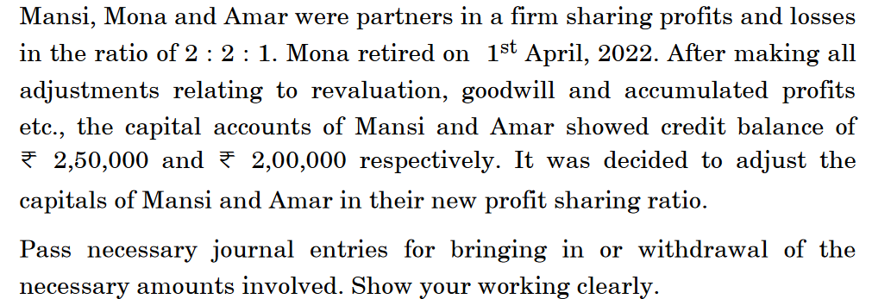
Pass necessary journal entries for the above transactions in the books of
7.

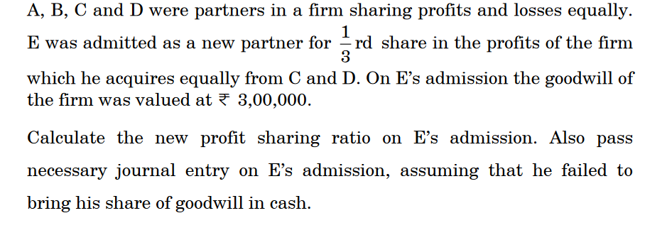

8.

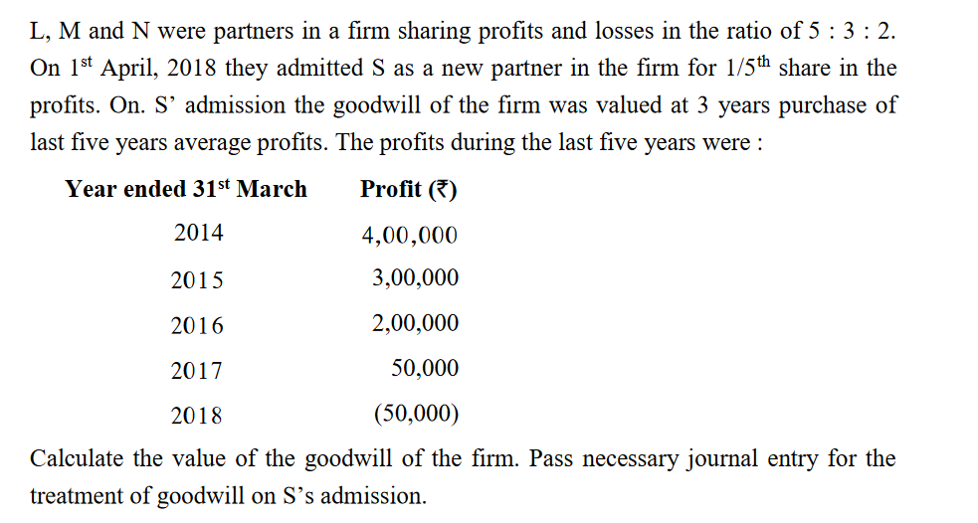

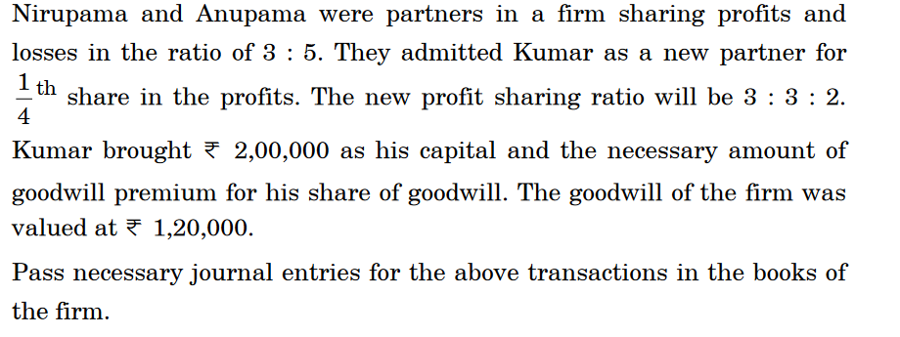
10.

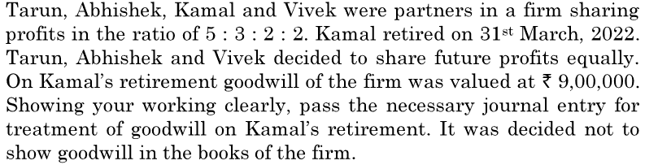
11.
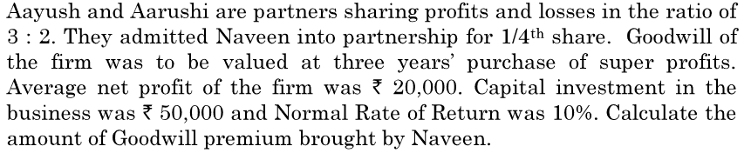
12.

13.
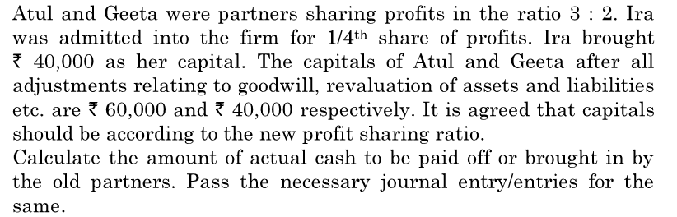

14.
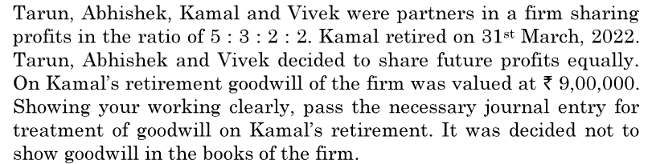

15.
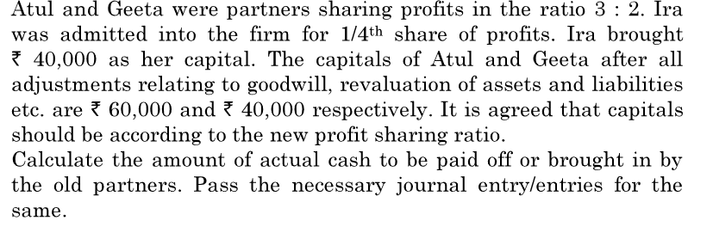

4 marks
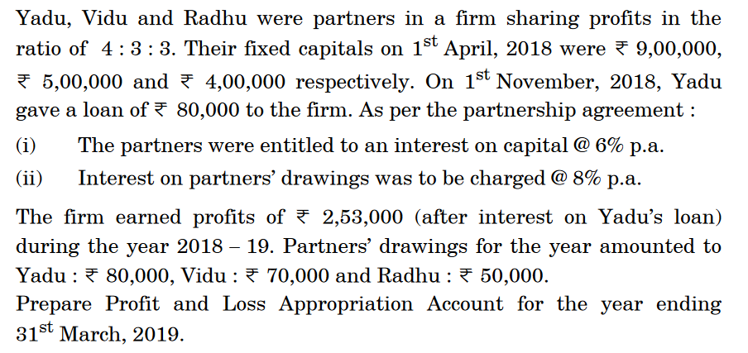

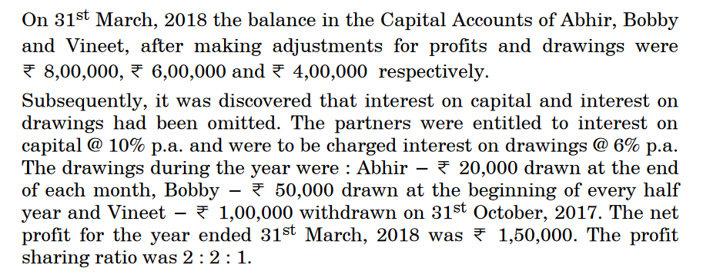
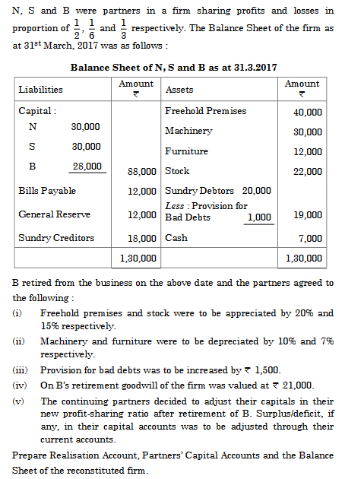
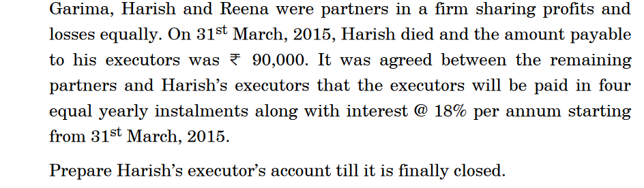

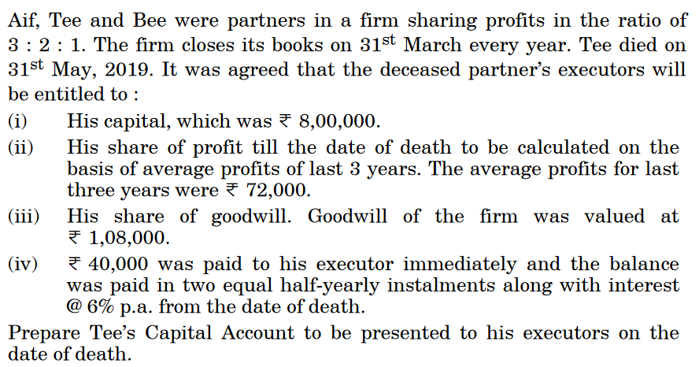

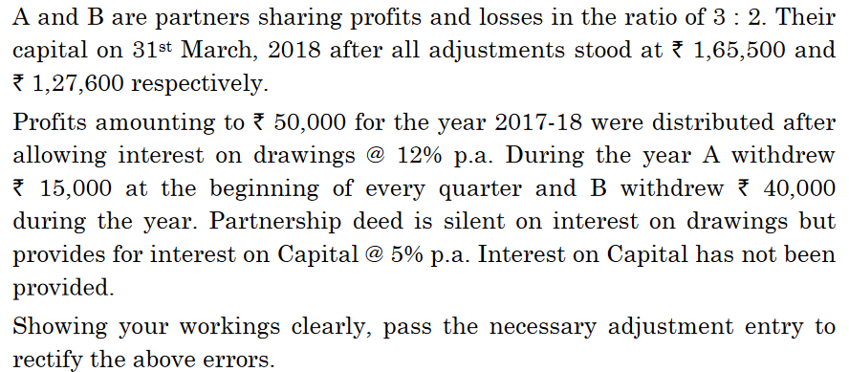

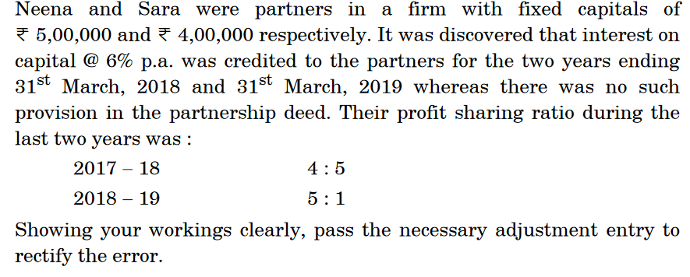

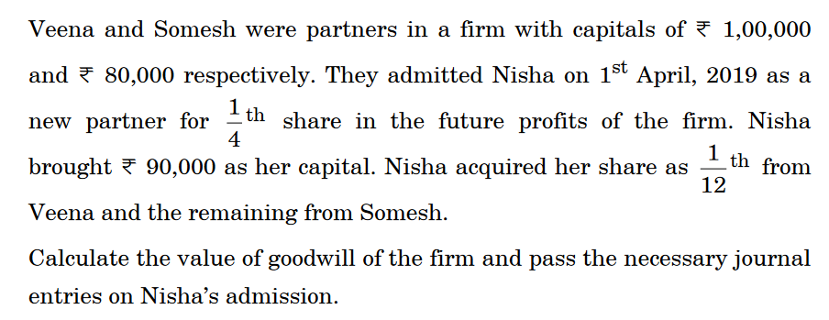

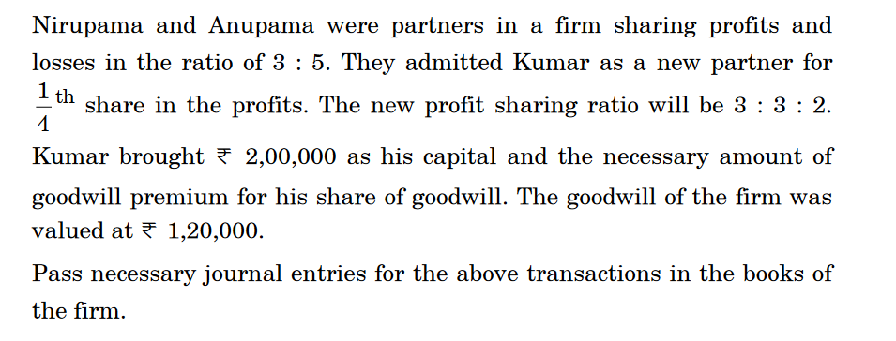

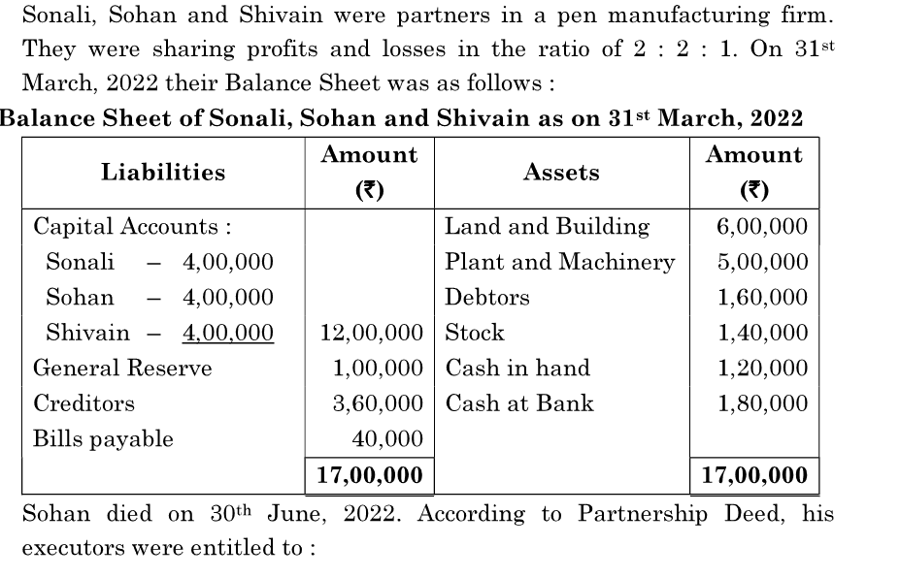

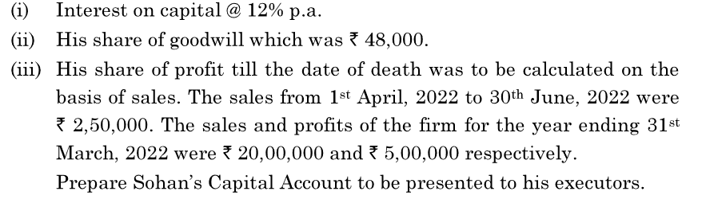

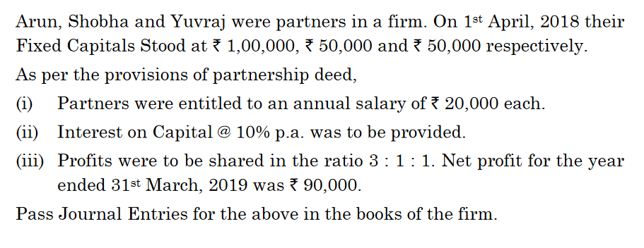
11

12.
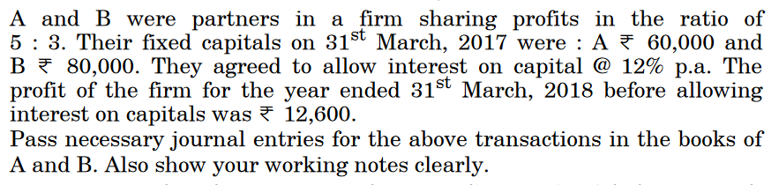

13.
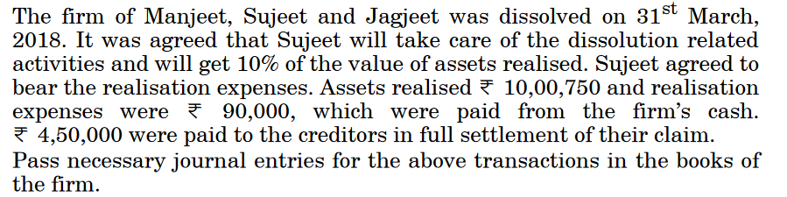

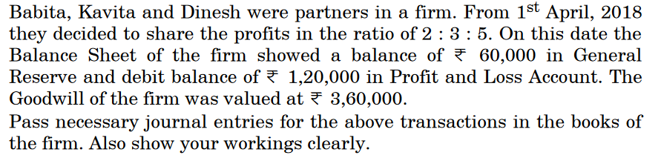
14.

15.
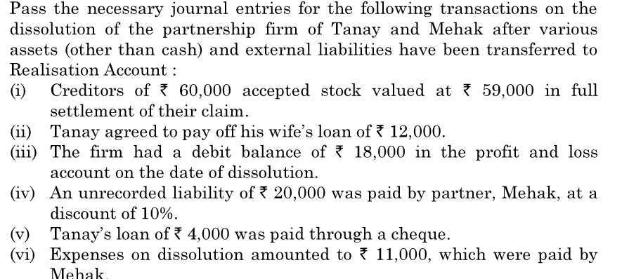

******************************************************************
MATHEMATICS

1. If 𝐴 = {5,6,7} and let R = {5,5), (6,6)), (7,7), (5,6), (6,5), (6,7), (7,6)}. Then R is
A) Reflexive, symmetric but not Transitive B) Symmetric, transitive but not reflexive
C) Reflexive, Transitive but not symmetric D) an equivalence relation
2. The maximum number of equivalence relations on the set A= {1, 2, 3} is
A) 1 B) 2
C) 3 D)5
3 . The number of elements in set A is 3. The number of possible relations that can be defined on
A is
A)8 B)4 C)64 D)512
4. The number of elements in set P is 4. The number of possible symmetric relations that canbe
defined on P is
A) 16 B) 32 C)512 D)1024
5. Let P = {a, b, c}. Then the number of Equivalence relations containing (a, b) is
A) 1 B) 2 C) 3 D) 4
6. If f(x) = ax + b, where a and b are integers, f (–1) = – 5 and f (3) = 3, then a and b are equal to
A) a = – 3, b = –1 B) a = 2, b = – 3 C) a = 0, b = 2 D) a = 2, b = 3
7. If f(x) = x2 + 2, x ∈ R, then the range of f(x) is
A) [2, ∞) B) (-∞, 2] ) C) (2, ∞) D) (-∞, 2) U (2, ∞)

(D)

8)EvaluateCos[^{𝜋}-Sin⁻¹(¹)]
2 2

A)1 (B)^{√3}
2
- ¹
2
- 0

9The valueoftan⁻¹1+Cos⁻¹(⁻¹)
2
(A)11π
12

(B)^{𝜋}
12

(C)^{3𝜋}
4

(D)^{5𝜋}
6

10)Thevalueofcosec⁻¹(-1)+ Cot⁻¹(⁻¹) /√3
11). A = [aij]mxn is a square matrix, if

a. m < n b. m > n c. m = n d. none of these
12)The number of all possible matrices of order 3x3 with each entery 0 or 1 is:
a. 27 b. 18 c. 81 d. 512
13). If for a square matrix A , A2 – A + I = O, then A-1 equals
a. A b. A + I c. I – A d. A – I
14). If A is a square matrix and A2 = A, then (I + A)2 – 3A is equal to:
a. I b. A c. 2A d. 3I
15). If A is a square matrix such that A2 = A, then find (2 + A)3 – 19 A.
a. 8I b. 2I c. I d. A
16). The numbers of all possible matrices of order 2x2 with each entry 1,2 or 3 is
a. 12 b. 64 c. 81 d. 7
17). The numbers of all possible matrices of order 2x3 with each enter 1 or 2 is
a. 12 b. 64 c. 36 d. 8
18). If A and B are square matrices of same order , then AB' - BA' is a
a. skew – symmetric matrix b. symmetric matrix
c. null matrix d. unit matrix
19). If the matrix A is both symmetric and skew symmetric matrix, then
a. A is a diagonal matrix b. A is a zero matrix
c. A is a square matrix d. none of these.
20) If A is a Singular Matrix then A(adjA) is
(a) Scalar matrix (b) Null matrix (c) Identity matrix (d) None of these
21) . The sum of the products of elements of any row with the co-factors of corresponding elements is equal
(a) Adjoint of the matrix (b) 0 (c)1 (d) Value of the determinant
22). If P is a square matrix of order 3,such that P( adjoint P) =10 I , then the determinant of adjoint P is equal to
(a) 0 (b) 1 (c) 10 (d) None of these
23). If A is an invertible square matrix, then
(a) (adjoint A)′ = (adjoint A′) (b) adjoint A = O(c) (adjoint A)′ = adjoint A (d) None of these
24). The area of a triangle with vertices (-3,2), (5,4), (k,-6) is 42 sq units . What is the value of k?
(a) 6 (b) 5 (c) 7 (d) None of these
25)If A is a square matrix such that square of A =I then inverse of A is
a) A (b) 2A (c) A/2 (d) None of these
25). A system of equations is said to be inconsistent if the solution
(a) exists (b) is unique (c) does not exist (d) None of these
26). If A is a non- singular matrix of order 3 and determinant value of A is 3 then determinant value of (2A) is
(a) 24 (b) 12 (c) 40 (d) None of these
27). If A is a square matrix of order 3 and det A=7 what is the value of det (adjoint A) ?
(a) 39 (b) 49 (c) 30 (d) None of these
28). A square matrix is invertible if and only if
(a) A is not a non- singular matrix (b) A is a singular matrix c) A is a non-singular matrix (d) None of these
29). The function(𝑥) = 𝑥(𝑥 − 3)2 decreases for the values of given by 𝑥
(a) 1 <𝑥< 3 (b) 𝑥< 0 (c) 𝑥> 0 (d) 0 <𝑥< 3
30). The function (𝑥) = 𝑡𝑎𝑛𝑥 − 𝑥 is
(a) Always increases (b) always decreases
(c) never increases (d) sometimes increasing & sometimes decreasing
31). The function (𝑥) = 𝑥𝑥 decreases in the interval
(a) (0, 𝑒) (b) (0, 1) (c) (0,1) (d)e
32)efunction𝑓(𝑥)=𝑥(𝑥−3)²decreasesforthe valuesofgivenby𝑥
(a) 1<𝑥<3 (b)𝑥<0 (c)𝑥>0 (d) 0<𝑥<3
2

33).Thefunction(𝑥)=𝑡𝑎𝑛𝑥− 𝑥is
  - Alwaysincreases (b)alwaysdecreases
- neverincreases (d)sometimesincreasing&sometimesdecreasing

34)Thefunction𝑓(𝑥)=𝑥^{𝑥}decreasesintheinterval
(a)(0,𝑒) (b)(0,1) (c)(0,1) (d)
𝑒
35). A man of height 6 ft walks at a uniform speed of 9 ft/sec from a lamp post fixed at 15 ft height. The length of his shadow is increasing at a rate of-
(a) 15 ft/sec (b) 9 ft/sec (c) 6 ft/sec (d) none of these

36). If the function (𝑥) = 𝑥 + 𝑐𝑜𝑠𝑥 + 𝑏 is strictly decreasing over R, Then
(a) 𝑏< 1 (b) no value of b exists (c) 𝑏 ≤ 1 (d) 𝑏 ≥ 1

37). The interval in which (𝑥) = 𝑥3 + 6𝑥2 + 6 is increasing, is a) (−∞, −4) 𝖴 (0, ∞) (b) (−∞, −4) (c) (−4, 0) (d) (−∞, 0) 𝖴 (4, ∞)
38). The function (𝑥) = 𝑥 − 𝑠𝑖𝑛𝑛𝑥 decreases for
(a) All 𝑥 (b) 𝑥 ≤ 𝜋 c) no value of 𝑥
39). The real function (𝑥) = 2𝑥3 − 3𝑥2 − 36𝑥 + 7 is
(a) stricty increasing in (−∞, 2) and strictly decreasing in(−2, ∞)
(b) strictly decreasing in(−2, 3)
(c) stricty decreasing in (−∞, 3) and strictly increasing in(3, ∞)
(d) stricty decreasing in (−∞, −2) 𝖴 (3, ∞)
40). The least value of the function (𝑥) = 𝑥3 − 18𝑥2 + 96𝑥 in the interval [0, 9] is (a) 126 (b) 135 (c) 160 (d) 0
41. The function (𝑥) = 𝑥𝑥 has a stationary point at(a) 𝑥 = 𝑒 (b) 𝑥 = 1

(c) 𝑥 = 1 (d) 𝑥 = √𝑒

42) The least value of function (𝑥) = 𝑒𝑥 + 𝑒−𝑥 is

a)-2 b) 0 c)2 d)cannot be determined.

43)The point on the curve 𝑦2 = 4𝑥 which is nearest to the point (2, 1) is
(a) (1, 2√2) (b) (1, 2) (c) (1, −2) (d) (−2, 1)
44). If the function (𝑥) = 𝑥2 − 𝑘𝑥 + 5 is increasing on [2, 4], then 𝑘 belongs to
(a) (2, ∞) (b) (−∞, 2) (c) (4, ∞) (d) (−∞, 4)

45) If 𝑥 + 𝑦 = 8 then the maximum value of 𝑥𝑦 is
(a) 8 (b) 16 (c) 20 (d) 24

46). If 𝑥 is real, the minimum value of 𝑥2 − 8𝑥 + 17 is
a)-1 (b)0 (c) 1 (d)2
1.

47). ¹
∫
𝑠𝑖𝑛2𝑥𝑐𝑜𝑠2𝑥

dxis equalto

(a)𝑠𝑖𝑛²𝑥−𝑐𝑜𝑠²𝑥+𝑐 (b) −1 (c) tan x+cot x+c (d) tanx−cot x+c.

48)∫cos2𝑥−cos2𝜃dxisequalto
cos𝑥−cos𝜃

  - 2(sin x+ xcos𝜃) +c(b)2(sinx- xcos𝜃) +c (c)2(sin x+ 2xcos𝜃) +c (d)2(sinx-2xcos𝜃)+c

49)∫𝑐𝑜𝑡²xdxequalsto
a) cot x−x +c (b) cot x + x +c (c) −cot x + x +c (d) −cot x −x +c
50). If ∫ 𝑠𝑒𝑐2(7 − 4𝑥)𝑑𝑥 = a tan(7 − 4𝑥) + 𝑐, then value of a is
(a) 7 (b) −4 (c) 3 (d) −1/4 )
51. Which of the following functions from Z into Z are bijections?
(A) f (x) = x 3 B) f (x) = x + 2 (C) f (x) = 2x + 1 (D) f (x) = x 2+ 1
52. Write direction ratio of the vector 𝑎⃗ = 𝑖̂ +𝑗̂ -2𝑘̂
(A) (1,1, −2) (B) (1,1,2) (C) (1, −1,2) (D) (−1,1,2)
53). Write the value of( 𝑖̂ x 𝑗̂) .𝑘̂ + ( 𝑗̂ x 𝑘̂). 𝑖̂ + ( ̂ x 𝑖̂). 𝑗̂
(A) 1 (B) 3 (C) 2 (D) 0
54). Find |𝑥⃗| if for a unit vector 𝑎⃗ , (𝑥⃗ − 𝑎 ⃗ ).(𝑥⃗ + 𝑎 ⃗ ) =15
(A) ±1 (B) ±4 (C) ±2 (D) ±3
55). Find the angle between 𝑎⃗ &𝑏⃗⃗ if |𝑎⃗. 𝑏⃗⃗|=|𝑎⃗𝑥 𝑏⃗⃗|
(A) 00 (B) 300 (C) 600 (D) 900
56). Find Projection of 𝑎⃗ on 𝑏⃗⃗ if 𝑎⃗. 𝑏⃗⃗ =8, 𝑏⃗⃗ =6𝑖̂ +2𝑗̂ +3𝑘̂
(A) 8 3 (B) 8 5 (c) 87 (d) 8
(57)Find the angle between two vectors vector𝑎⃗ on the vector𝑏⃗⃗ with magnitudes √3 and 2 respectively having 𝑎⃗. 𝑏⃗⃗. =√6

(A) 15 (B) 1 3 C) 1 2 (D) 1/√2
58). Let the vector 𝑎⃗ and 𝑏⃗⃗ be such that |𝑎⃗| =3 and |𝑏⃗⃗| =√2/3 and the angle between 𝑎⃗ and𝑏⃗⃗. So that 𝑎⃗ 𝑥𝑏⃗⃗ is a unit vector.
(A) 𝜋 3 (B) 𝜋 6 (c) 𝜋 5 D) 𝜋 /4
59. Find |𝑥⃗| if for a unit vector 𝑎⃗ , (𝑥⃗ − 𝑎 ⃗ ),(𝑥⃗ + 𝑎 ⃗ ) =15
(A) ±1 (B) ±4 (C) ±2 (D) ±3
60. What are the direction cosines of line which makes equal angles with the coordinate axis.
(A) 𝑙 = 𝑚 = 𝑛 = ± 1/√3 (B) 𝑙 = 𝑚 = 𝑛 = ± 1/√7 (C) 𝑙 = 𝑚 = 𝑛 = ± 1/5 (D) 𝑙 = 𝑚 = 𝑛 = ± 1/√24.
61). The line of shortest distance between two skew-lines is to both the line
a) Perpendicular b) parallel c) interest d) none of these.
62). If a line makes angles 90o, 60o and 𝜃 with x, y and z axes respectively, where
𝜃 is acute then the value of 𝜃 is
a)30o b) 60o c) 90o d) 45o
63)Directionratioof linejoining(2,3,4) and (-1,-2,1) are
a)(-3,-5,-3) b)(-3,-5,-3) c)(-1,-5,-3) d)-3,3,2)
64))Thedirectioncosinesof they-axisare
a)(-1,0,0) b) (1,0,0) c)(0,1,0) d) (0,0,1)
65))Theangle betweenthe lines2x=3y=-zand6x=-y=-4z
a)90º b)45º c) 60º d) 0º

66) In solving the LPP: “minimize f = 6x + 10y subject to constraints x ≥ 6, y ≥ 2, 2x + y ≥ 10, x ≥ 0, y ≥ 0” redundant constraints are
a) x ≥ 6, y ≥ 2 b) None of these c) x ≥ 6 d) 2x + y ≥ 10, x ≥ 0, y ≥ 0
67). The optimal value of the objective function is attained at the points:
a) Corner points of the feasible region b) On X-axis c) On Y-axis d) None of these
68)Feasible region in the set of points which satisfy.
a) All of the given constraints b) None of thesec) Some the given constraints d) The objective functions
69). The objective function of a linear programming problem is:
a) None of these b) Function to be optimizedc) A relation between the variables d) A constraint
70). The maximum value of Z = 4x + 2y subject to the constraints 2x + 3y ≤ 18, x + y ≥ 10, x, y ≤ 0 is
a) 40 b) None of these c) 30 d) 36
71). Z = 8x + 10y, subject to 2x + y ≥ 1, 2x + 3y ≥ 15, y ≥ 2, x ≥ 0, y ≥ 0. The minimum value of Z occurs at
a) (1.5, 4) b) (0, 7) c) (4.5, 2) d) (7, 0)
72) If A and B are two events such that, P (A) =0.2, P (B) =0.4 and P (AUB) = 0.6 then, P (A/B) is equal to:
a. 0 b. 0.5 c. 0.3 d. 0.8
73) If P(A∩B) = ½ and P (A’∩ B’) = 1/3, P(A) = P, P(B)=2P(A) then the value of P is
a.1/9 b. 1/3 c. 4/9 d. 7/18
74) If A and B are two independent events such that P (A U B’) = 0.8 and P (A)=0.3 then P(B) is:
a. 2/3 b. 2/7 c. 1/8 d. 3/8
75) 5 Boys and 5 Girls are sitting in a row randomly. The probability that boys and girls sit alternately
: a. 5/126 b. 4/126 c. 3/126 d. 1/126
76) Three persons A, B and C fire a target in turn. Their Probabilities of hitting the target one 0.4; 0.3 and 0.2 respectively. The probability of two hits is:
a. 0.024 b. 0.188 c. 0.336 d. 0.452
77)A and B toss 3 coins Probability that they both obtain the same number of heads is:
a. 1⁄9 b. 3/16 c. 5/16 d.3/8
78)For the random variable 𝑋, E(X)=3 and E ( 𝑋2) =11 then the variance of X is equal to:
a.8 b. 5 c. 2 d. 1
79) X speaks truth in in 60% and Y in 50% of the cases. The probability contradicts each other while narrating the same fact in
X 30 10 -10
P(X) 1/5 3/10 1/2
a. 1/4 b. 1/3 c. 1/2 d. 2/3
80)The probability distribution of a discrete random variable X is given below. Then E(X) is equal to
a.6 b.4 c.3 d. -5
81) A bag contains 5 brown and 4 black socks. A man pulls out two socks. The probability that these one of the same colors is:
a. 5/108 b.18/108 c. 30/108 d. 48/108
82) If A and B are two events such that P (A) ≠ 0 and P (B/A) = 1 then:
a. ACB b. BCA c. B= 𝜙 d. A= 𝜙
83) If P (A/B) >P(A) then which of the following is correct
a. P(B/A) < P(B) b. P(A∩B) < P(A). P(B) c. P(B/A) > P(B) d. P(B/A) = P(B)
84) If A and B are any two events such that P (A) + P(B) – P(A∩B) = P(A) then:
a. P(B/A) =1 b. P(A/B) =1 c. P(B/A) =0 d. P(A/B) =0
85)Thefunction𝑓(𝑥)=[𝑥] ,denotes the greatest integer function,is continuousat(A)4 (B)–2 (C)1 (D)1.5

86)Thefunction𝑓(𝑥)={

valueof𝑘is.
^{𝑠𝑖𝑛𝑥}+𝑐𝑜𝑠𝑥,𝑖𝑓𝑥≠0
𝑥
𝑘 ,𝑖𝑓𝑥=0
iscontinuousat𝑥=
,thenthe
2

(A)3 (B)2 (C)1 (D)1.5
87).Thefunction(𝑥)=|𝑥|+|𝑥−1|is
  - Continuousat𝑥=0as wellasat𝑥=1
  - Continuousat𝑥=1butnot at 𝑥=0
  - Discontinuousat𝑥=0as wellas at𝑥=1
  - Continuousat𝑥=0butnot at 𝑥=1
𝑒3𝑥−𝑒−5,𝑖𝑓𝑥≠0

88)The function𝑓(𝑥)={ 𝑥 iscontinuousat𝑥=0, thenvalueof𝑘is
𝑘 ,𝑖𝑓𝑥=0
(A)3 (B)5 (C)6 (D)8
89)Thefunction𝑓(𝑥)=𝑡𝑎𝑛𝑥isdiscontinuous onthe set

(A){𝑛𝜋∶𝑛𝜖𝑍} (B){2𝑛𝜋∶𝑛𝜖𝑍} (C){(2𝑛+1)𝜋
2
∶𝑛𝜖𝑍}
(D){𝑛𝜋∶𝑛𝜖𝑍

90). Let T be the set of all triangles in the Euclidean plane, and let a relation R on T be defined as aRb if a is congruent to b ∀ a, b ∈ T. Then R is
(A) reflexive but not transitive (B) transitive but not symmetric(C) equivalence (D) none of these
91). If the set A contains 5 elements and the set B contains 6 elements, then the number of one-one and onto mappings from A to B is
(A) 720 (B) 120 (C) 0 (D) none of these
92)For real numbers x and y, define xRy if and only if x – y + √2 is an irrational number. Then the relation R is
(A) reflexive (B) symmetric (C) transitive (D) equivalence
93)If A = {2, 3, 4, 5} and B = {3, 6, 7, 10}. R is a relation defined by R = {(a, b) : a is less than to b, a ∈ A and b ∈ B}, then domain of R is
(a) {2, 3, 5} (b) {3, 5} (c) {2, 3, 4} (d) {2, 3, 4, 5}
94) Which of the following functions from Z into Z are bijections?
(A) f (x) = x 3 (B) f (x) = x + 2 (C) f (x) = 2x + 1 (D) f (x) = x 2 + 1
95)let A = { 1, 2, 3, ….,n}and B= {a, b}. then the number of surjections from A to B is
(a)n (b) 2n-2 (c)2n-1 (d) none of these
96). Let 𝑓∶R → R defined by f(x) = 1+ x2
. Choose the correct answer
(a) both one -one and onto (b)one-one but not onto
(c) onto but not one-one (d) Neither one- one nor onto
97). The maximum number of equivalence relation on the set A ={ 2, 4, 6} is/are
(a) 1 (b) 2 (c) 3 (d) 5
98). Let the relation R in the set A = { xϵ Z: 0 ≤ x ≤ 12}, given by R = { (a,b): |a-b| is multiple of 4 }. Then
the equivalence class of 1is
- {1, 5, 9} (b) { 0, 1, 2, 5} (c)∅ (d) A
99) The maximum number of equivalence relations on the set A = {1, 2, 3} are
(A) 1 (B) 2 (C) 3 (D) 5
100). If the set A contains 3 elements and the set B contains 4 elements, then the number of one-one
mappings from A to B is
(A) 144 (B) 81 (C) 24

SECTION-B(75X2M)
1) Let R be the relation on the set {1, 2, 3, 4} given by R  (1,2),(2,2),(1,1),(1,3),(3,2),(3,3),(4,4)}
Check whether the function is reflexive, symmetric or transitive?
2.Show that the relation R in R is defined by R = { (a, b) : a  b } is reflexive and transitive but not symmetric
3.Determine whether given relation in N is reflexive, symmetric and transitive where R = {( x, y) : y = x + 5 and x < 4}.
4). Show that the relation R defined in the set A of all polygons as R = {(P1, P2): P1 and P2 have samenu
mber of sides}, is an equivalence relation. What is the set of all elements in A related to the right angle
triangle T with sides 3, 4 and 5?
5. Show that the number of equivalence relation in the set {1, 2, 3} containing (1, 2) and (2, 1) is two.

6). If the relation R be defined on the set N is given by a R b if 2a+3b=30, then find R.
7). Show that the relation R in the set {1,2,3} given by R = {(1,1),(2,2),(3,3),(1,2),(2,3)} is reflexive but neither symmetric nor transitive.
8). Let L be the set of all lines in the xy plane defined as R= {(L1, L2): L1|| L2}. Show that R is an equivalence relation.
9). Let T be the set of all triangles in a plane with R a relation in the set T given by R={(T1, T2) : T1≅T2}. Show that R is an equivalence relation.
10). Let set A represents the set of all the girls of a particular class. Relation R on A is defined as R={(a,b) : difference between weights of a and b is less than 30 kg}. Show that relation R is a universal relation.
11). Show that the function f: R → R, defined as f(x) = x2 , is neither one-one nor onto.
12)Draw the Graphs of Signum function, Modulus function and Greatest integer function.
13) Draw the graph of the principal value branch of the function f(x)= Cos-1x
14 . Discuss the differentiability of (𝑥) = 𝑥|𝑥|at 𝑥 = 0 .
15. Differentiate tan−1 ( ) with respect to .
𝑠𝑖𝑛𝑥

16)Findtheintervalinwhichthefunction𝑓givenby 𝑓(𝑥)=2𝑥³− 3𝑥²−36𝑥+7is
  - strictlyincreasing (b)strictlydecreasing.
17) particlemovesalongthe curve6𝑦=𝑥³+2. Findthe pointsonthecurve atwhichtheycoordinateis changing8 times as fastas xcoordinate.
18)Thetotal costC(x) inRupees associatedwith the production ofxunitsof anitem isgiven by
(𝑥)=0.007𝑥³−0.003𝑥²+15𝑥+4000.Findthemarginalcostwhen17unitsareproduced.
19)Findtheleastvalueof‘a’suchthatthefunctionfisgivenby𝑓(𝑥)=𝑥²+𝑎𝑥+1isstrictlyincreasingon(1, 2).
20)Thetotal revenuereceived fromthesaleofxunitsof aproduct isgiven by
(𝑥)=6𝑥²+13𝑥+10.Findthemarginalrevenuewhenx=10.

21)Find thepointon the curve𝑦²=8𝑥forwhich the abscissa and ordinatechange atthesamerate.
22). Find the area bounded by the curve y = 3x, x-axis and between the ordinates x = 1 and x = 3.
23). Find the area bounded by the curve y = x, x-axis and the ordinates x = −1 and x = 2.

24) Find the area bounded by the curve 𝑥𝑦 = 4, x-axis and the line x = 1 and x = 4.
25). Find the area bounded by the curve 𝑦 = cos 𝑥 between 0 𝑎𝑛𝑑 2 .
26) . Find the area of the parabola bounded by 𝑥2 = 4𝑦, 𝑦 = 2, 𝑦 = 4 𝑎𝑛𝑑𝑦 − 𝑎𝑥𝑖𝑠 in the first quadrant 27)Write the position vector of the mid-point of the vector joining the points P(2 ,3 ,4) and Q(4 ,1 ,-2)
28). If ̂ +𝑗̂ +𝑘̂ , 2𝑖̂ +5𝑗̂ , 3𝑖̂ +2𝑗̂ -3𝑘̂ and 𝑖̂ -6𝑗̂ -𝑘̂ are the position vectors of the points A ,B ,C and D
,29) Find the angle between ⃗𝐴⃗⃗⃗𝐵⃗⃗ and ⃗𝐶⃗⃗⃗𝐷⃗⃗ . Deduce that ⃗𝐴⃗⃗⃗𝐵⃗⃗ and ⃗𝐶⃗⃗⃗𝐷⃗⃗ are collinear.
30. Find the position vectors of the point R which divides the line joining two points P and Q whose position vectors are (2𝑎⃗⃗⃗⃗⃗+⃗⃗⃗𝑏⃗⃗ ) and ( 𝑎⃗ -⃗3⃗⃗⃗𝑏⃗) respectively in the ratio 1:2 .
31)Find direction ratios equation of line $\frac{x-3 }{5}=\frac{y-2}{12}=\frac{2z-1}{16}$

32 Find the value of K if lines $\frac{x-5 }{7}=\frac{y+2}{k}=\frac{z}{1}$and $\frac{x}{1}=\frac{y}{2}=\frac{z}{3}$ are perpendicular.
33 Find the intercepts cut off by the plane 2x+y-z=5.
34 Write equation of line $\frac{x-1}{2}=\frac{y+1}{3}=\frac{y+1}{4}$in vector form.
35 Write direction cosines of line.
$$\frac{x-1}{2}=\frac{y+1}{3}=\frac{y+1}{4}$$
35). Draw the graph of the following LPP: 5𝑥 + 2𝑦 ≤ 10, 𝑥 ≥ 0 ,𝑦 ≥ 0
36)Maximize𝑍 = 3𝑥 + 4𝑦 subjected to the constraints:
𝑥 + 𝑦 ≤ 4, 𝑥 ≥ 0, 𝑦 ≥ 0.
37). Determine the maximum value of 𝑍 = 11𝑥 + 7𝑦 subjected to the constraints:
2𝑥 + 𝑦 ≤ 6, 𝑥 ≤ 2, 𝑥 ≥ 0, 𝑦 ≥ 0.
38)Feasible region for the LPP is shown Maximize 𝑍 = 5𝑥 + 7𝑦.
39)If P(A) =0.4, P(B)=0.8 and P(B/A) = 0.6 then find P(A 𝖴 B).

40)Mother, father and son line up at a random for a family photo then find the probability of father should be in the middle when his son on one end.
41)Probability of solving specific problem independently by A and B are $\frac{1 }{2}$and $\frac{1}{3}$ respectively if both
are trying to solve the problem independently then find the probability of that
(i) The problem is solved (ii) Exactly one of them solves the problem
42) Find the value of cot(cos-1 x)
43) Find the value of cos-1 (cos 10)
44) If cos-1 (-5/12) = tan-1 x, then find the value of x
45 Find the domain of tan-1 (3x + 4)
46) Find the principal value of 2cos-1 (1) + sin-1 (1/√2)
47The solution set of sin-1 x ≤ cos-1 x
48) Find the value of cos(π/3 + cos-1 (-1))
49) Find the value of sin-1(sin5π/3)
50) Find the value of cos(tan-1 {cot(sin-1 1/2)})
51Write the value of sin (π/3 - sin-1(-1/2))

52. A stone is dropped into a quiet lake and waves move in circles at the speed of 5cm/sec. At the instant when the radius of circular wave is 8 cm,how fast is the enclosed area increasing ?
53) A balloon ,which always remains spherical on inflation is being inflated by pumping in 900 cubic centimeters of gas per second.Find the rate at which the radius of the balloon increases when the radius is 15 cm.
54) A ladder 5 m long is leaning against a wall. The bottom of the ladder is pulled along the ground away from the wall at the rate of 2cm/sec.How fast is its height on the wall decreasing when the foot of the ladder is 4m away from the wall ?
55) Sand is pouring from a pipe at the rate of 12cm3/s. The falling sand forms a cone on the ground in such a way that the height of the cone is always one-sixth of the radius of the base.How fast is the height of the sand of the cone increasing when the height is 4 cm ?

56) Twenty meters of wire is available for fencing of a flower bed in the form of a circular sector. Find the maximum area of the flower bed.
57) The sides of an equilateral triangle is increasing at the rate of 2cm/sec.Find the rate at which the area increases when the side is 10cm.
58) Find the rate of change of volume of a sphere with respect to it‟s surface area when the radius of the sphere is 12 cm.
59).Let x and y be the radius two circles such that y=x2+1.Find the rate of change of circumference of the second circle with respect to the circumference of first circle .
60)Write two different vectors having same magnitude.
61. Write two different vectors having same direction.
62. Write down a unit vector in XY-plane, making an angle of 30° with the positive direction of x-axis.
63. Find the scalar and vector components of the vector with initial point (2, 1, 3) and terminal point (– 5, 7, 7).
64. Find the unit vector in the direction of the vector a = i + 2 j + 2 k

.65Find the direction cosines of the line passing through the two points (1,– 2, 4) and (– 1, 1, – 2).
66. Find the direction cosines of x, y and z-axis.
67. If a line makes angles 90o, 135 o, 45 owith the x, y and z axes respectively, find its direction cosines.
68. Find the length of the perpendicular drawn from the point (4, –7, 3) on the y-axis.
69. Find the coordinates of the foot of the perpendicular drawn from the point (2, –3, 4) on the y-axis.
70. Find the coordinates of the foot of the perpendicular drawn from the point (–2, 8, 7) on the XZ-plane.
70 Find the image of the point (2, –1, 4) in the YZ-plane.
71 Find the vector and Cartesian equations for the line passing through the points (1, 2, –1) and (2, 1, 1).
72. In shop A, 30 tin pure ghee and 40 tin adulterated ghee are kept for sale while in shop B, 50 tin pure ghee and 60 tin adulterated ghee are there. One tin of ghee is purchased from one of the shops randomly and it is foundto be adulterated. Find the probability (i) Getting adulterated ghee (ii) it is getting from shop B. 73.Often it is taken that a truthful person commands, more respect in the society. A man is known to speak the truth 4 of 5 times. He throws a die and reports that it is actually a six. Find the probability that it is actually a six. Do you also agree that the value of truthfulness leads to more respect in the society ?
74. In a game of Archery, each ring of the Archery target is valued. The centre most ring is worth 10 point and rest of the rings are allotted points 9 to 1 in sequential order moving outwards. Archer A is likely to earn 10 points with a probability of 0.8 and Archer B is likely to earn 10 points with a probability of 0.9. Based on the above information answer the following questions. If both of them hit the Archery target , then find the probability that
(i) exactly one of them earns 10 points (ii) both of them earn 10 points.
75. If P(A) = 4/7, P(B) = 0, then find P (A/B).

SECTION-C(50X3M)
1.A stone is dropped into a quiet lake and waves move in circles at the speed of 5cm/sec. At the instant when the radius of circular wave is 8 cm, how fast is the enclosed area increasing ?
2A balloon ,which always remains spherical on inflation is being inflated by pumping in 900 cubic centimeters of gas per second.Find the rate at which the radius of the balloon increases when the radius is 15 cm.
3.A ladder 5 m long is leaning against a wall. The bottom of the ladder is pulled along the ground away from the wall at the rate of 2cm/sec. How fast is its height on the wall decreasing when the foot of the ladder is 4m away from the wall ?
4.Sand is pouring from a pipe at the rate of 12cm3/s. The falling sand forms a cone on the ground in such a way that the height of the cone is always one-sixth of the radius of the base.How fast is the height of the sand of the one increasing when the height is 4m?
5.Find the intervals in which the following functions are strictly increasing or decreasing
(b) -2x3-9x2-12x+1 (b)(x + 1)3(x − 3)3
6Twenty meters of wire is available for fencing of a flower bed in the form of a circular sector. Find the maximum area of the flower bed.
7The sides of an equilateral triangle is increasing at the rate of 2cm/sec. Find the rate at which the area increases when the side is 10cm.
8Find the rate of change of volume of a sphere with respect to its surface area when the radius of the sphere is 12 cm.
9.Let x and y be the radius two circles such that y= x2 +1.Find the rate of change of circumference of the second circle with respect to the circumference of first circle.
10. Find ∫ 3+3 cos x dx
11. Find√5−4x−x2

12. Find $\frac{x3 -1 dx}{x^{2}}$

13) Find ∫ $\frac{sin 2x-cos 2 }{sinxcosx}$ dx
14) Find $\frac{dx}{x^{2}+16}$
15. The volume of a cube is increasing at rate of 8cm3/sec. How fast is the surface area increasing when length of its edge is 12 cm?
16. Radius of the variable circle is changing at the rate of 5cm/sec. What is the radius of the circle at a time when its area is changing at the rate of 100 cm2/sec?
17. A balloon which always remains spherical has a variable diameter 3 (2𝑥 + 3).Find the rate ofchange of its volume w.r.t. 𝑥.
18. Find the intervals in which the function f given by (𝑥) = 𝑠𝑖𝑛𝑥 + 𝑐𝑜𝑠𝑥, 0 ≤ 𝑥 ≤ 2π.is strictly increasing or strictly decreasing.Coordinatechangesasfastasx coordinate?
19Findtheintervalinwhichthefunction(𝑥)=2𝑥³−3𝑥maybestrictlyincreasing.
20)Findabsolutemaximaandminimafor thefunction𝑓(𝑥)=𝑥³intheinterval[-2,2].
21)Findthemaximumvalue,if any,withoutusingderivatives ofthefollowingfunction
(a)(𝑥)=5+𝑠𝑖𝑛2𝑥 (b)𝑓(𝑥) =−|𝑥−1|+5 for all 𝑥 R
(c)(𝑥)=𝑠𝑖𝑛3𝑥+4 forall𝑥 (^{𝜋},−𝜋/2) (d)𝑓(𝑥)=sin(𝑠𝑖𝑛𝑥) forall𝑥R
2
(e)(𝑥)=−(𝑥−1)²+10 forall ,𝑥R
22)Anedgeofavariablecubeisincreasingattherateof10cm/sec.Howfastthevolumeofthecubeisincreasingwhen theedge is 5 cm long?
23Showthatthefunctionfdefinedby(𝑥)=(𝑥−1)𝑒^{𝑥}+1isanincreasingfunctionforall𝑥˃0
24)Is g = {(1, 1), (2, 3), (3, 5), (4, 7)} a function? If g is described by g (x) = αx + β, then what
value should be assigned to α and β.
25 Find the area enclosed between curves y = x 2 + 2, y = x, x = 0, x = 3
Ans. 21 /2 sq. units
26. Find the area of the region bounded by the curve y=sinx between the lines x=0 , x=π/2 and the x-axis.
Ans 4 sq units
27. Find the area enclosed between curves y = 4x – x2 , 0 ≤ x ≤ 4, x-axis
Ans. 32 /3 sq. units
28Find the area enclosed between curves y = x 2 + 2, y = x, x = 0, x = 3
Ans. 21 /2 sq. units
29. Find the area x, y : x2  y2  1  x  y { (x , y) : x2 + y2< 1< x+y}
Ans. π/4 - 1/ 2 sq. units.
30. Find the area enclosed between y 2 = 4ax and its latus rectum.
Ans. 8 a2/3 sq. units.
31. Find the area enclosed between curves y = x 3, x = - 2, x = 1, y = 0
Ans. 15 /4 sq. units
32. Find the area bounded by the curve y = cos x between x = 0 and x = 2π
Ans. 4 sq. units
33 Two coins are tossed. What is the probability of coming up two heads if it is known that at least one head comes up.
34 Four cards are drawn from 52 cards with replacement. Find the probability of getting at least 3 aces.3. A pair of dice is thrown 7 times. If getting a total of 7 is considered a success, what is the probability of getting
(i) Exactly 6 successes
(ii) At most 6 successes. 4
35 An insurance company insured 3,000 scooters, 4,000 cars and 5,000 trucks. The probabilities of the accident involving a scooter, a car and a truck are 0.02, 0.03 and 0.04 respectively. One of the insured vehicles meet with an accident. Find the probability that it is a scooter.
36 By examining the chest X-ray, the probability that T.B. is detected when a person is actually suffering from it is 0.99. The probability that the doctor diagnosis correctly that a person has T.B. on the basis of X- ray is 0.001. In a certain city, 1 in 1,000 persons suffers from T.B. A person selected at random is diagnosed to have T.B. What is the chance that the person has actually T.B.?
37.A bag contains 5 red marbles and 3 black marbles. Three marbles are drawn one by one without replacement.What is the probability that at least one of the three Marbles drawn be black if the first marble is red ?
.
38 Find the equation of the line joining (1,2) and (3,6) using determinants.
39. Verify A(adj. A) =(adj. A)A = (det A). I for A= [ 2 3 ]
−4 −6
40. Solve using matrix method 2x-y = 1, 3x+2y=5

41. Solve system of equations

x-y+2z=7, 2x-y+3z =12, 3x+2y-z =5 using matrix method

42 Show that the points (a, 0) , (0, b ) and (1,1) are collinear if a + b = ab

43. In a factory the social worker decided to distribute gifts to workers of a particular CABIN. If there were 8 workers less, everyone would have got Rs 10 more. Also, it was observed that if there were 16 students more, everyone would have got Rs 10 less.
(i) (a) If the number of workers in the CABIN be x and the social worker has decided to give Rs y to each worker, then find the system of linear equations for this situation. (1 mark)
(b) If AX=B, where A, X, B are matrices then what will be the value of X.
(ii) Find the number of workers and amount distributed by the social worker. (2 marks

44 A wire of length 28 m is to be cut into two pieces. One of the pieces is to be made into a circle and the other into a square. What should be the lengths of the two pieces so that the combined area of the square and the circle is minimum.
45. Show that the surface area of a closed cuboid with a square base and given volume is maximum when it is a cube.
46. Show that the maximum volume of the cylinder which can be inscribed in a sphere of the radius5√3 cm is 500𝜋𝑐𝑚3
47 The median of an equilateral triangle is increasing at the rate of 2√3 𝑐𝑚3⁄𝑠𝑒𝑐. Find the rate at which is side is increasing.
48 Sum of two numbers is 5. If the sum of the cubes of these numbers is least, find the sum of the squares of these numbers.
49 A window is in the form of a rectangle surmounted by a semi circle .If the total perimeter of the window is 30 m, find the dimensions of the window so that maximum light is admitted
50 Show that the height of the cylinder of maximum volume that can be inscribed in a sphere ofradius R is 2𝑅. Also find the maximum volume.

SECTION-D(25X4m)

1. Find the area of the region bounded by the curve x2 + y2 = 1.

2. Using the method of integration find the area bounded by the curve
Ans. 4 sq. units
3. Find the area lying above x-axis and included between the circle x2  y2  8x and the parabola y2  4x .
Ans. 4π + 32/3 sq. units
4. Draw the rough sketch and find the area of the region bounded by two parabolas 4y2 = 9x and 3x2 = 16y by using method of integration.
5. Find the area of the region bounded by the line y = 3x + 2, the x-axis and the ordinates x = –1 and x = 1.
Ans. 13 /3 sq. units.
.6 Find the general solution of the differential equation $\frac{dy}{dx}$– y = cosxdx
7. Show that the differential equation ( x – y )$\frac{dy}{dx}$ = x + 2y is homogeneous equation and solve it .
8 Solve : dy/dx== $\frac{{x2+y2}^{}}{2xy\frac{}{}}$
9. Solve the initial value problem : ( x3+ x2 + x + 1 ) dy = 2x2 + x when y (0) = 1
dx
10. Find the particular solution of dy + ycotx = 2x + x2cotx given that y=0 when x = $\frac{π}{2}$

1 1)The probability that a bulb produced by a factory will fuse after 100 days of use is 0.05. Find the probability that out of such five such bulbs
(i) Not more than one
(ii) More than one
Will fuse after 100 days of use
12) In a bolt factory, 3 machines A, B and C manufacture 25, 35 and 40 per cent of the total bolts manufactured.Of these output, 5, 4 and 2 per cent are defective espectively. A bolt is drawn at random and is found to be defective. Find the probability that it was manufactured by either machine A or B
13 An urn contains 4 white and 3 red balls. Let X be the number of red balls in a random draw of 3 balls. Find the mean and variance of X.
14)A doctor is to visit a patient. From the past experience, it is known that the probabilities that he will come by train, bus, scooter or by other means of transport are respectively 3/10, 1/5, 1/10and 2/5. The probabilitiesthat he will be late are 1/4,1/3 and 1/12 , if he comes by rain, bus and scooter respectively, but if he comes by othermeans of transport, then he will not be late. When he arrives, he is late.What is the probability that he comes by train?
15 Suppose that the reliability of a HIV test is specified as follows: of people having HIV, 90% of the test detects the disease but 10% go undetected. Of the people free of HIV, 99% of the tests are judged HIV-ve but 1% are diagnosed as showing HIV +ve. From a large population of which only 0.1% have HIV, one person is selected at random, given the HIV test, and the pathologist reports him/her as HIV+ve. What is the probability that the person actually has HIV ?
16 In an examination, an examinee either guesses or copies or knows the answer of multiple choice questions with four choices. The probability that he makes a guess is 1/3, and probability that he copies the answer is 1/6 . The probability that his answer is correct, given that he copied it, is 1/8 . Find the probability that he knew the answer to the question,answered it correctly
17 If R1 and R2 are two equivalence relations in a set A, show that R1∩R2 is also an equivalence relation.
18 Show that the relation R in the set A of points in a plane given by
R = {(P, Q): distance of the point P from the origin is same as the distance of the point Q from the origin}, is an equivalence relation.
Further, show that the set of all points related to a point P ≠ (0,0) is the circle passing through P with origin as Centre.
19 Show that the relation R on the set A = {x ϵ Z : 0 ≤ x ≤ 12}, given by R = {(a,b):│a-b│is a multiple of 4} is an equivalence relation.
20 . A trust fund has Rs. 30,000 that must be invested in two different types of bonds. the first bond pays 5% interest per year, and the second bond pays 7% interest per year. Using matrix multiplication, determine how to divides Rs. 30,000 among the two types of bonds. If the trust fund must obtain an annual total interest of.
a. Rs. 1800 b. Rs. 2000
21 Express the following matrix as the sum of a symmetric and a skew symmetric Matrix

3 −2 −4
[ 3 −2 −5]
−1 1 2

22 If A = [ 1 0 , find k such that A2 = 8A + KI
−1 7
23. If A = [ 3 4 ], find f(A), where f(x) = x2 -5x + 7
−4 −3

24. Ram purchases 3 pens, 2 bags, and 1 instrument box and pays ₹ 41. From the same shop, Dheeraj purchases 2 pens, 1 bag, and 2 instrument boxes and pays ₹29, while Ankur purchases 2 pens, 2bags, and 2 instrument boxes and pays ₹44.Read the above information and answer the following questions
1)Find the cost of 1 pen
2) Find the cost of1 pen and 1 bag
3)Find the cost of 1 instrument10.
25Find the intervals in which following functions are strictly increasing or strictly decreasing.

(𝑥) = 𝑥4 − 𝑥3 − 5𝑥2 + 24𝑥 + 12

*************************************************************

COMPUTERSCIENCE

1 | Process of inserting an element in stack is called
2 | Process of removing an element from stack is called
3 | Pushing an element into stack already having five elements and stack size of 5, then stack becomes
4 | Integer, real, character, pointer and reference are ……… data structures
5 | Pile of books is an example of ………
6 | What is data structure ?
7 | Define any two operations on data structure.
8 | A stack is a
9 | What is the use of “Top” in a stack
10 | List some of the advantages of data structure
11 | Which of the following is not considered a valid identifier in Python:  (i)three3 (ii)_main (iii)hello_kv1 (iv)2 thousand
12 | Which of the following is the mutable data type in python:  (i)int (ii) string (iii)tuple (iv)list
13 | Which of the following statement converts a tuple into a list in Python:  (i) len(string) (ii)list(tuple) (iii)tup(list) (iv)dict(string)
14 | Which of the following statement converts a tuple into a list in Python:  (i) len(string) (ii)list(tuple) (iii)tup(list) (iv)dict(string)
15 | Name of the process of arranging array elements in a specified order is termed as  i)indexing ii)slicing iii)sorting iv) traversing
16 | What type of value is returned by input() function bydefault?  i)int ii)float iii)string iv)list
17 | Which of the following operators cannot be used with string  (i) + ii) * iii) - iv) All of these
18 | If L = [0.5 * x for x in range(0,4)] , L is  i)[0,1,2,3] ii)[0,1,2,3,4] iii) [0.0,0.5,1.0,1.5] iv) [0.0,0.5,1.0,1.5,2.0]
19 | write the ouput of following code  A = 10/2  B = 10//3  print(A,B)  i)5,3.3 ii) 5.0 , 3.3 iii) 5.0 , 3 iv) 5,4
20 | Name the built-in mathematical function / method that is used to return square root of a number. i)SQRT() ii)sqrt() iii) sqt() iv) sqte()
21 | Which type of object is given below  >>> L = 1,23,"hello",1  a. list b. dictionary c. array d. tuple
22 | Which operator tells whether an element is present in a sequence or not  a. exist b. in c. into d. inside
23 | Suppose a tuple T is declared as T = (10,12,43,39), which of the following is incorrect  a. print(T[1]) b. T[2] = -2 c. print(max(T)) d. print(len(T))
24 | Which index number is used to represent the last character of a string  a. -1 b. 1 c. n d. n – 1
25 | Which function returns the occurrence of a given element in a list?  a. len() b. sum() c. extend() d. count()
26 | which type of slicing is used to print the elements of a tuple in reverse order  a. [:-1] b. [: : -1] c. [1 : :] d. [: : 1]
27 | Dictionaries are also called  a. mapping b. hashes c. associative array d. all of these
28 | Which function returns the value of a given key, if present, from a dictionary?  a. items() b. get() c. clear() d. keys()
29 | What is the default return value for a function that does not return any value explicitly?  (a) None (b) int (c) double (d) null
30 | Which of the following keyword marks the beginning of the function block?  (a) func (b) define (c) def (d) function
31 | Which of the following function header is correct?  (a) def f(a=1,b): (b) def f(a=1,b,c=2):  (c) def f(a=1, b=1, c=2): (d) def f(a=1,b=1,c=2,d);
32 | Which of the following statements is not true for parameter passing to functions?  (a) You can pass positional arguments in any order.  (b) You can pass keyword arguments in any order.  (c) You can call a function with positional and keyword arguments.  (d) Positional arguments must be before keyword arguments in a function call
33 | The .........................refers to the order in which statements are executed during a program  run.  (a) Token (b) Flow of execution (c) Iteration (d) All of the above
34 | The ............................of a variable is the area of the program where it may be referenced  a) external b) global c) scope d) local
35 | Errors resulting out of violation of programming language’s grammar rules are known as:  (a) Compile time error (b) Logical error (c) Runtime error (d) Exception
36 | An unexpected event that occurs during runtime and causes program disruption, is called:  (a) Compile time error (b) Logical error (c) Runtime error (d) Exception
37 | Which of the following keywords are not specific to exception handling ?  (a) try (b) except (c) finally (d) else
38 | Which of the following blocks is a ‘must-execute’ block ?  (a) try (b) except (c) finally (d) else
39 | Which keyword is used to force an exception ?  (a) try (b) except (c) raise (d) finally
40 | To read three characters from a file object f, we use ……… .  (a) f.read(3) (b) f.read() (c) f.readline() (d) f.readlines()
41 | The files that consists of human readable characters  (a) binary file (b) text file (c) Both (a) and (b) (d) None of these
42 | Which function is used to write a list of string in a file?  (a) writeline() (b) writelines() (c) writestatement() (d) writefullline()
43 | What is the output of following code?  f=open(‘story.txt’, ‘r’)  s=f.readline()  lcount=len(s)  print(lcount)  f.close( )  (a) 4 (b) 2 (c) 1 (d) 8
44 | What is the output of following code?  def test() :  f=open (“Para.txt”, “r”)  lines=0  l=f.readlines( )  for i in l:  if i [0] = = ‘E’ :  lines+=1  print(lines)  (a) 2 (b) 1 (c) 3 (d) Error
45 | Binary files commonly have the extension :  a) .TXT b) .DAT c) .DOC d) .PDF
46 | The method is used to read data from a binary file
47 | Which module is required to use the built-in function dump() ?  a) math b) flush c) pickle d) unpickle
48 | The mode used for both writing and reading data from a binary file :  a) wb+ b) w c) wb d) a
49 | The statement automatically closes the file after processing on the file gets over
50 | The method is used to read data from a binary file
51 | The method used to write an object into a binary file is :  a) load() b) dump() c) write() d) None of these
52 | Which of the following module is provided by Python to do several operations on the  CSV files?  (A) os (B) xls (C) csv (D) py
53 | Which of the following is tasks cannot be done or difficult with CSV module?  (A) Storing data in tabular form (B) Finding data uniquely  (C) Saving data permanently (D) All of these
54 | The writer() function of csv module has how many mandatory parameters?  (A) 4 (B) 3 (C) 2 (D) 1
55 | Which of these is not relevant to csv file?  (A) Text file (B) Binary file  (C) Easily openable in text editor (D) None of the above
56 | You are having myfile.csv file on c drive. You want to access it in python, how can you  do this?  (A) source=”c:\\myfile.csv” data = pd.read_csv(source)  (B) source=”c:\\myfile.csv” data = pd.reads_csv(source)  (C) source=”c:\\myfile.csv” data = pd.reader(source)  (D) None of the above
57 | Stack is also known as:  a) First-in First-out b) Last-in-First-out c) Both a and b d) None of these
58 | In a stack, if a user tries to remove an element from empty stack, it is known as:  a) Underflow b) Empty c) Overflow d) None
59 | What type of data structure a stack is?  a) Linear b) Non-Linear c) Both A and B d) None
60 | Which one of the following is an application of Stack Data Structure?  a) Managing Function Call b) Arithmetic Expression Evaluation  c) Undo Redo d) All of the above
61 | Which data structure we can use for reversing a string?  a) Queue b) List c) Stack d) Dictionary
62 | Stack can be implemented in Python using:  a) Tuple b) Dictionary c) Set d) List
63 | What are the two operations of stack?
64 | How do we test for empty stack?
65 | Why do we use append() method of list in push operation?
66 | Define any two characteristics of stacks.
67 | What is the Use of Bridge?  (a) To Connect two LAN (b) To Connect two LAN Segment  (a) To Connect Internet (d) Amplify Signal
68 | With the use of computer network, we can share  (a) Data (b) Resources  (c) Both of the above (d) None of the above
69 | Which of the following is used in computer network  (a) Router (b) Switch (c) Bridge (d) All of the Above
70 | When we connect our mobile with Laptop then we call it  (a) MAN (b) WAN (c) PAN (d) LAN
71 | Mbps stands for  (a) Mega Byte Per Second (b) Million Byte Per Second  (c) Megabits Per Second (d) Maximum Bit Per Second
72 | Full form of NIC  (a) New Interface Card (b) Network Interface Card  (c) New Internet Card (d) Network Internet card
73 | Which device Convert Analog to Digital and vice-versa  (a) Hub (b) Bridge (c) Modem (d) Switch
74 | Arun wantsto create his own website, which language he can use to create new website.  (a) XML (b) HTML (c) Python (d) C++
75 | Amit’s computer is running slow due to virus. Then what he has to do.  (a) Format Computer (b) Install Firewall  (c) Install Antivirus (d) Do Nothing
76 | Hari is copying Mohan’s software without taking permission with Mohan.So which  type of crime is Hari doing  (a) Cyber Bulling (b) Cyber Stalking  (c) Cyber Theft (d) Copyright Infringement
77 | which among the following is not an example of browser.  a. Chrome b. Firefox  c. Avast d. edge
78 | _________ is a networking device that forwards the data packets between computer  network  a. Repeater b. Hub  c. Switch d. Router
79 | Which transmission media provides highest transmission speed in a network?  a. Twisted Pair Cable b. Coaxial cable  c. Optical Fiber d. All of these
80 | NSFNET stands for ___________  a. National Science Foundation Network  b. National Science fundamental network  c. neuro Science Foundation Network  d. National Search Foundation Network
81 | Physical or logical arrangement of network refers to as ________  a. Routing b. Looping  c. Topology d. Networking
82 | Bluetooth is an example of ________  a. Personal Area Network b. Local Area Network  c. Virtual Private Network d. wide area network
83 | Which networking device is used to transfer communication signal to long directions?  a. Amplifier b. Repeater  c. Router d. all of the above
84 | Which is called as smart hub?  a. Hub with high-speed ports b. Switch  c. Router d. All of the above
85 | Which topology in general uses less wire length compare to other?  a. Star topology b. Ring topology  c. Bus topology d. All use same length of wire
86 | A collection of hyperlinked documents on the internet forms the  a. World Wide Web (WWW) b. Email system  c. Mailing list d. Hypertext Markup Language
87 | HTML is used to create:  a. Machine Language program b. High level program  c. web page d. web server
88 | Which term identifies a specific computer on the web and the main page of the entire site?  a. WWW b. link  c. SQL d.URL
89 | To establish connection between Python and MySql Which connector is required.  (a) mysql.connection (b) connector (c) mysql.connect (d) mysql.connector
90 | If you want to check whether connection between Python and MySql is established or not. Which  function is used?  (a) con.isconnected() (b) con.connected() (c) con.is_connect (d) con.is_connected
91 | Fill the connection string with the required parameter name: -  con=mysql.connector.connect(<1>= localhost , user= “scott” <2>= ‘tiger’ , database=’mydb’  (a) <1>= host , <2> =passwd (b) <1>= host , <2> =password  (b) <1>= 127.0.0.1 , <2> =password (d) <1>= 127.0.0.1, <2> =pass
92 | Which of the following component act as a container to hold all the data returned from the query and  from there we can fetch data at a time?  (a) Resultset (b) Container (c) Table (d) Cursor
93 | Differentiate between fetchone() and fetchall() ?
94 | Which properties of cursor is used to get number of records stored in cursor(Assuming cursor name  is dbcursor?  (a) dbcursor.count (b) dbcursor.row.count  (b) dbcursor.records (d) dbcursor.rowcount
95 | Out of which ofthe following symbol is used for passing parameterized query fro execution to cursor?  a) { } b) % c) $ d) Both (a) and (b)
96 | Which cursor function is used to fetch n number of records from cursor?  a) fetchone() b) fetch( ) c) fetchmany() d) fetchall()
97 | Which cursor function is used to fetch one record at a time from cursor?  a) fetchone() b) Onefetch() c) fetch() d) fetchonce()
98 | Which cursor function is used to send query to connection?  (a) query() (b) execute() (c) run() (d) send()
99 | What is Degree and Cardinality of table?
100 | What is Database? What are the advantages of Database System?
1 | Find the following python expressions:  a) (3-10**2+99/11) b) not 12 > 6 and 7 < 17 or not 12 < 4  c) 2 ** 3 ** 2 d) 7 // 5 + 8 * 2 / 4 – 3
2 | i) Convert the following for loop into while loop  for i in range(10,20,5):  print(i)  ii) Evaluate:- not false and true or false and true
3 | What are advantages of using local and global variables ?
4 | Remove the errors from the following code Rewrite the code by underlining the errors .  x = int((“enter the value”)  for i in range [0,11]:  if x = y  print x+y  else:  print x-y
5 | Rewrite the following code in python after removing all syntax errors. Underline each correction done in the code:  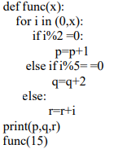
6 | . Write the output of the following code:-  String1="Coronavirus Disease"  print(String1.lstrip("Covid"))  print(String1.rstrip("sea"))
7 | L = [“abc”,[6,7,8],3,”mouse”]  Perform following operations on the above list L.  i)L[3:] ii) L[: : 2] iii)L[1:2] iv) L[1][1]
8 | Write the output of the following:  word = 'green vegetables'  print(word.find('g',2))  print(word.find('veg',2))  print(word.find('tab',4,15))
9 | Rewrite the following code in python after removing all syntax error(s). Underline each correction done in the code.  STRING=""WELCOME  NOTE""  for S in range[0,8]:  print (STRING(S))
10 | Find output generated by the following code:  Str=”Computer”  Str=Str[-4:]  print(Str*2)
11 | What will be the output of the following question  L = [10,19,45,77,10,22,2]  i) L.sort() ii) max(L)  print(L)
12 | Find the output  L = [10,19,45,77,10,22,2]  i) L[3:5] ii) L[: : -2]
13 | Distinguish between list and tuple
14 | Read the code given below and show the keys and values separately.  D = {‘one’ : 1, ‘two’ : 2, ‘three’ : 3}
15 | Observe the given list and answer the question that follows.  List1 = [23,45,63, ‘hello’, 20, ‘world’,15,18]  i) list1[-3] ii) list1[3]
16 | What do you mean by a function? How is it useful?
17 | Observe the following Python code very carefully and rewrite it after removing all syntactical errors with each correction underlined.  def execmain():  x = input("Enter a number:")  if (abs(x)= x):  print("You entered a positive number")  else:  x=*-1  print("Number made positive : ",x)  execmain()
18 | What is an argument? Give an example.
19 | What is the output of the program given below?  x = 75  def func (x) :  x = 10  func (x)  print ('x is now', x)
20 | Is return statement optional? Compare and comment on the following two return  statements:  (i) return  (ii) return val
21 | Write a function that takes a positive integer and returns the one’s position digit of the integer
22 | What is the difference between parameter and argument?
23 | What is the significance of having functions in a program?
24 | What is the difference between local variable and global variable? Also give a suitable Python code to illustrate both.
25 | Read the code given below and answer the questions  f1=open('main.txt','w')  f1.write('bye')  f1.close()  If the file contains 'GOOD' before execution, what will be the content of the file after  execution of the code
26 | Observe the following code and answer the follow  f1=open("mydata","a")  #blank1  f1.close()  (i) what type of file is mydata  (ii) Fill in the blank1 with statement to write "abc" in the file "mydata"
27 | What would be the data types of variables data in following statements?  i) Data=f.read( )  ii) Data=f.read(10)  iii) Data=f.readline()  iv)Data=f.readlines()
28 | What is standard input, output and error steams?
29 | Write a short note on flush() function.
30 | What is the use of load( ) and dump( ) methods?
31 | Explain seek( ) method.
32 | Write in short :  i) What is the use of open( ) method ?  ii) What is the use of tell( ) method ?
33 | Answer in brief :  i) Purpose of close( ) function.  ii) Purpose of flush( ) function
34 | Assertion: To specify a different delimiter while writing into a csv file, delimiter argumentis used with  csv.writer().  Reason: The CSV file can only take a comma as a delimiter.  (A) Both Assertion and reason are true and reason is the correct explanation of assertion.  (B) Assertion and reason both are true but reason is not the correct explanation of assertion.  (C) Assertion is true, reason is false.  (D) Assertion is false, reason is true.
35 | Find the error in the following code and write the correct code and underline the corrected ones: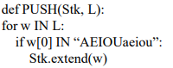
36 | Write a function in Python PUSHD3(L), where L is a list of numbers. from this list push all numbers divisible by 3 into a stack implemented using a list. Display the stack if it has at least one element, otherwise display appropriate error message
37 | Sakshi has created a dictionary D, containing names and salary as key value pairs of 5 employees. Write two separate functions to perform the following  operations:  ● PUSH(HS, D), where HS is the stack and D is the dictionary which containing  names and salaries. Push the keys (name of the employee) of the dictionary into  a stack, where the corresponding value (salary) is greater than ₹75,000.  ● POP(HS), where HS is the stack. Pop and display the content of the stack.
38 | What is the difference between Packet switching and circuit switching techniques?
39 | Difference between LAN and WAN
40 | Explain Any two Wired Media
41 | Define Any Two Topologies
42 | Write short note on the following: (a) Bandwidth (b) DNS
43 | Difference between CHAR & VARCHAR
44 | List of Aggregate functions
45 | In the table “Student”, Priya wanted to increase the Marks(Column Name: Marks) of those students by 5 who have got Marks below 33. She has entered the following statement:
46 | Table Student has the columns RNO and SCORE. It has 3 rows in it. Following two SQL statements were entered that produced the output (AVG(SCORE) as 45 and COUNT(SCORE) as 2) : (i) AVG(SCORE) (ii) Count(score)
47 | Ms. Rajshri is the Class Teacher of Class XII. She wants to create a table named ‘Student’ to store marks in different subjects of her class. Identify any 4 columns for the table along with their suitable data types
48 | How is HAVING clause similar to WHERE clause? How is HAVING clause different from WHERE clause? Explain with the help of examples of each.
49 | What is Natural Join?
50 | Consider the following Python code written to access the record of CODE passes to  function.Complete the missing statements:  def Search(eno):  #Assume that all the basic setup import, connection and cursor is already created  query=”select * from emp where emp where empno = ”.format(eno)  mycursor .execute(query)  result = mycursor.  print(results)  (a) { } and fetchone() (b) fetchone() and {}  (b) %s and fetchone() (d) %eno and fetchone()
51 | Consider the following Python code written for updating the records:  def Update(eno):  #Assume basic setup import, connection(con) and cursor(mycursor) is created  query = “update emp set salary = 90000 where empno =”+str(eno)  mycursor.execute(query)  Code is running but the record in actual database is not updating, what could be the possible reason?  (a) save() function is missing (b) con.save() function is missing  (b) con.commit() function is missing (d) commit() is missing
52 | Differentiate between fetchone() and fetchmany()
53 | What is the role of a cursor? Write syntax to create a cursor?
54 | To perform query sting based on some parameter. There are two method. Write the given query in (i) String Templates with % formatting and (ii) String Template with { } formatting “select all fields from table student where marks >70”
55 | What is MySQL used for? Abhay wants to start learning MySQL. From where can he obtain the MySQL software ?
56 | Priyanka a beginner in IT field has just started learning web technologies. Help her in understanding the difference between website and web pages with the help of a suitable general example of each.
57 | Sahil a class X student has just started understanding the basics of internet and web technologies. He is a bit confused in between the terms World Wide Web and Internet. Help him in understanding both the terms with the help of suitable examples of each
58 | Murugan wants to send a report on his trip to the North East to his mentor. The report contains images and videos. How can he accomplish his task through internet?
59 | Explain VoIP
60 | What is the difference between Hub, Switch and Router?
61 | What are DDL and DML? Give one command of each.
62 | What is domain name, explain with example?
63 | Differentiate between Bus and Star Topology?
64 | Which clause is used to search for NULL values in any column?
65 | Explain count () and count (*)?
66 | 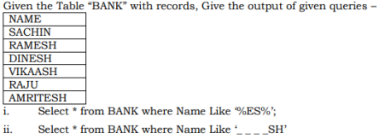
67 | Write the syntax of elif
68 | Write the syntax of for and while
69 | Write the different modes of text file opening
70 | Write the different modes of binary file to open
71 | Write the different between text file and binary file
72 | Write a program to read the data from mysql
73 | Write a program to read the data from csv file
74 | Write a program to store the data in csv file
75 | Write a program to store data in sql
1 | Write the python program to print the index of the character in a string.  Example of string : “pythonProgram”  Expected output:  Current character p position at 0  Current character y position at 1  Current character t position at 2
2 | Find and write the output of the following python code:  string1 = "Augmented Reality"  (i) print(string1[0:3]) (ii) print(string1[3:6]) (iii) print(string1[:7])  (iv) print(string1[-10:-3]) (v) print(string1[-7: :3]*3) (vi) print(string1[1:12
3 | Find the output of the give program :  x = "abcdef"  j = "a"  for i in x:  print(j, end = " ")
4 | Find output generated by the following code:  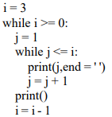
5 | Find output generated by the following code  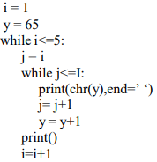
6 | Which of the string built in methods are used in following conditions?  ii)Returns the length of a string  iii)Removes all leading whitespaces in string  iv) Returns the minimum alphabetic character from a string
7 | Write a program to remove all the characters of odd index value in a string
8 | Write a python program to count the frequencies of each elements of a list using dictionary
9 | what will be the output of the following python code  L = [10,20]  L1 = [30,40]  L2 = [50,60]  L.append(L1)  print(L)  L.extend(L2)  print(L)  print(len(L)
10 | Find the output of the given question  t = (4,0,’hello’,90,’two’,(‘one’,45),34,2)  i) t[5]  ii) t[3:7]  iii) t[1] + t[-2]
11 | Write a user defined function to print the odd numbers from a given list passed as an argument. Sample list: [1,2,3,4,5,6,,7,8,9,10] Expected Result: [1,3,5,7,9]
12 | Which line in the given code(s) will not work and why?  def interest(p,r,t=7):  I=(p*r*t)  print(interest(20000,.08,15)) #line 1  print(interest(t=10, 20000, 0.75)) #line 2  print(interest(50000, 0.7)) #line 3  print(interest(p=10000,r=.06,time=8)) #line 4  print(interest(80000, t=10)) #line 5
13 | Write a python function showlarge() that accepts a string as parameter and prints the  words whose length is more than 4 characters.  Eg: if the given string is “My life is for serving my Country”  The output should be  serving  Country
14 | Write a function Interchange (num) in Python, which accepts a list num of integers, and  interchanges the adjacent elements of the list and print the modified list as shown below:  (Number of elements in the list is assumed as even)  Original List: num = [5,7,9,11,13,15]  After Rearrangement num = [7,5,11,9,15,13]
15 | function. The function returns another list named ‘indexList’ that stores the indices of all  Non-Zero Elements of L.  For example:  If L contains [12, 4, 0, 11,0, 56]  The indexList will have - [0,1,3,5]
16 | Write a python code to find the size of the file in bytes, number of lines and number of words.
17 | Write code to print just the last line of a text file “data.txt”.
18 | Write a program to count the words “to” and “the” present in a text file “python.txt”.
19 | Write a program to display all the lines in a file “python.txt” along with line/record number.
20 | Write a program to display all the lines in a file “python.txt” which have the word “to” in it.
21 | a) Explain the wb+ mode in binary files.  b) Explain the ab+ mode in binary files.  c) Explain the rb mode in binary files
22 | Write a program that reads a binary file “emp.dat” and displays all records of employees one by one
23 | Write a program that reads a binary file “emp.dat” and display the records of all those employees who are getting salary greater than 20000.
24 | a) Which method is used to write list, tuple and sequence data types in a binary file ?  b) Which function forces Python to write the contents of buffer to file?  c) Which area is automatically associated with the file when we open it?
25 | Write a function in Python PUSHD3(L), where L is a list of numbers. from this list push all numbers divisible by 3 into a stack implemented using a list. Display the stack if it has at least one element, otherwise display appropriate error message.
26 | Write the functions in python, PUSH(Stk, L) and POP(Stk), where Stk is the stack and L is a list of strings. In PUSH function read the list and push those string into the stack which start with a vowel. And in POP function display the stack
27 | Write a function DoubleStack(Stk), where Stk is a stack containing integers. In the function pop all the element of the stack and double the elements then push back to the stack in its original place. For example: Stk = [10,20,30,40,50] After the execution of the function the stack should be: Stk = [20,40,60,80,100]
28 | What is ARPANET? What is NSFNET?
29 | What is Cloud Computing? Name three types also
30 | Draw diagram of coaxial cable and explain about them
31 | Draw a diagram of fiber cable and explain about it
32 | Explain the purpose of the following lines in the given code:-  import mysql.connection as con  mycon = con.connect(host=”localhost”, user=”root”,passwd= “admin” , database=”employee”)  mycursor=mycon.cursor() ←------------ 1  mycursor.execute(“select * from emp”) ← ------------2  mydata = mycursor.fetchall() ← ------------3  nrec = mycursor.rowcount() ← -------------4  print(“Total records fetched till now are:”,nrec)
33 | What is resultset? Write code to execute the query “Select * from student” and store the retrieved record in the cursor object after creating cursor.
34 | What will be the generated query string of the following code, also write statement to execute Query  and save the changes:-  import mysql.connection as con  mycon = con.connect(host=”localhost”, user=”root”,passwd= “admin” , database=”mybooks”)  mycursor = mycon.cursor()  Query = “INSERT INTO books (title, isbn, author, price) VALUES (%s, %s, %s,  %s)”.%(“Panchatantra’,123456, “John Fedrik”,500.00)
35 | Write all the steps for creating database connectivity?
36 | The resultset refers to a logical set of records that are fetched from the database by executing an SQL  query and made available to the application program.  cursor = con.cursor()  cursor.execute(“select * from student”)
37 | 1. Create an instance(object) of a cursor using cursor()  2. Executing sql query to retrieve all the records of the table emp in the mycursor object.  3. Fetch all the record in the resultset.  4. To count the number of rows/records returned by sql query
38 | INSERT INTO books (title, isbn, author, price) VALUES (“Panchatantra’,123456, “John  Fedrik”,500.00)  mycursor.execute(Query)  mycon.commit()
39 | Differentiate between ALTER and UPDATE commands in SQL
40 | Explain the use of ORDER BY clause.
41 | What do you mean by an operator? Name any four operators used in queries
42 | How NOT operator is used with WHERE clause? Give an example
43 | What is the purpose of GROUP BY clause in MySQL? How is it different from ORDER BY clause?
44 | What is the differences between HAVING clause and WHERE clause?
45 | Write the code to create the connection in which database’s name is Python, name of host, user and password can taken by user. Also, print that connection.
46 | Consider the following table structure  Faculty with fields as  F_ID(P)  Fname  Lname  Hire_date  Salary  Write the Python code to create the above table.
47 | Consider the table Persons whose fields are P_ID, LastName, FirstName, Address, City. Write a Python code to add a new row but add data only in the P_Id, LastName and columns as 5, Peterson, Kari respectively
48 | Explain the different operations possible in a stack.
49 | Write one advantage and one disadvantage of using optical fibre cable
50 | In which communication, the computers in a network are connected through wire or cable? Explain its types, if any.
1 | Consider the following python and MySql connectivity code and answer the following questions:  import mysql.connector  mydb=mysql.connector.connect(host="localhost",user="root",passwd="12345",database= "student")  if mydb.is_connected()==True:  print("connection ok")  else:  print("error connecting to mysql database")  mycursor=mydb.cursor()  r=int(input("enter the rollno"))  n=input("enter name")  m=int(input("enter marks"))  mycursor.execute("INSERT INTO student(rollno,name,marks) VALUES({},'{}',{})".format(r,n,m))  mydb.commit()  print(mycursor.rowcount,"RECRD INSERTED")  (i) Which of the following statement is connecting database server?  (ii) What is the role of the statement ‘mycursor=mydb.cursor()’?  (iii) Which statement will add record to the table?  (iv) What is the purpose of the ‘cursor.rowcount in the following print statement.  print(mycursor.rowcount,"RECRD IN
2 | What are the various methods for fetching record from the table? Explain the purpsose of different  fetch function available in Mysql and fill in the blanks given 1 and 2.  import mysql.connector  mydb=mysql.connector.connect(host="localhost",user="root",passwd="12345",database="student")  if mydb.is_connected()==True:  print("connection ok")  else:  print("error connecting to mysql database")  1  mycursor.execute("SELECT * FROM STUDENT")  2  for row in rs:
3 | Consider the following menu driven program of python and MySql Connectivity and fill the gap with  the correct statement.  import sys  mydb=mysql.connector.connect(host="localhost",user="root",passwd="12345")  mycursor=mydb.cursor()  while True:  print("MENU")  print("1-Creating Database\n 2-Displaying Database List\n 3-Creating Table\n 4- Showing tables  List\n 5-To See the structure of Table\n 6-exit\n")  ch=int(input("enter your choice"))  if ch==1:  (i)  if ch==2:  (ii)  for x in mycursor:  print (x)  if ch==3:  (iii)  if ch==4:  (iv)  for x in mycursor:  print(x)  if ch==5:  (v)  for x in mycursor:  print(x)  sys.exit()  (i) Write command to create database SCHOOL.  (ii) Write command for displaying database list.  (iii) Write statement to create table FEES with FIELD [ROLLNO, NAME, AMOUNT] assume  datatype from your own.  (iv) Write statement to display tables in current user.  (v) mycursor.execute("DESC STUDENT")
4 | Difference between HTML and XML
5 | Differentiate between break and continue statement used in python.
6 | What is comment in python ? Explain its significance
7 | Explain the types of errors occurring in python programming language.
8 | Differentiate between type conversion and type casting in python with examples
9 | Explain mutable and immutable objects in python with examples.
10 | What is the use of else statement in for loop and in while loop ? Explain
11 | Find the output of the following code:  a = (5,(7,5,(1,2)),5,4)  print(a.count(5))  print(a[1][2])  print(a * 3)  print(len(a))  b = (7,8,(4,5))  print(a + b)
12 | Following is a program to check a list is same if it is read from front or from back.  Observe the program and answer the following questions:  a = [1,2,3,3,2,1]  i =  mid = (len(a)) / 2  same = True  # statement 1  while : # statement 2  if a[i] != : # statement 3  print(“NO”)  same = False  break  # statement 4  if same == : # statement 5  print(“YES”)  vii) Which value will be assigned to the variable I in statement 1?  viii) Fill the blank line in statement 2.  ix) Fill the blank line in statement 3.  x) Fill the blank line in statement 4.  xi)Fill the blank line in statement 5
13 | Krishnav is looking for his dream job but has some restrictions. He loves Delhi and would take a job there if he is paid over Rs.40,000 a month. He hates Chennai and demands at least Rs. 1,00,000 to work there. In any another location he is willing to work for Rs. 60,000 a month. The following code shows his basic strategy for evaluating a job offer.  def DreamProject():  pay=____________  location=____________  if location == "Mumbai":  print ("I’ll take it!") #Statement 1  elif location == "Chennai":  if pay < 100000:  print ("No way") #Statement 2  else:  print("I am willing!") #Statement 3  elif location == "Delhi" and pay > 40000:  print("I am happy to join") #Statement 4  elif pay > 60000:  print("I accept the offer") #Statement 5  else:  print("No thanks, I can find something better") #Statement 6  On the basis of the above code, choose the right statement which will be executed when  different inputs for pay and location are given  (i) Input: location = “Chennai”, pay = 50000  a. Statement 1 b. Statement 2 c. Statement 3 d. Statement 4  (ii) Input: location = “Surat” ,pay = 50000  a. Statement 2 b. Statement 4 c. Statement 5 d. Statement 6  (iii) Input- location = “Any Other City”, pay = 1  a Statement 1 b. Statement 2 c. Statement 4 d. Statement 6  Input location = “Delhi”, pay = 500000 a. Statement 6 b. Statement 5 c. Statement 4 d. Statement 3
14 | Kids Elementary is a Playway school that focuses on “Play and learn” strategy that helps toddlers understand concepts in a fun way. Being a senior programmer, you have taken responsibility to develop a program using user-defined functions to help children differentiate between upper case and lower case letters/ English alphabet in a given sequence. Make sure that you perform a careful analysis of the type of alphabets and sentences that can be included as per age and curriculum. Write a python program that accepts a string and calculates the number of upper case letters and lower case letters.
15 | Observe the following code and select appropriate answers for the given questions:  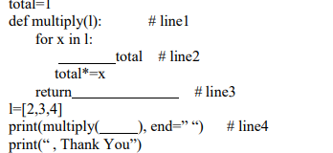  (i)Identify the part of function in # line1  (a) Function header (b) Function calling (c) Return statement (d)Default argument  (ii) Which of the keyword is used to fill in the blank for # line2 to run the program  without error.  (a) eval (b) def (c) global (d) return  (iii) Which variable is going to be returned in # line3  (a) total (b) x (c) l (d) None  (iv) Which variable is required in the # line4  (a) total (b) x (c) l (d) None
16 | Below is a program to delete the line having word (passed as argument). Answer the questions that follow to execute the program successfully  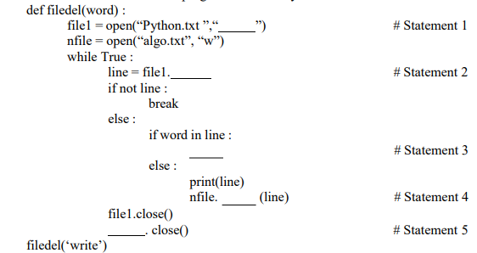  (i). In which mode, program should open the file to delete the line in statement 2?  (a) w (b) r (c) r+ (d) a+  (ii). Choose the correct option to fill up the blank in line marked as Statement 3.  (a) read() (b) read(n) (c) readlines() (d) readline()  (iii). Identify the missing code for blank space in line marked as Statement 4.  (a) True (b) Flag (c) pass (d) False  (iv). Choose the correct option to fill up the blank in line marked as Statement 5.  (a) read (b) write (c) writelines (d) writeline
17 | Consider a binary file EMP.DAT containing details empno:name:salary : (separator ‘:’) Write a function function Readfile( ) to display details of those employees who are earning between 20000 and 40000 ( both values inclusive)
18 | Create the file phonebook.dat that stores the details in following format :  Name Phone  Alex 7865443  Neha 8855342  Obtain the details from the user.
19 | Write a function to write numbers into a binary file and read the same
20 | A binary file “Book.dat” has structure [BookNo, Book_Name, Author, Price].  1. Write a user defined function CreateFile() to input data for a record and add to  Book.dat .  2. Write a function CountRec(Author) in Python which accepts the Author name as  parameter and count and return number of books by the given Author are stored in  the binary file “Book.dat
21 | A binary file “STUDENT.DAT” has structure [admission_number, Name, Percentage]. Write a function countrec() in Python that would read contents of the file “STUDENT.DAT” and display the details of those students whose percentage is above 75. Also display number of students scoring above 75%.
22 | Write a function addrec() in Python to add more new records at the bottom of a binary file “STUDENT.dat”, assuming the binary file is containing the following structure : [Roll Number, Student Name]
23 | Amit is a monitor of class XII-A and he stored the record of all the students of his class in a file named “class.dat”. Structure of record is [roll number, name, percentage]. His computer teacher has assigned the following duty to Amit Write a function remcount( ) to count the number of students who need remedial class (student who scored less than 40 percent)
24 | Rohit, a student of class 12th, is learning CSV File Module in Python. During examination, he has  been assigned an incomplete python code (shown below) to create a CSV File 'Student.csv' (content  shown below). Help him in completing the code which creates the desired CSV File.  CSV File  1,AKSHAY,XII,A  2,ABHISHEK,XII,A  3,ARVIND,XII,A  4,RAVI,XII,A  5,ASHISH,XII,A  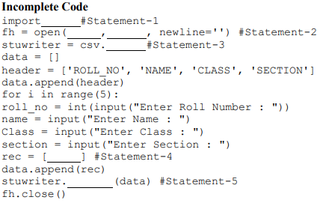  Identify the suitable code for blank space in line marked as Statement-1.  a) csv file b) CSV c) csv d) Csv  ii. Identify the missing code for blank space in line marked as Statement-2?  a) "School.csv","w" b) "Student.csv","w"  c) "Student.csv","r" d) "School.csv","r"  iii. Choose the function name (with argument) that should be used in the blank  space of line marked as Statement-3  a) reader(fh) b) reader(MyFile) c) writer(fh) d) writer(MyFile)  iv. Identify the suitable code for blank space in line marked as Statement-4.  a) 'ROLL_NO', 'NAME', 'CLASS', 'SECTION' b) ROLL_NO, NAME, CLASS, SECTION  c) 'roll_no','name','Class','section' d) roll_no,name,Class,sectionc) co.connect()
25 | In Hyderabad, 5 ABC Bank branches are available. One is at RR Pet, other at Market, other at Ashok Nagar, other at Fire Station and the last one at Bus Stand. Higher official wants to keep a network between these 5 branches. The branch names (A to E) and the number of computers in each branch (given inside the rectangle) is given below.  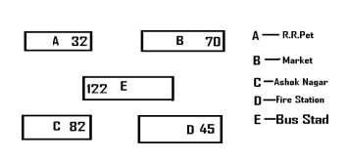  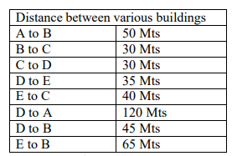  (i) Suggest a possible cable layout for connecting the buildings.  (ii) Suggest the most suitable place to install the server of this organization with a suitable  reason  (iii) Suggest the placement of the following devices with justification.  (a) Hub/Switch (b) Modem  (iv) The Bank wantsto link its head Office in ‘A’ building to its main office at Mumbai.  (a) Which type of transmission medium is appropriate for such a link?  (b) What type of network this connection result into?

****************************************************************

IP

1 | Which of the following command will show the last 3 rows from a Pandas Series named NP?  a. NP.Tail( ) b. NP.tail(3)  c. NP.TAIL(3) d. All of the above
2 | To display last five rows of a series object ‘S’, you may write:  a. S.head() b. S.Tail(5)  c. S.head(5) d. S.tail()
3 | Which of the following statement will import pandas library?  i. Import pandas as pd ii. import Pandas as py  iii. import pandas as pd iv. import panda as pd
4 | Fill in the blanks:  import pandas as pd  l1 =[11,12,13,14]  (a) row (b) index (c) row_index (d) All of the above
5 | While trying to create series from dictionary, keys of dictionary become index.  (a) True (b) False (c) Depends on Python Version (d) None of the above
6 | Which index,data element will be printed by below code as output:-  import pandas as pd  l1 =[11,12,13,14]  series1 = pd.Series(l1)  (a) Data : 12,13,14 along with series-index 1,2,3  (b) Data : 13,14 along with series-index 'C','D'  (c) Data : 13,14 along with series-index 2,3  (d) Data : 12,13,14 along with series-index 'B','C','D'
7 | To get the number of dimensions of Series object, _______ attribute is used.  (a) size (b) shape (c) itemsize (d) ndim
8 | To skip not numeric or null values in series, we can use _________ attribute  (a) skip (b) skipna (c) skipNaN (d) None of the above
9 | What will be correct syntax for pandas series?  (a) pandas_Series( data, index, dtype)  (b) panda.series( data, index, dtype)  (c) pandas.Series( data, index, dtype)  (d) panda_Series( data, index, dtype)
10 | To get the number of dimensions of a Series object, ___________ attribute is displayed.  (a) Index (b) Size (c) Itemsize (d) Ndim
11 | To get the size of the datatype of the items in Series object, you can use ____________attribute.  (a) Index (b) Size (c) Itemsize (d)Ndim
12 | To get the number of elements in a Series object, _____________ attribute may be used.  (a) Index (b) Size (c)Itemsize (d)Ndim
13 | To get the number of bytes of the Series data, _____________ attribute is displayed.  (a) hasnans (b) nbytes (c) ndim (d) dtype
14 | To display third element of a Series object S, you will write__________________  import pandas as pd  list1=[10,20,30,40,50]  S = pd.Series(list1)  print(S[2])  (a) S[:3] (b) S[2] (c) S[3] (d) S[:2]
15 | Which library in Python is used for working with DataFrames?  a) NumPy b) Pandas c) Matplotlib d) Scikit-learn
16 | Which of the following is a valid method to create a DataFrame in Pandas?  a) From a CSV file b) From dictionary of series  b) c) From CSV File d) All of the above
17 | How can you access the first five rows of a DataFrame?  a) df.head(5) b) df.tail(5) c) df[0:5] d) df.loc[0:4]
18 | Which method is used to check the dimensions of a DataFrame?  a) df.info() b) df.shape() c) df.describe() d) df.columns()
19 | Which method is used to check the summary statistics of a DataFrame?  a) df.info() b) df.shape() c) df.describe() d) df.columns()
20 | How can you select a specific column in a DataFrame?  a) df['column_name'] b) df.column_name  b) c) df.loc[:, 'column_name'] d) All of the above
21 | How can you drop a column from a DataFrame?  a) df.drop('column_name', axis=1) b) df.delete('column_name', axis=1)  b) df.remove('column_name', axis=1) d) df.drop_column('column_name')
22 | How can you filter rows in a DataFrame based on a condition?  a) df[condition] b) df.filter(condition) c) df.loc[condition] d) df.select(condition)
23 | How can you sort a DataFrame based on a specific column?  a) df.sort_by('column_name') b) df.sort_values('column_name') c)  df.sort('column_name') d) df.order_by('column_name')
24 | Pandas Dataframe is:  a) 3 Dimensional b) 1 Dimensional c) 2 Dimensional d) Multidimensional
26 | The axis 0 identifies a dataframe’s_____________.  a) rows b) columns c) values d) datatype
27 | What is the correct syntax to return the 5th row of a pandas DataFrame? Consider the name of the DataFrame is df:  a) df[5] b) df.loc[5] c) df.loc[4] d) df.iloc[5]
28 | The function to_csv used for converting a DataFrame to a CSV File is found in ____  a) Pandas Module b) CSV Module c) Python Module d) None of these
29 | When a DataFrame to a CSV File the attribute ______ is used to specify a separator other than comma(,)  a) other b) sep c) separator d) None of these
30 | Which attribute of dataframe is used to perform the transpose operation on a dataframe?  a) T b) Ndim c) Empty d)Shape
31 | What is a correct syntax to return the values of 1st row of a Pandas DataFrame dfRent.?  a. dfRent[0] b. dfRent.loc[1] c. dfRent.loc[0] d. dfRent.iloc
32 | Which among the following options can be used to create a DataFrame in Pandas?  (a) Scalar values (b) An ndarray (c) A python dict (d) All of these
33 | Which of the following functions is used to import data from a CSV file into a DataFrame?  a) read_csv() b) to_csv()  c) write_csv() d) import_csv()
34 | Which of the following functions is used to export a DataFrame to a CSV file?  a) read_csv() b) to_csv()  c) write_csv() ) import_csv()
35 | Which of the following parameters is used to specify whether the first row of the CSV file  contains column names?  a) header b) sep c) index_col d) na_values
36 | Which of the following parameters is used to specify the separator character used in the CSV file?  a) header b) sep c) index_col d) na_values
37 | Which of the following parameters is used to specify the column that should be used as the index of the DataFrame?  a) header b) sep c) index_col d) na_values
38 | What is the Use of Bridge?  (a) To Connect two LAN (b) To Connect two LAN Segment  (a) To Connect Internet (d) Amplify Signal
39 | With the use of computer network, we can share  (a) Data (b) Resources  (c) Both of the above (d) None of the above
40 | Which of the following is used in computer network  (a) Router (b) Switch (c) Bridge (d) All of the Above
41 | When we connect our mobile with Laptop then we call it  (a) MAN (b) WAN (c) PAN (d) LAN
42 | Mbps stands for  (a) Mega Byte Per Second (b) Million Byte Per Second  (c) Megabits Per Second (d) Maximum Bit Per Second
43 | Full form of NIC  (a) New Interface Card (b) Network Interface Card  (c) New Internet Card (d) Network Internet card
44 | Which device Convert Analog to Digital and vice-versa  (a) Hub (b) Bridge (c) Modem (d) Switch
45 | Arun wantsto create his own website, which language he can use to create new website.  (a) XML (b) HTML (c) Python (d) C++
46 | Amit’s computer is running slow due to virus. Then what he has to do.  (a) Format Computer (b) Install Firewall  (c) Install Antivirus (d) Do Nothing
47 | Hari is copying Mohan’s software without taking permission with Mohan.So which  type of crime is Hari doing  (a) Cyber Bulling (b) Cyber Stalking  (c) Cyber Theft (d) Copyright Infringement
48 | which among the following is not an example of browser.  a. Chrome b. Firefox  c. Avast d. edge
49 | _________ is a networking device that forwards the data packets between computer  network  a. Repeater b. Hub  c. Switch d. Router
50 | Which transmission media provides highest transmission speed in a network?  a. Twisted Pair Cable b. Coaxial cable  c. Optical Fiber d. All of these
51 | NSFNET stands for ___________  a. National Science Foundation Network  b. National Science fundamental network  c. neuro Science Foundation Network  d. National Search Foundation Network
52 | Physical or logical arrangement of network refers to as ________  a. Routing b. Looping  c. Topology d. Networking
53 | Bluetooth is an example of ________  a. Personal Area Network b. Local Area Network  c. Virtual Private Network d. wide area network
54 | Which networking device is used to transfer communication signal to long directions?  a. Amplifier b. Repeater  c. Router d. all of the above
55 | Which is called as smart hub?  a. Hub with high-speed ports b. Switch  c. Router d. All of the above
56 | Which topology in general uses less wire length compare to other?  a. Star topology b. Ring topology  c. Bus topology d. All use same length of wire
57 | A collection of hyperlinked documents on the internet forms the  a. World Wide Web (WWW) b. Email system  c. Mailing list d. Hypertext Markup Language
58 | HTML is used to create:  a. Machine Language program b. High level program  c. web page d. web server
59 | Which term identifies a specific computer on the web and the main page of the entire site?  a. WWW b. link  c. SQL d.URL
60 | SELECT MOD(11,2);
61 | SELECT POWER(2,3);
62 | SELECT POWER(4,.5);
63 | SELECT SQRT(81);
64 | SELECT ROUND(45678.2546,3);
65 | SELECT DAYNAME(“1995-04-12”);
66 | SELECT MONTHNAME(“1995-04-12”);
67 | SELECT DATE(“2022-02-02 12:15:46”);
68 | SELECT CONCAT(“MR”,”ANIL”);
69 | SELECT LOWER(“AAkarsh”);
70 | SELECT UPPER(“AAkarsh”);
71 | SELECT LENGTH(“KUMAR”);
72 | SELECT LTRIM(“ EDUCATION”);
73 | SELECT TRIM(“ EDUCATION ”);
74 | SELECT INSTR(“SUBSTANTIAL”,”TAN”);
75 | SELECT LEFT(“MALAYALAM”,4);
76 | SELECT RIGHT(“MALAYALAM”,4);
77 | SELECT MID(“EDUCATION”,3,4);
78 | SELECT SUBSTR(“ALOGRITHM”,5,3);
79 | SELECT RIGHT (LEFT(“APPROXIMATELY”,8),5);
80 | SELECT MID(LEFT(“APPROXIMATELY”,9),5,3);
81 | For web pages where the information is changed frequently, for example, stock prices,weather information which out of the following options would you advise.  a. static webpage b. dynamic webpage  c. both a and b d. none of the above
82 | which among the following is not an example of browser.  a. Chrome b. Firefox  c. Avast d. edge
83 | _________ is a networking device that forwards the data packets between computer network  a. Repeater b. Hub  c. Switch d. Router
84 | Which transmission media provides highest transmission speed in a network?  a. Twisted Pair Cable b. Coaxial cable  c. Optical Fiber d. All of these
85 | Which topology in general uses less wire length compare to other?  a. Star topology b. Ring topology  c. Bus topology d. All use same length of wire
86 | A collection of hyperlinked documents on the internet forms the  a. World Wide Web (WWW) b. Email system  c. Mailing list d. Hypertext Markup Language
87 | HTML is used to create:  a. Machine Language program b. High level program  c. web page d. web server
88 | Which term identifies a specific computer on the web and the main page of the entire site?  a. WWW b. link  c. SQL d.URL
89 | From which year did the IT Amendment Act, 2008 come into force?  i. 2009 ii. 2008 iii. 2000 iv. 20004
90 | Online ____________ is a theft of personal information in order to commit a fraud.  i. Phishing ii. Prank iii. Identity theft iv. All of these
91 | ____________ is a specific type of disorder where a person can’t strike a balance between their online and offline time?  i. Phishing ii. Tech savvy iii. Internet Addiction iv. None of these
92 | Any fraudulent business practice that extract money from an ignorant person is called.  i. Phishing ii. Scam iii. Both iv. None of these
93 | Any information about you created by you that exists in digital form is referred to as.  i. Intellectual property ii. Digital property iii. Both iv. None of these
94 | Using someone else’s twitter handle to post something will be termed as.  i. Fraud ii. Identity Theft iii. Online stealing iv. Violation
95 | Standard security protocol that establish encrypted link between web server and browser is called.  i. Web encryption Technology ii. STD Technology  iii. Online safety Technology iv. Security socket Technology
96 | Intellectual property right protect the use of information and idea that are of.  i. Ethical value ii. Moral value iii. Commercial value iv. Social value
97 | Which of the following is an open-source software?  i. Microsoft Windows ii. Adobe Photoshop iii. My SQL iv. MS power point
98 | The term intellectual property right covers.  i. Copyrights ii. Trademark iii. Patent iv. All of these
99 | What is the term used for entering someone's account without their consent?  i. Hacking ii. Phishing  iii. Cybercrime vi. Copyright infringement
100 | Online personal account, personal websites are example of.  i. Digital Wallet ii. Digital property iii Digital Certificate iv. Digital signature
101 | Unsolicited commercial email is known as.  i. Spam ii. Malware iii. Virus iv. Spyware
102 | Which of the following is not a type of cybercrime?  i. Data Theft ii. Forgery  iii. Damage of Data iv. Installation antivirus for protection
103 | Which of the following is not covered under IPR?  i. Music ii. Insurance iii. Logo Designed iv. Invention
104 | Which of the following is one of the impacts of e-waste on the environment?  i. Global Warming ii. Deforestation iii. Soil Erosion iv. Emission of Gases
105 | When circuits burnt for disposals, it creates which of the following harmful chemical?  i. Beryllium ii. Lead iii. Copper iv. Mercury
106 | The process of re-selling old electronic goods at lower prices is called.  i. Recycling ii. Refurbishing ii. Reusing iv. All of these
107 | _____________ deals with designing and arranging such furniture, equipment and systems  to make the work comfortable on computer.  i. Economic ii. Micro-economic iii. Ergonomics iv. None of these
1 | Name the crimes for which cyber laws are enforced strictly in India.
2 | What do you mean by cyber security?
3 | What is phishing?
4 | Explain the term ‘web beacon’.
5 | List any four health hazards related to excessive use of Technology.
6 | Mention net etiquettes.
7 | Rewrite the following code in python after removing all syntax error(s). Underline each correction done in the code.  STRING=""WELCOME  NOTE""  for S in range[0,8]:  print (STRING(S))
8 | Find output generated by the following code:  Str=”Computer”  Str=Str[-4:]  print(Str*2)
9 | Distinguish between list and Dictionary
10 | Read the code given below and show the keys and values separately.  D = {‘one’ : 1, ‘two’ : 2, ‘three’ : 3}
11 | Write the advantages of bus topology
12 | Difference between LAN and WAN
13 | Explain Any two Wired Media
14 | Define Any Two Topologies
15 | Write short note on the following: (a) Bandwidth (b) DNS
16 | Difference between CHAR & VARCHAR
17 | List of Aggregate functions
18 | In the table “Student”, Priya wanted to increase the Marks(Column Name: Marks) of those students by 5 who have got Marks below 33. She has entered the following statement:
19 | Table Student has the columns RNO and SCORE. It has 3 rows in it. Following two SQL statements were entered that produced the output (AVG(SCORE) as 45 and COUNT(SCORE) as 2) : (i) AVG(SCORE) (ii) Count(score)
20 | Ms. Rajshri is the Class Teacher of Class XII. She wants to create a table named ‘Student’ to store marks in different subjects of her class. Identify any 4 columns for the table along with their suitable data types
21 | How is HAVING clause similar to WHERE clause? How is HAVING clause different from WHERE clause? Explain with the help of examples of each.
22 | What is Natural Join?
23 | Murugan wants to send a report on his trip to the North East to his mentor. The report contains images and videos. How can he accomplish his task through internet?
24 | Explain VoIP
25 | What is the difference between Hub, Switch and Router?
26 | What are DDL and DML? Give one command of each.
27 | What is domain name, explain with example?
28 | Differentiate between Bus and Star Topology?
29 | Which clause is used to search for NULL values in any column?
30 | Explain count () and count (*)?
31
32 | Write the syntax of elif
33 | Write the syntax of for and while
34 | Ms. Rajshri is the Class Teacher of Class XII. She wants to create a table named ‘Student’ to store marks in different subjects of her class. Identify any 4 columns for the table along with their suitable data types.
35 | SELECT Marks+5 FROM Student WHERE Marks<33;  Identify errors(if any) in the above statement. Rewrite the correct SQL statement
36 | Write SQL statement to add a column ‘‘COUNTRY’’ with data type and size as VARCHAR(70) to the existing table named ‘‘PLAYER’’. Is it a DDL or DML or TCL command ?
37 | Write SQL statement to add a column ‘‘COUNTRY’’ with data type and size as VARCHAR(70) to the existing table named ‘‘PLAYER’’. Is it a DDL or DML or TCL command ?
38 | ‘Employee’ table has a column named ‘CITY’ that stores city in which each employee resides. Write SQL query to display details of all rows except those rows that have CITY as ‘DELHI’ or ‘MUMBAI’ or ‘CHANDIGARH’.
39 | What is Primary Key? What are the restriction imposed by Primary Key? How many primary key can be applied on a Table? What is the difference between Primary key and Candidate Key? 3. What is Degree and Cardinality of table?
40 | What is Degree and Cardinality of table?
41 | Explain the purpose of DDL and DML commands used in SQL. Also give two examples of each
42 | Name the library and interface used to plot a chart in python
43 | What are the ways of importing matplotlib?
44 | What are the basic elements/components of the chart?
45 | What types of graphs can be plotted using matplotlib?
46 | How to change the thickness of line, line style, line color, and marker properties of a chart?
47 | Write a program to create a single bar chart from two data sequences as given below:  Means=[20,35,30,35,27]  Stds=[2,3,4,1,2]  Make sure to show legends.
48 | You have a CSV file with data about students. The file has the following columns:  Name, age, gender, grade  Write a Python program to import the data from the CSV file into a DataFrame.
49 | You have a DataFrame with data about students. You want to export the DataFrame to a CSV file. The file should have the same columns as the original CSV file.
50 | You have a CSV file with data about students. The file has the first row as the column names
51 | Write code to create a new Dataframe n1 that stores the values of the Dataframe mdf multiplied by 3.
52 | Write code to add a column C4 in the dataframe which stores the differences of column C3 with column C2
53 | Ms. Sharma, the class teacher wants to add a new column, the ‘Grade’ with the values, ‘ A’, ‘B’, ‘A’, ‘A’, ‘B’, ‘A’ ,to the DataFrame. Help her to write code.
54 | Predict the output of the given Python code:  import pandas as pd  list1=[-10,-20,-30]  ser = pd.Series(list1*2)  print(ser)
55 | Complete the given Python code to get the required output as: Rajasthan  import _________ as pd  di = {'Corbett': 'Uttarakhand', 'Sariska': 'Rajasthan', 'Kanha': 'Madhya Pradesh’,  'Gir':'Gujarat'}  NP = ___________. Series( _____ )  print(NP[ ___________ ])
56 | Write a program to create a series object using a dictionary that stores the number of students in each house of class 12D of your school.
58 | What will be the output of the following code:  >>>import pandas as pd  >>>A=pd.Series(data=[35,45,55,40])
59 | Write the difference between hub and switch
60 | What is the purpose of gate way
61 | What is the difference series and data frames
62 | Explain about Data Frame method and Series method
63 | Consider the given SQL string:  “12#All the Best!”  Write suitable SQL queries for the following:  i. Returns the position of the first occurrence of the substring “the” in  the given string.  ii. To extract last five characters from the string.
64 | Predict the output of the given Python code:  import pandas as pd  list1=[-10,-20,-30]  ser = pd.Series(list1*2)  print(ser)
65 | Differentiate between the active digital footprint and passive digital footprints.
66 | What are aggregate functions in SQL? Name any two.
67 | List any four benefits of e-waste management
68 | Mention any four net etiquettes.
69 | What will be the output of the following code:  >>>import pandas as pd  >>>A=pd.Series(data=[35,45,55,40])  >>>print(A>45)
70 | Carefully observe the following code:  import pandas as pd  Year1={'Q1':5000,'Q2':8000,'Q3':12000,'Q4': 18000}  Year2={'A' :13000,'B':14000,'C':12000}  totSales={1:Year1,2:Year2}  df=pd.DataFrame(totSales)  print(df)  Answer the following:  i. List the index of the DataFrame df  ii. List the column names of DataFrame df
71 | Aman, a freelance web site developer, has been assigned a task to design few web pages for a book shop. Help Aman in deciding out of static web page and dynamic web page, what kind of web pages should be designed by clearly differentiating between static and dynamic web pages on at least two points
72 | Priyanka, a beginner in IT field has just started learning web technologies. Help her in understanding the difference between website and web pages with the help of a suitable general example of each.
73 | Briefly explain the purpose of the following SQL functions:  i. power()  ii. mod()
74 | Navya has just created a website for her company and now need to host it. Briefly discuss the role of a web server in hosting a website.
75 | Aryan, a database administrator, has grouped records of a table with the help of group by clause. He needs to further filter groups of records generated through group by clause. Suggest suitable clause for it and properly explain its usage with the help of an example
1 | .Consider a DataFrame (MRK) given below:  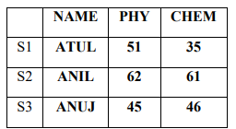  (A) Write commands to create the DataFrame (MRK) using a Dictionary of Lists  (B) If a DataFrame is created using a 2D dictionary, then the column labels are formed from the inner dictionary’s keys or outer dictionary’s keys?
2 | Assume the following Data Frame D1 and D2 given below:  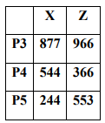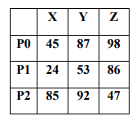  a) Write a command append the second to the first  b) Add a new Column between Y and Z in DataFrame D1 with any dummy values using insert  command  c) Rename the index of D2 : “P3” as PT2, “P4” as PT4 and “P5” as “PT5”
3 | A dictionary ‘Toys’ contains the following:  Toys = {‘Name’:[‘Doll’, ‘Ludo’, ‘Chess’ , ‘Blocks’], ‘Price’:[400,250,300,150]}  Write statements for the following:  i) Create a dataframe named “Stock” using dictionary ‘Toys’.  ii) Add a column called ‘Discount’ with the following data. [30,40,15,25]  iii)Delete column discount with all values
4 | Write a python code for the following Dataframe Library using python pandas. Give index as  ‘B1’, ‘B2’,’B3’,’B4’  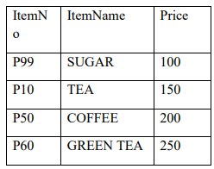  i) Display Item Number and name whose price is less than 150.  ii) Display details of different types of Tea available in shop.  iii) Display the dataframe.
6 | Consider the following DataFrame ‘df’ and answer questions from (i)-(iii):  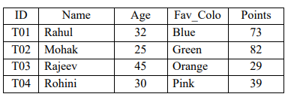  I. Write down the command that will add a column “eligible" with default value as ‘yes’.  II. Write the command to extract the complete row ‘T03’  III. Which command will be used to drop a row from dataframe ‘df’ labeled as ‘T04’?
10 | Write a Python code to create a DataFrame with appropriate column headings from the list given below: [[101,'Gurman',98],[102,'Rajveer',95],[103,'Samar' ,96],[104,'Yuvraj',88]]
11 | Consider the given DataFrame ‘Stock’:  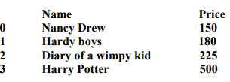  Write suitable Python statements for the following:  i. Add a column called Special_Price with the following data:  [135,150,200,440].  ii. Add a new book named ‘The Secret' having price 800.  iii. Remove the column Special_Price.
12 | What do you understand by plagiarism? Why is it a punishable offence? Mention any two ways to avoid plagiarism.
13 | Nadar has recently shifted to a new city and school. She does not know many  people in her new city and school. But all of a sudden, someone is posting  negative, demeaning comments on her social networking profile etc.  She is also getting repeated mails from unknown people. Every time she goes  online, she finds someone chasing her online.  i. What is this happening to Nadar?  ii. What immediate action should she take to handle it?  iii. Is there any law in India to handle such issues? Discuss briefly.
14 | Based on table STUDENT given here, write suitable SQL queries for the following:  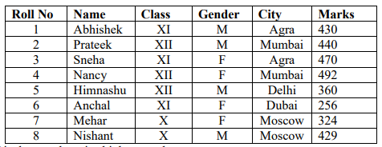  i. Display gender wise highest marks.  ii. Display city wise lowest marks.  iii. Display total number of male and female students.
15 | Create a DataFrame in Python from the given list:  [[‘Divya’,’HR’,95000],[‘Mamta’,’Marketing’,97000],[‘Payal’,’IT’,980000],  [‘Deepak’,’Sales’,79000]]
16 | What is ARPANET? What is NSFNET?
17 | Draw diagram of coaxial cable and explain about them
18 | Draw diagram of optical cable and explain about them
19 | Write MySQL statements for the following:  i. To create a database named FOOD.  ii. To create a table named Nutrients based on the following specification:  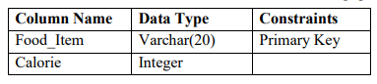
20 | Predict the output of the following queries:  i. select instr('exams@cbse.nic.in','.');  ii. select substr('exams@cbse.nic.in',7,4);  iii. select left('exams@cbse.nic.in',5);
21 | Ms.Saumya is working on a MySQL table named ‘Hotel’ having following structure:  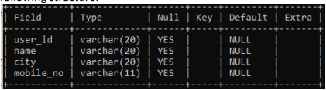  She need to perform following task on the table:  i. To fetch last 2 characters from the user_id column.  ii. To display the values of name column in lower case.  iii. To display 3 characters from 3rd place from the column city.  Suggest suitable SQL function for the same. Also write the query to achieve the desired task.
22 | Reena is working with functions of MySQL. Explain her following:  i. What is the purpose of now () function?  ii. How many parameters does it accept?  iii. What is the general format of its return type?
23 | While dealing with string data type in MySQL, its observed that sometimes unnecessary space character comes in between which hampers the successful execution of a string manipulation module. Name the suitable MySQL function (s) to remove leading, trailing and both type of space characters from a string. Also give MySQL queries to depict the same.
24 | Consider the given DataFrame ‘Genre’:  Type Code  0 Fiction F  1 Non Fiction NF  2 Drama D  3 Poetry P  Write suitable Python statements for the following:  i. Add a column called Num_Copies with the following data:  [300,290,450,760].  ii. Add a new genre of type ‘Folk Tale' having code as “FT” and 600  number of copies.  iii. Rename the column ‘Code’ to ‘Book_Code’
25 | Write a Python code to create a DataFrame with appropriate column headings from the list given below:  [[101,'Gurman',98],[102,'Rajveer',95],[103,'Samar' ,96],[104,'Yuvraj',88]]
26 | Nadar has recently shifted to a new city and school. She does not know many people in her new city and school. But all of a sudden, someone is posting negative, demeaning comments on her social networking profile etc. She is also getting repeated mails from unknown people. Every time she goes  online, she finds someone chasing her online.  i. What is this happening to Nadar?  ii. What immediate action should she take to handle it?  iii. Is there any law in India to handle such issues? Discuss briefly.
27 | What do you understand by plagiarism? Why is it a punishable offence? Mention any two ways to avoid plagiarism
28 | Discuss the significance of Group by clause in detail with the help of suitable example.
29 | What do you mean by Identity theft? Explain with the help of an example.
30 | Consider the following graph . Write the code to plot it.  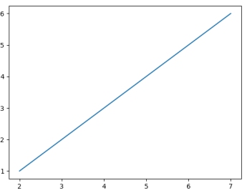
31 | Draw the following bar graph representing the number of students in each class.  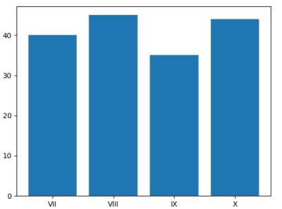
32 | A relation Vehicles is given below :  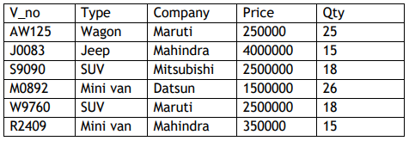  Write SQLcommands to:  a. Display the average price of each type of vehicle having quantity more than  20.  b. Count the type of vehicles manufactured by each company.  c. Display the total price of all the types of vehicles.
33 | Write a code to plot a bar chart to depict the pass percentage of students in CBSE exams for the years 2015 to 2018 as shown below  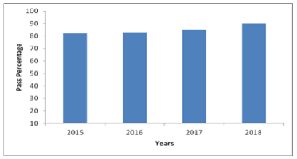
34 | Write a code in Python to search for a given value in a list of elements(Without using inbuilt function)  Example:  If the List contains: [20,30,40,50,60,80,120]  and the element to be searched is:60  Then the output should be: Found at position 4
35 | What is series? Explain with the help of an example.
36 | Write a code in python to find the minimum value in a list.  Example:  If the List contains: [100,150,90,65,180,200]  Then the output should be: Minimum Value is 65
37 | Consider the following dataframe, and answer the questions given below:  import pandas as pd  df = pd.DataFrame({“Quarter1":[2000, 4000, 5000, 4400, 10000],  "Quarter2":[5800, 2500, 5400, 3000, 2900], "Quarter3":[20000,  16000, 7000, 3600, 8200], "Quarter4":[1400, 3700, 1700, 2000,  6000]})  (i) Write the code to find mean value from above dataframe df over the index  and column axis.  (ii) Use sum() function to find the sum of all the values over the index axis.  (iii) Find the median of the dataframe df.
38 | Given a data frame df1 as shown below:  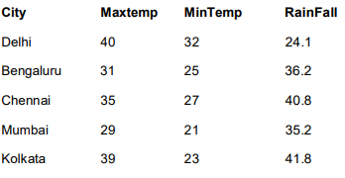  (i) Write command to compute sum of every column of the data frame.  (ii) Write command to compute mean of column Rainfall.  (iii) Write command to compute Median of the Maxtemp Column.
39 | Find the output of the following code:  import pandas as pd  data = [{'a': 10, 'b': 20},{'a': 6, 'b': 32, 'c': 22}]  #with two column indices, values same as dictionary keys  df1 = pd.DataFrame(data, index=['first', 'second'], columns=['a', 'b'])  #With two column indices with one index with other name  df2 = pd.DataFrame(data, index=['first', 'second'], columns=['a', 'b1'])  print(df1)  print(df2)
40 | Gunveen, Marshy and Aloha are three developers working on an exciting new app, and the launch day is just a day away. Gunveen creates an unmanaged package and saves it Aloha’s folder. Marshy also writes a new piece of code and saves it in Aloha’s folder. What could go wrong on the day of the launch? Explain and also mention how version control can help teams in this scenario.
41 | Write down any one situation where spiral delivery model can be used. Also mention one advantage and one disadvantage of spiral delivery model.
42 | Write down any one situation where waterfall software process can be used. Also mention one advantage and one disadvantage of waterfall software process.
43 | Shewani has recently started working in MySQL. Help her in  understanding the difference between the following :  (i) Where and having clause  (ii) Count(column_name) and count(*)
44 | Write any one similarity and one difference between primary key and unique Constraint
45 | Ms. Sen is an IT expert and a freelancer. She recently used her skill to access the Admin password for the network server of super Dopers technology Ltd and provided confidential data of the organisation to its CEO informing him about the vulnerability of their network security. Out of the following option (i) to (iv) which one most appropriately defines Ms. Sen?  (i) Hacker (ii) Cracker (iii) Operator (iv) Network Admin
46 | Given an array Rev storing Revenue of a small business in past some years:  Rev= np.array([12, 15, 13, 15, 16, 17, 14, 19, 19, 17, 19, 16, 17, 16, 18, 18, 18, 19, 19, 18, 19,  21, 20, 18, 19, 19, 21, 19, 19, 22])  (a) Write code to create a histogram as per following specifications:  ▪ Number of bins should be 10.  ▪ Plot color should be blue.  ▪ Outline/edge color should be red.  (b) Create a step type histogram.
47 | (a) Create a histogram that plots two ndarrays x and y with 48 bins, in stacked horizontal  histogram.  (b) Add plot title and axes titles to above plot.
48 | Write a code to plot the speed of a passenger train as shown in the figure given below:  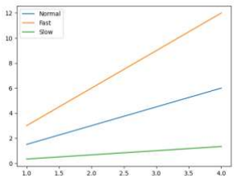
1 | Write Python statement to export the DataFrame to a CSV file named data.csv stored at D: drive.
Write suitable SQL queries for the following:
i. To calculate the exponent for 3 raised to the power of 4.
ii. To display current date and time.
iii. To round off the value -34.4567 to 2 decimal place.
iv. To remove all the probable leading and trailing spaces from the column userid of the table named user
2 | The heights of 10 students of eighth grade are given below:  Height_cms=[145,141,142,142,143,144,141,140,143,144]  Write suitable Python code to generate a histogram based on the given data, along with an appropriate chart title and both axis labels. Also give suitable python statement to save this chart.
3 | Write suitable Python code to create 'Favourite Hobby' Bar Chart as shown below:  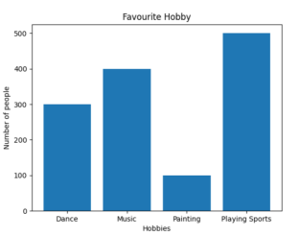  Also give suitable python statement to save this chart.
4 | Kabir has created following table named exam: +-------+---------+------------------+  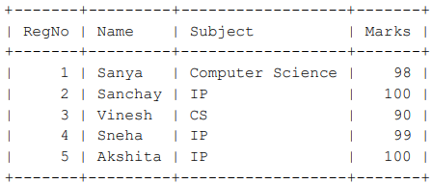  Help him in writing SQL queries to the perform the following task:  i. Insert a new record in the table having following values:[6,'Khushi','CS',85]  ii. To change the value “IP” to “Informatics Practices” in subject column.  iii. To remove the records of those students whose marks are less than  30 .  iv. To add a new column Grade of suitable datatype.
5 | Explain the following SQL functions using suitable examples.  i. UCASE()  ii. TRIM()  iii. MID()  iv. DAYNAME()  v. POWER()
6 | Write suitable SQL query for the following:  i. Display 7 characters extracted from 7 th left character onwards from the string ‘INDIA SHINING’.  ii. Display the position of occurrence of string ‘COME’ in the string ‘WELCOME WORLD’.  iii. Round off the value 23.78 to one decimal place.  iv. Display the remainder of 100 divided by 9.  v. Remove all the expected leading and trailing spaces from a column userid  of the table ‘USERS’
7 | Prime Computer services Ltd. is an international educational organization. It is planning to set up its India campus at Mumbai with its head office in Delhi. The Mumbai office campus has four main buildings-ADMIN, ACCOUNTS, EXAMINATION and RESULT.  You as a network expert have to suggest the best network related solutions for their problems raised in (i) to (v), keeping in mind the distances between the buildings and other given parameters.  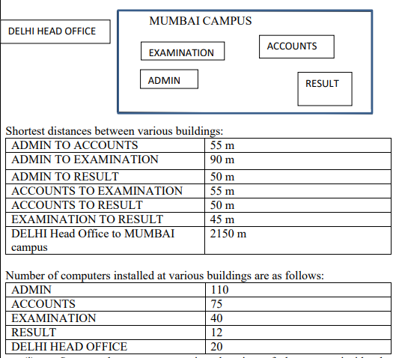  - Suggest the most appropriate location of the server inside the MUMBAI campus (out of the four buildings) to get the best connectivity for maximum number of computers. Justify your answer  - Suggest and draw cable layout to efficiently connect various buildings within the MUMBAI campus for a wired connectivity  - Which networking device will you suggest to be procured by the company to interconnect all the computers of various buildings of MUMBAI campus?  - Company is planning to get its website designed which will allow students to see their results after registering themselves on its server. Out of the static or dynamic, which type of website will you suggest?
8 | Write a python program to plot a line chart based on the given data to depict the changing weekly average temperature in Delhi for four weeks.  Week=[1,2,3,4]  Avg_week_temp=[40,42,38,44]
9 | Shreya, a database administrator has designed a database for a clothing shop. Help her by writing answers of the following questions based on the given table: TABLE: CLOTH  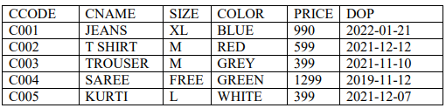  i. Write a query to display cloth names in lower case.  ii. Write a query to display the lowest price of the cloths.  iii. Write a query to count total number of cloths purchased of medium size.  iv. Write a query to count year wise total number of cloths purchased.
10 | Mr. Som, a data analyst has designed the DataFrame df that contains data about Computer Olympiad with ‘CO1’, ‘CO2’, ‘CO3’, ‘CO4’, ‘CO5’ as indexes shown below. Answer the following questions:  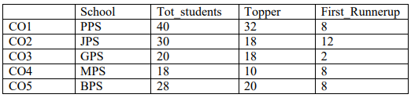  A. Predict the output of the following python statement:  i. df.shape  ii. df[2:4]  B. Write Python statement to display the data of Topper column of indexes CO2 to CO4
11 | Write Python statement to compute and display the difference of data of Tot_students column and First_Runnerup column of the above given DataFrame. Based on above question table
12 | Based on the above given table named ‘Student’, Satyam has executed following queries:  Select count(*) from student;  Select count(MARKS) from student;  Predict the output of the above given queries.  Also give proper justifications of the output generated through each query.
13 | Satyam, a database analyst has created the following table:  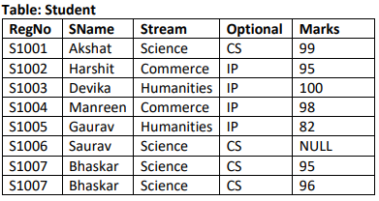  He has written following queries:  ( a) select sum(MARKS) from student where OPTIONAL= ‘IP’ and  STREAM= ‘Commerce’;  (b) select max(MARKS)+min(MARKS) from student where  OPTIONAL= ‘CS’;  (c) select avg(MARKS) from student where OPTIONAL= ‘IP’;  (d) select length(SNAME) from student where MARKS is NULL;  Help him in predicting the output of the above given queries.
14 | Write a program in Python Pandas to create the following DataFrame batsman from a Dictionary:  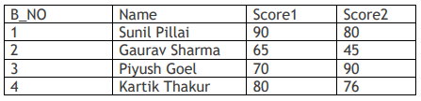  Perform the following operations on the DataFrame :  1)Add both the scores of a batsman and assign to column “Total”  2)Display the highest score in both Score1 and Score2 of the DataFrame.  3)Display the DataFrame
15 | Write the SQL functions which will perform the following operations:  i) To display the name of the month of the current date .  ii) To remove spaces from the beginning and end of a string, “ Panorama “.  iii) To display the name of the day eg, Friday or Sunday from your date of birth, dob.  iv) To display the starting position of your first name(fname) from your whole name  (name).  v) To compute the remainder of division between two numbers, n1 and n2
16 | Write a Python code to create the following Dataframe Empdf from a Dictionary:  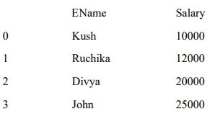  a) Write python code to rename the index to ‘A’,’B’,’C’,’D’ in place of 0,1,2,3.  b) Write python code to add a column ‘Commission’ with values as 5% of the Salary.
17 | Assume a dataframe DF That contains data about climate condition of various cities with C1,C2,C3,C4,C5 as index and give the output for the questions given below.  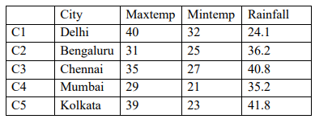  i) DF.shape ii) DF[1:2] iii) DF.loc[‘C1’: ‘C3’, ‘City’] iv)DF.City
18 | Using the below DataFrame mdf answer the questions a to d  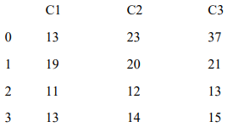  a) Write code to create a new Dataframe n1 that stores the values of the Dataframe mdf multiplied  by 3.  b) Write code to drop the index 2 from the above Dataframe. The Dataframe should be modified  after this statement.  c) Write the code to display the sum of rows with indexes 2 onwards from the Dataframe mdf.  d)Write code to add a column C4 in the dataframe which stores the differences of column C3 with column C2.
19 | Give the output of the command that follow based on the DataFrame DF below:  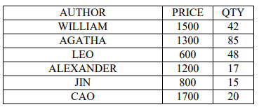  a) >>> DF['PRICE']>=1000 b) >>> DF[DF['QTY']<=50] c) >>> DF[‘QTY’]%5 d) >>> DF.iloc[[2,3],[1,2]] e)>>>DF.QTY[2]=300
20 | Atul has stored some data in a DataFrame “MDF” as shown below. He wants to shift the data to CSV file. Write commands for questions that follow  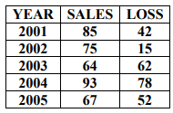  a) What is the full form of CSV  b) A CSV file can take ; character as separator  A) True B) False  c) To convert the above DataFrame “MDF” to a CSV file “TEXT.CSV”  d) To read and display the CSV file “TEXT.CSV” thus formed without header
21 | Write code for the following questions on the basis of following DataFrame ‘Sales’.  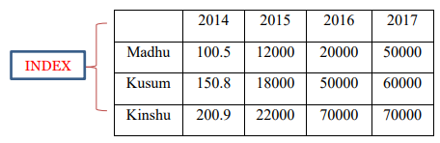  a)Display the transpose of DataFrame Sales.  b) Display the sales made by Madhu and Ankit in the year 2016 and 2017.  c) Delete the data for sales man Kinshuk from the DataFrame Sales.  d) Update the sale made by Shruti in 2017 to 100000
22 | Consider the following dataframe, and answer the questions given below:  df = pd.DataFrame({ "Quarter1":[2000, 4000, 5000, 4400, 10000], "Quarter2":[5800, 2500,  5400, 3000, 2900], "Quarter3":[20000, 16000, 7000, 3600, 8200], "Quarter4":[1400, 3700, 1700,  2000, 6000]})  Plot the line graph of data of all the quarters in one chart and also gives the legends to identify  the quarters.
23 | Draw a double bar graph chart showing the Cities in the X axis and happiness index in the Y axis for Male and Female. Use legends as Male and Female for identifying purpose.  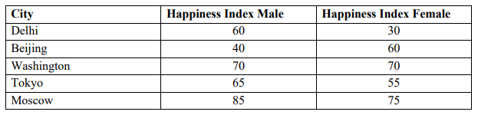
 | Given two ndarrays. Write a Program to plot them in the same line graph and show legends
24 | Given a dataframe namely prodf showing the production of various agricultural yields by four states UP,MP,AP and JK as shown below:  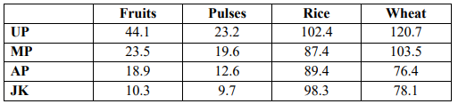  Write code to draw the multiple bar chart showing states on the x axis and production of various agricultural products on the y axis.
Multipurpose Public School, Bengaluru is setting up the network between its different wings of school campus. There are 4 wings named as: - SENIOR(S), JUNIOR(J), ADMIN(A) and HOSTEL(H)
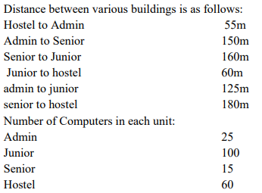
(i) Suggest and draw the cable layout to efficiently connect various wings of Multipurpose Public School, Bengaluru.
(ii) Name the most suitable wing where the servers should be installed. Justify your answer.
(iii) Suggest a device/software and its placement that would provide data security for the entire network of the school
(iv) Suggest a device and a protocol that shall be needed to provide wireless internet access to all smartphone/laptop users in the campus of Multipurpose Public School, Bengaluru.
(v) Suggest the placement of repeater with justification

********** All the Best !!!!! **********

